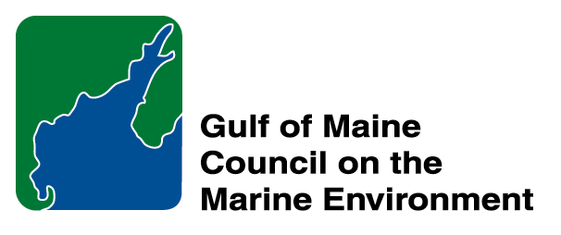 |  | 2015 Gulf of Maine  Longard Award  Nomination Form

The Longard Volunteer Award is bestowed each year in memory of Art Longard, a founding member of the Gulf of Maine Council on the Marine Environment and long-time Working Group member. The Award is given to an individual from one of the five states and provinces bordering the Gulf of Maine. The Longard Award recognizes individual commitment to volunteer programs dedicated to environmental protection and sustainability of natural resources within the marine, near shore, and watershed environments of the Gulf of Maine.

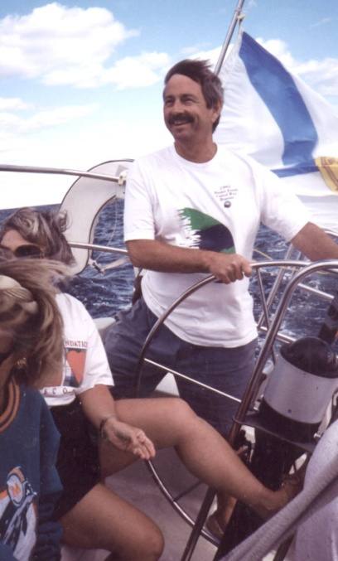  Art Longard | Nomination instructions  - Individuals or organizations may submit nominations. Self-nominations are not accepted.  - The nominee must be resident of Maine, Massachusetts, New Brunswick, New Hampshire, or Nova Scotia. The nominee’s contributions must have been to the Gulf of Maine watershed.  - Longard Award nominees must have contributed to the Gulf of Maine in their capacity as a volunteer, NOT as a paid professional.  - Nominations must be made on this form. Attachments will not be accepted.  - Nominations must be emailed to theresa.torrent@maine.gov by the close of business on March 30, 2015. Please rename the nomination form with _LastNameofNominee added to the end of the file name.
Questions? Please contact Theresa Torrent @maine.gov or 207.287.2351.

To view a list of past award winners, please visit: http://www.gulfofmaine.org/2/opportunities/

Nominee information
Name (as it would appear on the award plaque if selected): Stony Brook Herring Monitors
Mailing address: c/o Eleanor Johnson, 909 Stony Brook Rd, Brewster MA 02631
Phone: 508-986-3207
Email: petenellie@gmail.com

Brief background on why the individual/organization is being nominated:

Summary that will be read during the awards ceremony if nominee is selected. This text will also be used in media releases (not to exceed 2,000 characters, including spaces and punctuation):

Formed in 2007, the Stony Brook Herring Monitors is a group of fifteen volunteers that has been monitoring the Stony Brook herring run in Brewster MA since 2007 using a visual count method designed by Massachusetts Division of Marine Fisheries. The herring run three-year restoration project was concluded in 2013. Improvements including widening of an undersized culvert from 4 feet to 18 feet and rebuilding of the fish passage leading to the first of five ponds containing nearly 400 acres of spawning, nursery and feeding habitat for river herring. Each spring since 2007 the Stony Brook Herring Monitors painstakingly tracked the return of herring to these precious ponds, noting the decrease in population. Their efforts paid off as with the finalization of the restoration project, the herring run increased by more than 1000% over the last four years. The ecological success is demonstrated by the increase in herring population that use this run every year. Documentation of this success was made possible by the monitoring work of the Stony Brook Herring Monitors.

Name and contact information of person making the nomination:
Name: Jo Ann Muramoto
Affiliation: Association to Preserve Cape Cod
Address: 3010 Main St. P.O. Box 398, Barnstable MA 02630
Phone: 508-362-0226
Email: jmuramoto@apcc.org

