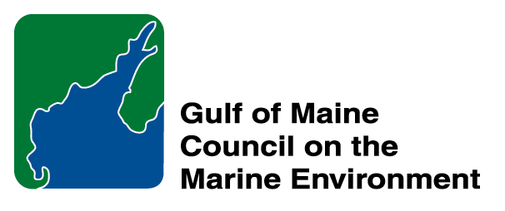 |  | 2015  Susan Snow-Cotter Leadership Award Nomination Form
The Susan Snow-Cotter Leadership Award is bestowed in memory of Susan Snow-Cotter, a long-time friend of the Council and Working Group. The Award is given to an individual from one of the five states and provinces bordering the Gulf of Maine. The Susan Snow-Cotter Leadership Award honors coastal management professionals who exemplify outstanding leadership or exceptional mentoring in the Gulf of Maine watershed. As former Director of the Massachusetts Office of Coastal Zone Management, Susan was recognized as a leader who exhibited unwavering passion, enthusiasm, and insight to develop pragmatic approaches to coastal management challenges. The Council presents this award to a professional who has demonstrated exceptional leadership in coastal and ocean planning and management by:

- Developing pragmatic approaches;
- Building collaborative efforts through mobilizing and unifying others around an issue or initiative; and/or
- Serving as a strong and supportive mentor to emerging coastal management professionals.

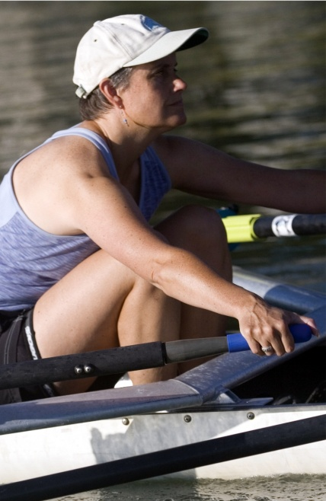  Susan Snow-Cotter | 0BNomination instructions  - Individuals or organizations may submit nominations. Self-nominations are not accepted.  - The nominee must be resident of Maine, Massachusetts, New Brunswick, New Hampshire, or Nova Scotia and his/her work be conducted primarily in the Gulf of Maine region.  - The nominee’s contributions must have occurred in the Gulf of Maine watershed.  - Nominations must be made on this form. Attachments will not be accepted.  - Nominations must be emailed to theresa.torrent@maine.gov by the close of business on March 30, 2015. Please rename the nomination form with _LastNameofNominee added to the end of the file name.
Questions? Please contact Theresa Torrent at theresa.torrent@maine.gov or 207.287.2351.

To view a list of past award winners, please visit: http://www.gulfofmaine.org/2/opportunities/

Nominee information
Name (as it would appear on the award plaque if selected): Linda Welch
Affiliation (if applicable): U.S. Fish and Wildlife Service
Mailing address: Maine Coastal Islands NWR, Milbridge, ME 04658
Phone: (207) 546-2124
Email: linda_welch@fws.gov

Brief background on why the individual/organization is being nominated: Summary that will be read during the awards ceremony if nominee is selected. This text will also be used in media releases (not to exceed 2,000 characters, including spaces and punctuation):

As a Wildlife Biologist at the Maine Coastal Islands National Wildlife Refuge, Linda Welch manages a multitude of important seabird colonies, and each summer supervises a small army of researchers working in harsh conditions on remote islands. Many of these young people return year after year, thanks largely to the nurturing environment Linda creates. Her passion for these islands is clearly evident, and she goes far above and beyond her official management role to identify critical research needs and initiate timely, innovative, and enlightening research projects. In recent years, she has carried out ground-breaking tracking studies highlighting the long-distance migrations of marine birds breeding in the Gulf. In one, partnering with Canadian researchers and Stellwagen Bank National Marine Sanctuary, she tracked Great Shearwaters to their colonies in the southern hemisphere. Linda not only has a significant impact on the biological programs at the refuge, she is also instrumental in building collaborative efforts across the region. For example, Linda led the development of the Gulf of Maine Integrated Ecosystem Research Program, a broad coalition working collaboratively towards truly integrated studies of the Gulf of Maine’s magnificent ecosystem. In 2013, they secured a State Wildlife Grant to carry out broad-scale, multidisciplinary ecosystem studies that include coastal surveys to collect data on the distribution of zooplankton, fish, marine birds, and marine mammals in combination with detailed oceanographic measurements. As if that wasn’t enough, Linda works tirelessly in fostering regional coalitions and scientific groups, such as the Atlantic Marine Bird Cooperative; she stays actively involved in professional groups, such as the Maine chapter of The Wildlife Society; she regularly contributes to scientific literature, and presents research at meetings and conferences; and still finds time to offer guidance to graduate students at the University of Maine.

Name and contact information of person making the nomination:
Name: Dr. Iain Stenhouse
Affiliation: Biodiversity Research Institute
Address: 276 Canco Road, Portland, ME 04103
Phone: (207) 839-7600 x 210
Email: iain.stenhouse@briloon.org

