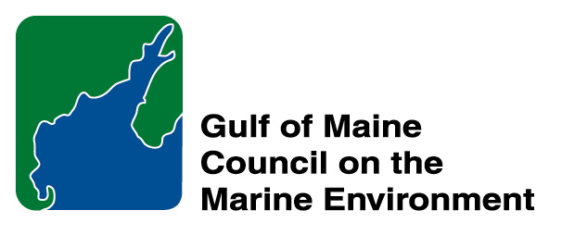 |  | 2015  Sustainable Communities  Nomination Form
The intent of the ‘Sustainable Communities Award’ is to recognize communities, or groups within communities, of their exemplary work in achieving sustainability outcomes related to the environment and economy, in line with the objectives of the GOMC Action Plan. The selection criteria are derived from the Melbourne Principles and the Government of New Brunswick’s Community Recognition Award selection criteria.

- Provides a long-term vision for communities based on pillars of sustainability: social /cultural, environmental and economic, as well as political equity, and the community’s individuality.
- Works towards achieving long-term economic, social, and environmental security.
- Recognizes the intrinsic value of biodiversity and natural ecosystems, and acts to promote the stewardship of biodiversity and natural ecosystems, and protects and/or restores them.
- Strives to enable communities to minimize their ecological footprint.
- Engages the community in the planning and implementation of sustainable solutions.
- Builds on the characteristics of ecosystems in the development and nurturing of healthy and sustainable communities.
- Recognizes and builds on the distinctive characteristics of the community, including their human and cultural values, history, and natural systems.
- Empowers people and fosters participation.
- Expands and enables communication and cooperative networks to work towards sustainability as a common and shared goal.
- Promotes sustainable production and consumption, through appropriate use of environmentally sound technologies and effective demand management.
- Enables continual improvement, based on action planning, accountability, transparency and good governance.

Overarching Program Criteria
Nominations should demonstrate that the community, group, program, or project contributed to the long-term viability of the community, improved the health of its immediate environment, and impacted positively the health of the Gulf of Maine.

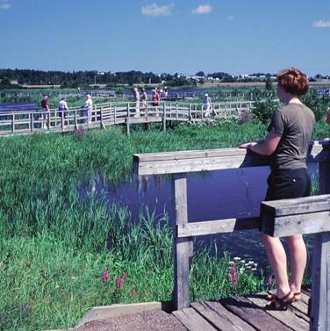 | Nomination instructions  - Individuals or organizations may make nominations. Self-nominations are not accepted.  - The community must be based in part or in whole in Maine, Massachusetts, New Brunswick, New Hampshire, or Nova Scotia. The nominee’s contributions must have occurred in the Gulf of Maine watershed.  - Nominations must be made on this nomination form. This form may be reproduced electronically. Nominations with missing information will not be considered. Please provide all information on this form—attachments will not be accepted.  - Nominations must be emailed to theresa.torrent@maine.gov by the close of business on March 30, 2015. Please rename the nomination form with _LastNameofNominee added to the end of the file name.
Questions? Please contact Theresa Torrent at theresa.torrent@maine.gov or 207.287.2351.
Nominee Information
Name (as it would appear on the award plaque if selected) City of Portsmouth, New Hampshire
Affiliation: Mayor Robert J. Lister
Mailing address: Mayor’s Office, 1 Junkins Avenue, Portsmouth, NH 03801
Phone: (603) 610-7200
Email: Not provided as public information.

Please continue to next page.

Brief background on why the community or group is being nominated:

The City of Portsmouth embraces the sustainable community ideal in their progressive municipal governance, management and public services focused on sustainability. The City demonstrates a consistent vision for ensuring a high quality of life and protecting the environment by initiatives such as:
- City Complete Streets, Bicycle Friendly Community and Walk Friendly Community policies, and a new City Bicycle and Pedestrian Plan
- State Street complete streets renovation project
- Green Infrastructure design for stormwater treatment at the Pierce Island Snow Dump
- Downtown Form-Based Districts and community visioning charrettes
- Partnership with the Portsmouth Historical Society to open the Discover Portsmouth Center, interpreting the City’s history and culture and serving as a non-profit hub
- Support for land conservation efforts and preservation of public parks and open space

Projects to improve infrastructure and services also engage the public about sustainability practices including:
- Installation of an electric vehicle charging station at the Hanover Street parking garage
- Annual Sustainability Fair and Market Square Day
- Installation of downtown on-street recycling receptacles
- Partner in Portsmouth Listens, a facilitated citizen dialogue on local issues from the Master Plan, Sustainability Plan and school redistricting

Community engagement activities are supported by a user-friendly City and Plan Portsmouth websites, and televised meetings of City Council, boards, commissions and committees as well as support from numerous non-profit organizations based in the city (Green Alliance, Seacoast Local, Seacoast Eat Local, PS21, Portsmouth Smart Growth for the 21st Century, Portsmouth Listens).

The City’s Coastal Resilience Initiative project, the first of its kind in NH, analyzed potential climate change impacts on infrastructure, historical resources and salt marshes. The project provides cost estimates to protect critical assets, flood potential maps, informational materials and a project website. Participation by City staff and officials in climate preparedness and adaptation activities include six years of membership in the NH Coastal Adaptation Workgroup and Mayor Lister’s support of the fall 2015 national climate conference in Hampton (a Union of Concerned Scientists event).

Contact Information for Person Making the Nomination
Name: Cliff Sinnott, Executive Director
Affiliation: Rockingham Planning Commission
Mailling Address: 156 Water Street, Exeter, NH 03833
Phone: (603) 778-0885
Email: csinnott@rpc-nh.org

