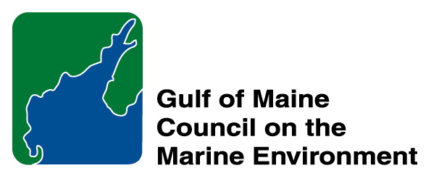 | 2015 Gulf of Maine Council Visionary Award  Nomination Form

The Gulf of Maine Visionary Award is presented annually to an individual or organization within each of the five Gulf of Maine jurisdictions of Massachusetts, New Hampshire, Maine, New Brunswick, and Nova Scotia. The Awards recognize innovation, creativity, and commitment to marine protection by businesses, environmental organizations, or individuals who are making a difference to the health of the Gulf of Maine.

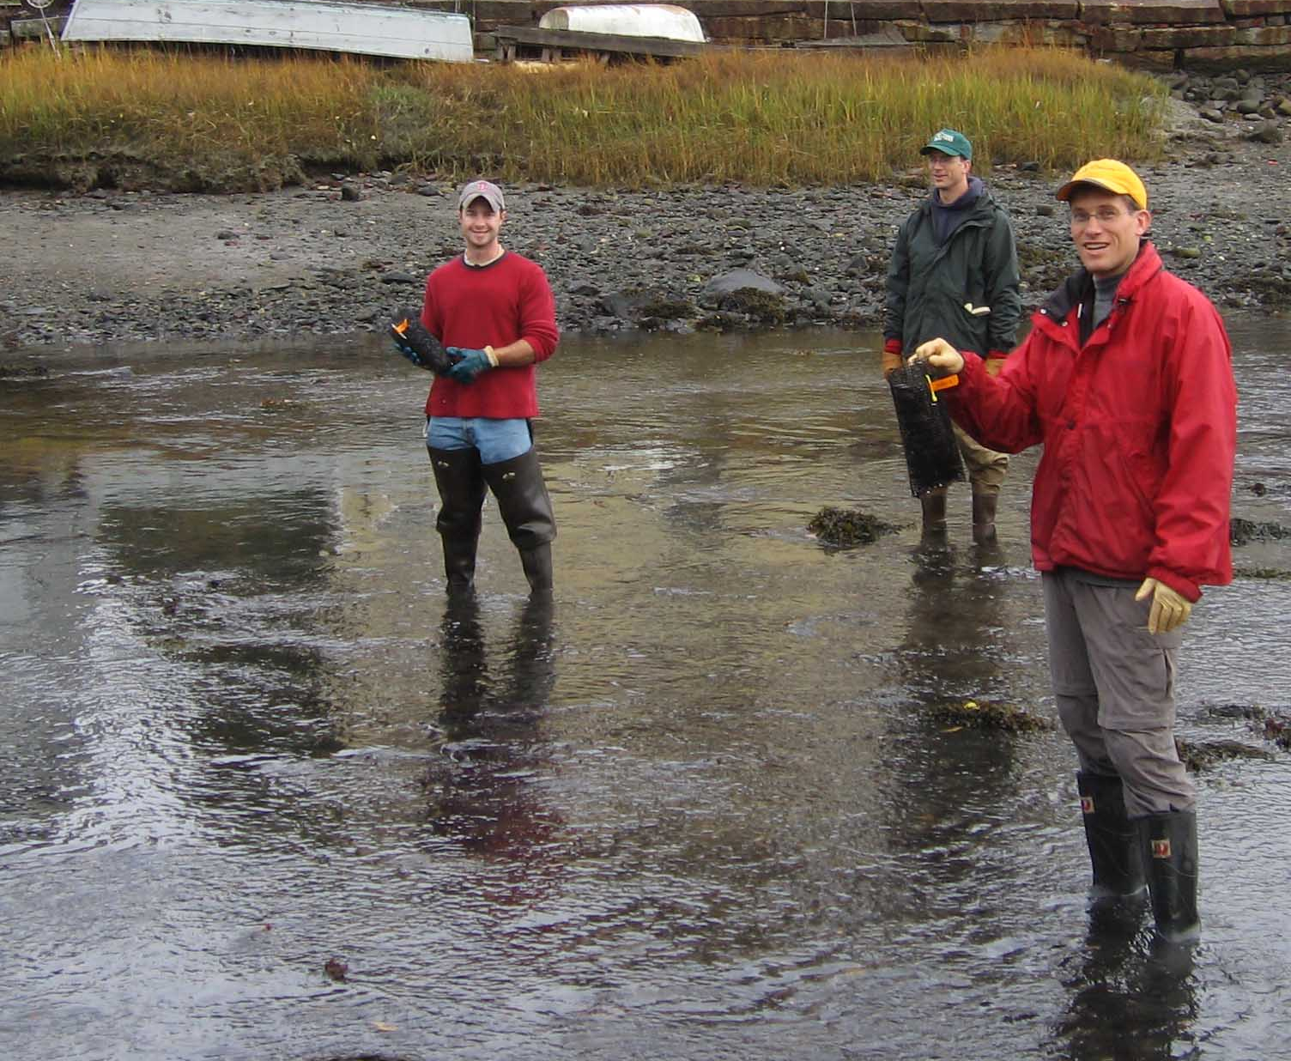 | Nomination instructions:  - Individuals or organizations may make nominations. Self-nominations are not accepted.  - The nominee must reside in Maine, Massachusetts, New Brunswick, New Hampshire, or Nova Scotia. The nominee’s contributions must have occurred in the Gulf of Maine watershed.  - Visionary Award nominees may be paid professionals or volunteers.  - Nominations must be made on this nomination form. Nominations with missing information will not be considered. Attachments will not be accepted.  - Nominations must be emailed to theresa.torrent@maine.gov by the close of business on March 30, 2015. Please rename the nomination form with _LastNameofNominee added to the file name.
Questions? Please contact Theresa Torrent at theresa.torrent@maine.gov or 207.287.2351.
To view a list of past award winners, please visit: http://www.gulfofmaine.org/2/opportunities/

Nominee information
Name (as it will appear on the award plaque if selected): Candace Dolan
Affiliation: Hodgson Brook Restoration Project
Mailing address: 143 Pleasant Street, Portsmouth, NH 03801
Phone: (603) 559-1529
Email: cjdolan@ccsnh.edu

Brief background on why the individual/organization is being nominated:

Candace Dolan serves as the Coordinator for the Hodgson Brook Restoration Project in Portsmouth, NH. Candace has provided strong leadership for this restoration effort that has been very challenging due to the brook’s highly urbanized setting. Through a combination of an ability to take risks, amazing people skills, and a very clear sense of purpose, Candace has initiated a range of watershed restoration projects that have ultimately made a very positive difference for the brook and the people who live in its watershed. She’s retiring this year so this honor would be so special and meaningful for her and the many partners who have worked with her on this great project.

Summary that will be read during the awards ceremony if nominee is selected. This text will also be used in media releases (not to exceed 2,000 characters, including spaces and punctuation):

For the past ten years, Candace Dolan has worked tirelessly to restore and protect Hodgson Brook – a tiny, degraded and forgotten stream that flows through the heart of Portsmouth, NH.

In her work as Coordinator for the Hodgson Brook Restoration Project, Candace Dolan has brought the brook’s plight to the attention of many including the City of Portsmouth, local businesses, educational institutions, state agencies, residents, visitors, and students. She has organized hundreds of volunteers to monitor water quality, pull thousands of pounds of trash from the brook, and install rain gardens. She has made the brook come alive for many local students with hands-on, in-the-brook water quality education. Candace has reached out to local businesses to convince them to partner with her to construct innovative treatment practices to clean stormwater runoff, reduce the use of salt on their parking lots, enhance stream buffers on their properties, and…donate money to the brook’s cause! She has spoken passionately on behalf of the brook numerous times in front of city boards and committees. She has provided a multitude of opportunities for college students to conduct scientific investigations on the brook and then has applied their results to restoration solutions. Candace is not afraid to tackle difficult restoration problems; in fact, she relishes a challenge, and will often jump right in without fear…if it’s something new or unknown that will help the brook, Candace will say “yes” first and then figure out how to get it done later. The list of Candace’s accomplishments – all conducted on behalf of a tiny little waterway that most would turn away from or forget – is endless. She is a force for the brook’s restoration; we have only the highest respect for her dedication, clear sense of purpose, and ability to blend science, policy, and culture for the health of Hodgson Brook.

Name and contact information of person making the nomination:
Name & Affiliation: Sally Soule, Coastal Watershed Supervisor, NH Department of Environmental Services
Address: 222 International Drive, Portsmouth, NH 03801
Phone: (603) 559-0032
Email: sally.soule@des.nh.gov

The mission of the Council is to maintain and enhance environmental quality in the Gulf of Maine and to
allow for sustainable resource use by existing and future generations.

Massachusetts Office of Coastal Zone Management • 2002-2003 Secretariat
GOMC • c/o NHDES • PO Box 95 • Concord, NH, US • 03302-0095 • Phone (603) 225-5544

The mission of the Council is to maintain and enhance environmental quality in the Gulf of Maine and to
allow for sustainable resource use by existing and future generations.

New Hampshire Department of Environmental Services • 2014-2015 Secretariat

