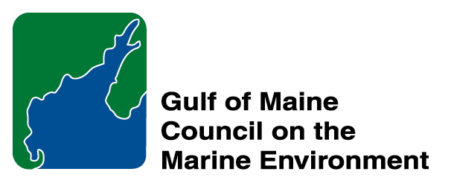 | 2015 Gulf of Maine Council Visionary Award  Nomination Form

The Gulf of Maine Visionary Award is presented annually to an individual or organization within each of the five Gulf of Maine jurisdictions of Massachusetts, New Hampshire, Maine, New Brunswick, and Nova Scotia. The Awards recognize innovation, creativity, and commitment to marine protection by businesses, environmental organizations, or individuals who are making a difference to the health of the Gulf of Maine.

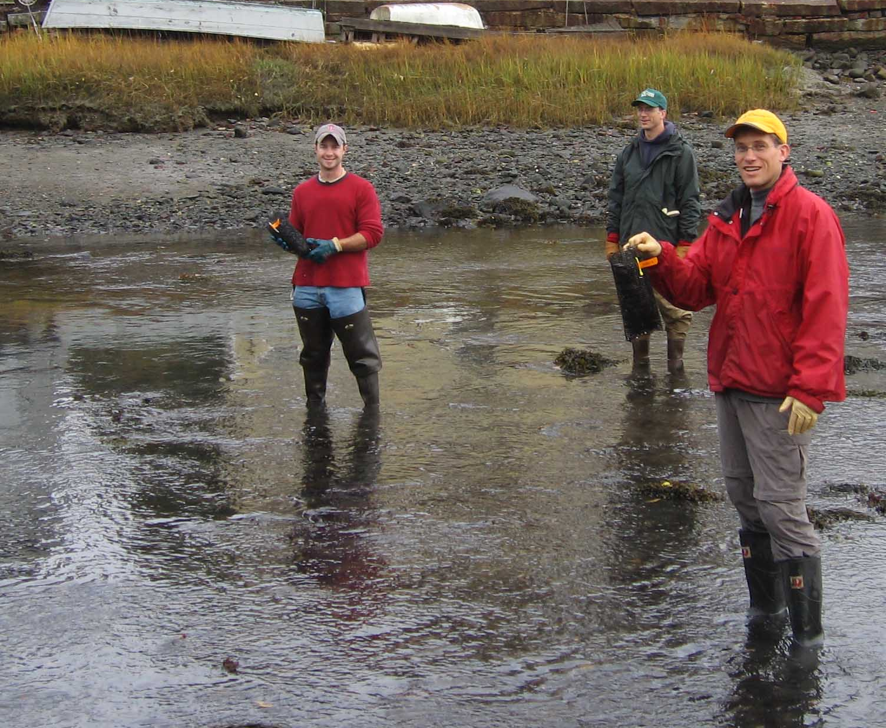 | Nomination instructions:  - Individuals or organizations may make nominations. Self-nominations are not accepted.  - The nominee must reside in Maine, Massachusetts, New Brunswick, New Hampshire, or Nova Scotia. The nominee’s contributions must have occurred in the Gulf of Maine watershed.  - Visionary Award nominees may be paid professionals or volunteers.  - Nominations must be made on this nomination form. Nominations with missing information will not be considered. Attachments will not be accepted.  - Nominations must be emailed to theresa.torrent@maine.gov by the close of business on March 30, 2015. Please rename the nomination form with _LastNameofNominee added to the file name.
Questions? Please contact Theresa Torrent at theresa.torrent@maine.gov or 207.287.2351.
To view a list of past award winners, please visit: http://www.gulfofmaine.org/2/opportunities/

Nominee information
Name (as it will appear on the award plaque if selected): Oyster Conservationist Program
Affiliation: The Nature Conservancy (TNC)
Mailing address: 112 Bay Road, Newmarket, NH 03857
Phone: 603 659-2678
Email: kara.russell@tnc.org

Brief background on why the individual/organization is being nominated and Summary:

The abundant wild oysters that local citizens knew fifty years ago are diminished but resilient. Once dominant in Great Bay Estuary (GBE), adult oyster populations plummeted with 90% losses by the year 2000 following disease outbreak in the 1990s. Oysters serve an important ecological role in cleaning the bay’s water and providing structural habitat for many fish and invertebrates. When oysters feed they clean and clear the water by filtering excess nutrients and suspended solids from the water column. One adult oyster filters 20 gallons of water per day, so every live acre of oyster reef removes substantial algae and controls as much as a half-ton of harmful nitrogen within the system.

Today in Great Bay Estuary, there is great hope for the oyster. The NH oyster population has slowly increased from a low in the early 2000s with the help of local restoration efforts, including the Oyster Conservationist (OC) Program. Since 2006, The Nature Conservancy (TNC), together with the University of New Hampshire (UNH), has organized and operated this community-based restoration effort. With nine years complete, the OC program is a unique way for local citizenry to directly engage in estuarine restoration. 2015 is the ten year anniversary of this program.

The Oyster Conservationist Program is based on local volunteers who raise oysters on private docks or moorings to help restore native oysters in Great Bay Estuary. Each summer, volunteer homeowners receive a small cage with juvenile oyster “spat” set at UNH’s Jackson Estuarine Laboratory, along with instructions on how to care and monitor the oysters over a ten week program. Assisted by TNC’s oyster conservation coordinator, the homeowners maintain the cages for fouling at least weekly and conduct growth measures for reporting bi-weekly. After ten weeks, the coordinator collects the young oysters and the spat are seeded on a newly created oyster reef to jump start natural recovery. A final report is produced and shared among all participants and the data provide important information for locating future oyster reefs.

In ten years of operation, the Oyster Conservationist Program has engaged more than 100 different families and raised more than 120,000 oysters for restoration efforts. In 2014 alone, 75 families participated in the program, with recent growth on the order of <25% annually. The program also expanded into Southern Maine in 2014, and now operates in 14 different towns in the seacoast areas of the Piscataqua Region of New Hampshire and Maine. The program is poised in 2015, the tenth anniversary, to be the largest group of participants yet.

Equally important to the restoration contribution, the OC program is building a cadre of community thought leaders that understand the valuable and irreplaceable services that our estuaries provide. The outreach benefits of oysters are evident in our OC families as they share experiences with neighbors, write newsletter articles, post results on social media, and provide a new source of energy in the Piscataqua Region for healthy estuaries!

For detailed information on the OC program, please review the 2014 Oyster Conservationist Final Report at http://www.nature.org/ourinitiatives/regions/northamerica/unitedstates/newhampshire/oyster-restoration/oc-report-2014-for-web.pdf.

Name and contact information of person making the nomination:
Name & Affiliation: Steve Couture, NH Dept. of Environmental Services
Address: 29 Hazen Drive Concord, NH 03301
Phone: 603-271-8801
Email: steven.couture@des.nh.gov

The mission of the Council is to maintain and enhance environmental quality in the Gulf of Maine and to
allow for sustainable resource use by existing and future generations.

Massachusetts Office of Coastal Zone Management • 2002-2003 Secretariat
GOMC • c/o NHDES • PO Box 95 • Concord, NH, US • 03302-0095 • Phone (603) 225-5544

The mission of the Council is to maintain and enhance environmental quality in the Gulf of Maine and to
allow for sustainable resource use by existing and future generations.

New Hampshire Department of Environmental Services • 2014-2015 Secretariat

