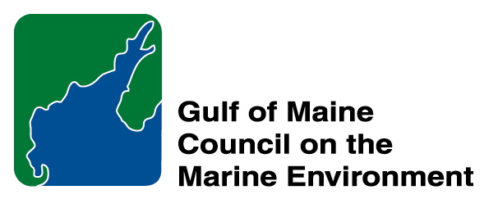 | 2015 Gulf of Maine Council Visionary Award  Nomination Form

The Gulf of Maine Visionary Award is presented annually to an individual or organization within each of the five Gulf of Maine jurisdictions of Massachusetts, New Hampshire, Maine, New Brunswick, and Nova Scotia. The Awards recognize innovation, creativity, and commitment to marine protection by businesses, environmental organizations, or individuals who are making a difference to the health of the Gulf of Maine.

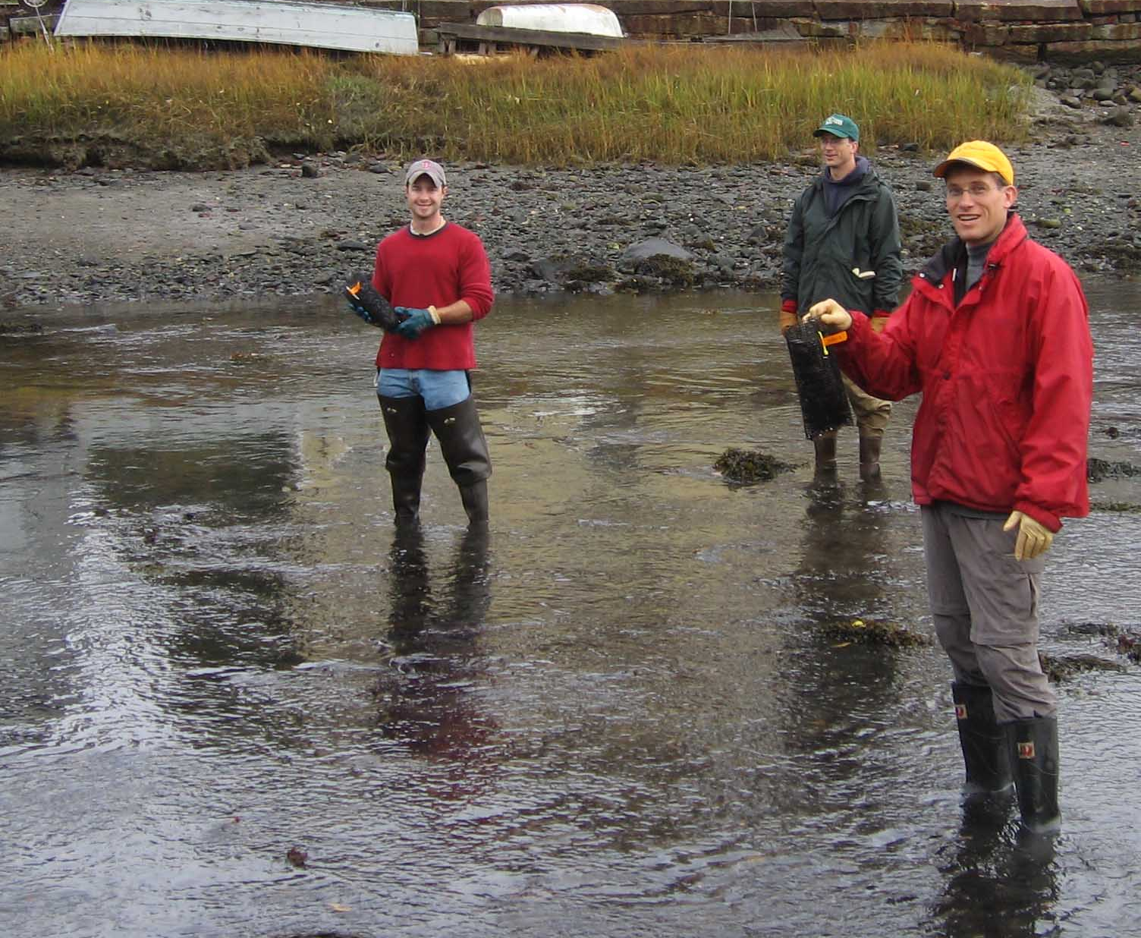 | Nomination instructions:  - Individuals or organizations may make nominations. Self-nominations are not accepted.  - The nominee must reside in Maine, Massachusetts, New Brunswick, New Hampshire, or Nova Scotia. The nominee’s contributions must have occurred in the Gulf of Maine watershed.  - Visionary Award nominees may be paid professionals or volunteers.  - Nominations must be made on this nomination form. Nominations with missing information will not be considered. Attachments will not be accepted.  - Nominations must be emailed to theresa.torrent@maine.gov by the close of business on March 30, 2015. Please rename the nomination form with _LastNameofNominee added to the file name.
Questions? Please contact Theresa Torrent at theresa.torrent@maine.gov or 207.287.2351.
To view a list of past award winners, please visit: http://www.gulfofmaine.org/2/opportunities/

Nominee information
Name (as it will appear on the award plaque if selected): The Jones River Watershed Association
Affiliation:
Mailing address: 55 Landing Road, Kingston, MA 02364
Phone: 781-585-2322
Email: pine@jonesriver.org

Brief background on why the individual/organization is being nominated:
Since 1985, the Jones River Watershed Association (JRWA) has been building its capacity and influence within the watershed and surrounding towns. By the 2010’s their work had earned them the respect and admiration of state officials, regulators, citizens, and other Watershed Associations alike. The 2011 removal of the Wapping Road Dam shone the spotlight brightly on this small organization and the staff rose to the challenge, leading a project that has become a teachable landmark for a number of other dam removal proponents. This dam removal helped spur the subsequent efforts to secure fish passage into, and sustainable flow releases out of, the Jones’ headwater source and the City of Brockton’s main reservoir, Silver Lake. JRWA has broadened the scope of their flow restoration efforts to encompass two additional watersheds besides their own, the Taunton and the North River, which are affected by Brockton’s management for water supply. JRWA’s work has also extended downstream into Kingston Bay where they engage with partners in a variety of monitoring and restoration efforts. Recently, the Jones River Watershed Association has contributed to the efforts of Cape Cod Bay Watch, an organization focused on addressing threats from the Pilgrim Nuclear Plant. In this way, the JRWA reaches outside of its 30 square mile watershed and is taking the broadest view possible of its mission to protect and restore the ecology of the watershed. Last, but not least, the JRWA has been a source of education and experience for numerous volunteers and interns who share the passion for local actions that have regional benefit.

Summary that will be read during the awards ceremony if nominee is selected. This text will also be used in media releases (not to exceed 2,000 characters, including spaces and punctuation):
For a small organization, it can be easy to become overwhelmed with the effort it takes just to maintain your existence, and, whittled down by the slow pace of progress toward real change, to focus narrowly on what seems accomplishable. Under the leadership of Pine DuBois, the JRWA has instead leveraged the staff’s scientific aptitude and raw muscle to attract partners that have made what seemed impossible, possible. These attributes, plus the willingness to listen to all stakeholders without losing the urgency of their mission, made JRWA an appealing partner for the state and federal agencies that collaborated on the 2011 removal of the Wapping Road Dam. Following on that success, JRWA has set their sights on other limiting factors to the health of not only the Jones River but also neighboring watersheds and Cape Cod Bay itself, talking with landowners and resource agencies to organize a critical mass for effecting change.

JRWA has always made a point of taking the time to do things right, and thus to ensure that their work is supported by the key players and the results are held up as a model for others to follow. Such is the case with the Association’s dogged work to address water use impacts to the Jones River and two adjoining watersheds, all connected by the City of Brockton’s water supply system. JRWA has enlisted support from stakeholders in all three watersheds, and beyond, to make the ecological and economic case for improved water management to support watershed functions, including fish passage for river herring and American eel. Similarly, JRWA has arranged for solid scientific research into Cape Cod Bay Watch’s concerns regarding potential vulnerabilities at the Pilgrim Nuclear Power Station, and threats to Cape Cod Bay.

Through all this, JRWA remains true to its community engagement goals, hosting interns and volunteers, and maintaining a dedicated and passionate membership. For all of these reason, the Jones River Watershed Association is truly a Visionary for the Gulf of Maine.

Name and contact information of person making the nomination:
Name & Affiliation: Nick Wildman, MA Division of Ecological Restoration
Address: 251 Causeway Street, Suite 400, Boston, MA 02114
Phone: 617-626-1527
Email: nick.wildman@state.ma.us

The mission of the Council is to maintain and enhance environmental quality in the Gulf of Maine and to
allow for sustainable resource use by existing and future generations.

Massachusetts Office of Coastal Zone Management • 2002-2003 Secretariat
GOMC • c/o NHDES • PO Box 95 • Concord, NH, US • 03302-0095 • Phone (603) 225-5544

The mission of the Council is to maintain and enhance environmental quality in the Gulf of Maine and to
allow for sustainable resource use by existing and future generations.

New Hampshire Department of Environmental Services • 2014-2015 Secretariat

