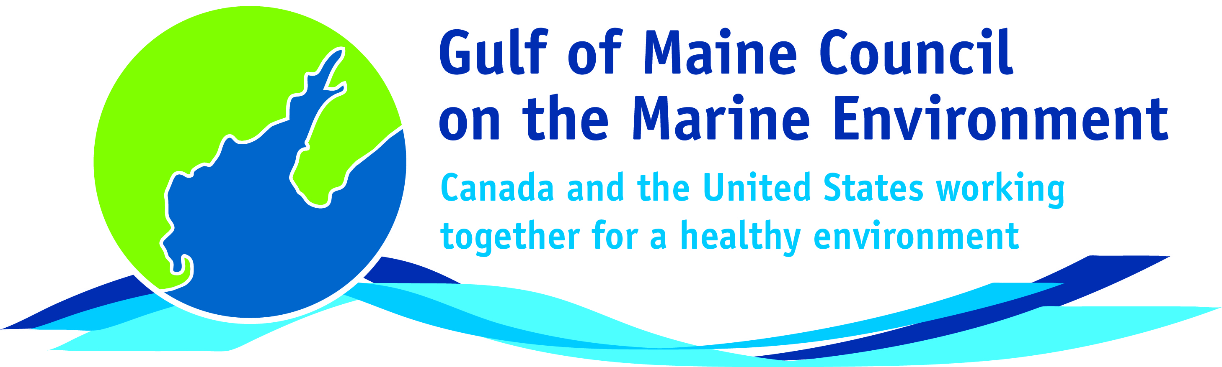**2016**

**Industry Award**

**Nomination Form**

The Gulf of Maine Council’s Industry Award is made annually to an individual, company, or organization within the Gulf of Maine region (Massachusetts, New Hampshire, Maine, New Brunswick, and Nova Scotia). This award recognizes demonstrated innovation and leadership in efforts to improve the well-being of the Gulf of Maine ecosystem and the communities that call it home. Nominations are sought from the following sectors: tourism; fisheries (commercial and recreational); aquaculture (finfish and shellfish); renewable energy generation (tidal, wave and wind); and / or transportation (shipping, ferries, etc.).

**Nomination instructions**

1. 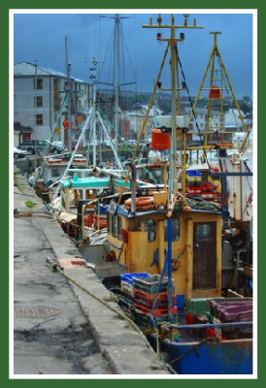Individuals or organizations may make nominations. Self-nominations are not accepted.
2. The nominee must be a resident of (or a company or organization doing business in) Maine, Massachusetts, New Brunswick, New Hampshire, or Nova Scotia. The nominee’s contributions must have occurred in the Gulf of Maine watershed.
3. Industry Award nominees may be paid professionals or volunteers.
4. Nominations must be made on this nomination form. Nominations with missing information will not be considered. Please provide all information on this form. Attachments will not be accepted.
5. Nominations must be emailed to [jleblanc@gulfofmaine.org](mailto:jleblanc@gulfofmaine.org) by the close of business on **March 31, 2016**. Please rename the nomination form with _LastNameofNominee added to the end of the file name.

|  |
| --- |
| **Questions?** Please contact Council Coordinator Joan LeBlanc at [jleblanc@gulfofmaine.org](mailto:jleblanc@gulfofmaine.org).  To view a list of past award winners, please visit: <http://www.gulfofmaine.org/2/gomc-home/awards/> |

|  |  |
| --- | --- |
| **Nominee information (REQUIRED)**  Name (as it would appear on the award plaque if selected): Hana Nelson  Mailing address: 2530 Agricola St Halifax, Nova Scotia B3K 4C5 Canada  Phone: 902-717-7657  Email: hana.nelson@gmail.com |  |
| **Brief background on why the individual/organization is being nominated (REQUIRED):**  Hana Nelson, through her company Afishionado Halifax Fishmongers, is committed to the sustainability of the fishing industry in Atlantic Canada and works closely with seafood producers and harvesters in the Gulf of Maine. She provides direct access for Nova Scotia consumers to local seafood and makes sure she is providing the freshest and most sustainable options. Afishionado uses Ocean Wise certification as its main guide, but goes beyond that to provide products that otherwise would not be available. This includes wild cod and halibut that are caught using hook and line, land-based closed-system aquaculture products, diver caught urchins and scallops and traditional wire caught fish like shad and gaspereau.  Afishionado is the only distributor of sustainably-caught seafood products in Nova Scotia and one of the few companies in Canada to provide consumers 100% traceability from source to sale. The products are available through a weekly subscription program, the Sea Port Farmers Market in Halifax, a number of small local grocery retailers and on the menus at a number of Halifax restaurants. One of the goals of the subscription program which started in 2016 is to bring unique fish that are not often available in grocery stores to the kitchens of Nova Scotians.  Not only does she run her fast growing business, but she is also a strong supporter of the aquaculture and fishing industry; encouraging them to produce and harvest more sustainably by providing a point-of-sale for sustainable products, buying at fair prices and communicating their story to the public, including the dangers and hardships of fishing work. She also provides added value to consumers. This includes running classes on oyster shucking and seafood preparation and sending out via email and social media information about local producers and harvesters, nutrition information and cooking tips. For Hana knowing the story behind the fish she sells is important!  She is looking to expand her business in the near future to provide sustainable, 100% traceable seafood through-out Atlantic Canada. |  |
| **Summary that will be read during the awards ceremony if nominee is selected. This text will also be used in media releases (not to exceed 2,000 characters, including spaces and punctuation – REQUIRED):**  Hana Nelson’s company Afishionado Halifax Fishmongers, is committed to the sustainability of the fishing industry and works closely with seafood producers and harvesters in the Gulf of Maine. Afishionado is the only distributor of sustainably-caught seafood products in Nova Scotia and one of the few companies in Canada to provide consumers 100% traceability from source to sale. Afishionado products are available through weekly subscription, the Sea Port Farmers Market in Halifax, a number of small grocery retailers and on the menus at a number of Halifax restaurants. Afishionado uses Ocean Wise certification as its main guide, but also includes wild cod and halibut that are caught using hook and line, land-based closed-system aquaculture products, diver-caught urchins and scallops and traditional Wire caught fish like shad and gaspereau.  Not only does she run her fast growing business, but she is also a strong supporter of the aquaculture and fishing industry; encouraging them to produce and harvest more sustainably by providing a point-of-sale for sustainable products, buying at fair prices and communicating their story to the public, including the dangers and hardships of fishing work. She also provides added value to consumers. This includes running classes on oyster shucking and seafood preparation and sending out via email and social media information about local producers and harvesters, nutrition information and cooking tips. For Hana, knowing the story behind the fish she sells is important! |  |
| **Name and contact information of person making the nomination (REQUIRED):**  Name: Will Fawcett Hill  Affiliation: Instructor, Mount St. Vincent University  Address: 5781 Sarah St. Apt. A, Halifax. B3K 1H4  Phone: 902-817-4570  Email: [williamfawcetthill@gmail.com](mailto:williamfawcetthill@gmail.com)  **Please contact me by email if necessary** |  |