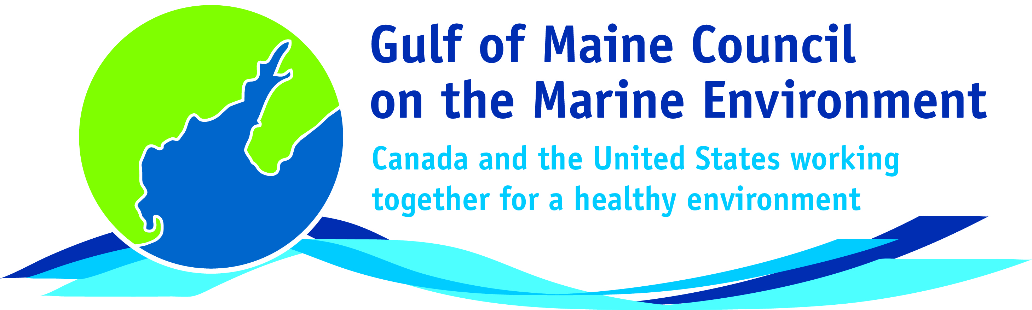**2016**

**Longard Award**

**Nomination Form**

The Longard Award is bestowed upon an outstanding volunteer each year in memory of Art Longard, a founding member of the Gulf of Maine Council on the Marine Environment and long-time Working Group member. This award is given to an individual from one of the five states and provinces bordering the Gulf of Maine. The Longard Award recognizes individual commitment to volunteer programs dedicated to environmental protection and sustainability of natural resources within the marine, near shore, and watershed environments of the Gulf of Maine.

#### Nomination instructions

* 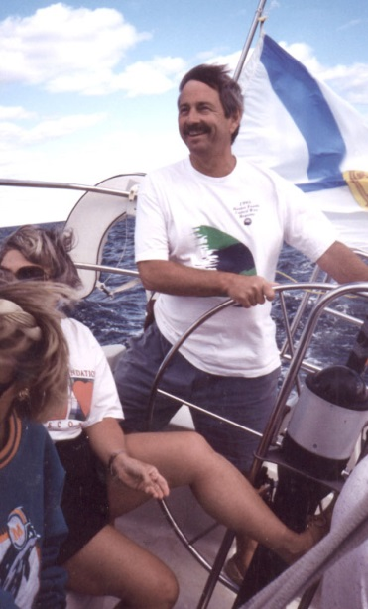Individuals or organizations may submit nominations. Self-nominations are not accepted.
* The nominee must be a resident of Maine, Massachusetts, New Brunswick, New Hampshire, or Nova Scotia. The nominee’s contributions must have been to the Gulf of Maine watershed.
* Longard Award nominees must have contributed to the Gulf of Maine in their capacity as a volunteer, **NOT** as a paid professional.
* Nominations must be made on this form. Attachments will not be accepted.
* Nominations must be emailed to [jleblanc@gulfofmaine.org](mailto:jleblanc@gulfofmaine.org) by the close of business on **March 31, 2016**. Please rename the nomination form with _LastNameofNominee added to the end of the file name.

|  |
| --- |
| Questions? Please contact Council Coordinator Joan LeBlanc at [jleblanc@gulfofmaine.org](mailto:jleblanc@gulfofmaine.org).  To view a list of past award winners, please visit: <http://www.gulfofmaine.org/2/gomc-home/awards/> |

|  |  |
| --- | --- |
| **Nominee information (REQUIRED)**  Name (as it would appear on the award plaque if selected): Hugh M. Akagi [need to verify with Hugh, can wait until awarded]  Mailing address: 488 Water St., St. Andrews, NB  Phone: 902-529-3402  Email: akagih@nb.aibn.com |  |
| **Brief background on why the individual/organization is being nominated (REQUIRED):** Chief Hugh Akagi was elected chief of the Schoodic Band of Passamaquoddy in 1998. The Passamaquoddy have lived in the Passamaquoddy Bay region for millennia. However, they were not recognized by the Government of Canada until very recently. Chief Akagi led the struggle for federal recognition. He has also been a leader in work to support to support a healthy Bay of Fundy and Gulf of Maine ecosystem, recognizing the interconnection of humans and the environment. He has been involved in many efforts to share the knowledge of First Nations with others. Through the Bay of Fundy Ecosystem Partnership (BoFEP), Chief Akagi co-hosted talking circles where scientific information, First Nations knowledge, and local community ecological knowledge could be shared. The talking circles aim to build trust and understanding among participants with different backgrounds. Chief Akagi is a strong supporter of BoFEP’s goal of promoting the integrity, vitality, biodiversity and productivity of the Bay of Fundy Ecosystem, and protecting the social well-being and economic sustainability of its coastal communities. He has tirelessly provided time and resources to BoFEP and to supporting this goal in general in the Bay of Fundy watershed. |  |
| **Summary that will be read during the awards ceremony if nominee is selected. This text will also be used in media releases (not to exceed 2,000 characters, including spaces and punctuation - REQUIRED):**  NOTE: THIS CAN BE FILLED OUT LATER, NOT DUE MARCH 31. |  |
| **Name and contact information of person making the nomination (REQUIRED):**  Names: Martin Tango and Marianne Janowicz  Affiliation (Martin Tango): Acadia University and Bay of Fundy Ecosystem Partnership (BoFEP)  Address: School of Engineering, Acadia University, 27 University Avenue, Wolfville Canada, B4P 2R6  Phone: 1 902 585 1149  Email: [martin.tango@acadiau.ca](mailto:martin.tango@acadiau.ca)  Affiliation (Marianne Janowicz): Bay of Fundy Ecosystem Partnership  Address: 3378 Dixon Road, Breadalbane, PE C0A 1E0  Phone: 902-621-0575  Email: [mjanowicz@hotmail.com](mailto:mjanowicz@hotmail.com) |  |