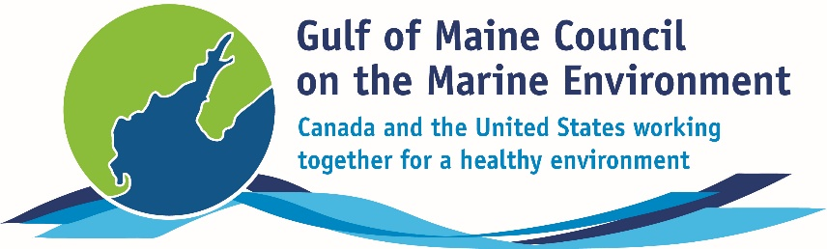**2016**

**Longard Award**

**Nomination Form**

The Longard Award is bestowed upon an outstanding volunteer each year in memory of Art Longard, a founding member of the Gulf of Maine Council on the Marine Environment and long-time Working Group member. This award is given to an individual from one of the five states and provinces bordering the Gulf of Maine. The Longard Award recognizes individual commitment to volunteer programs dedicated to environmental protection and sustainability of natural resources within the marine, near shore, and watershed environments of the Gulf of Maine.

#### Nomination instructions

* 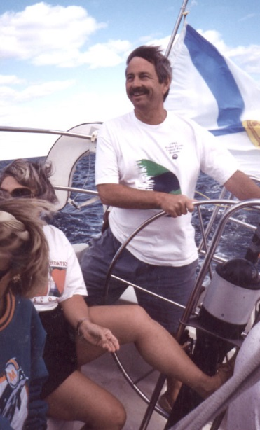Individuals or organizations may submit nominations. Self-nominations are not accepted.
* The nominee must be a resident of Maine, Massachusetts, New Brunswick, New Hampshire, or Nova Scotia. The nominee’s contributions must have been to the Gulf of Maine watershed.
* Longard Award nominees must have contributed to the Gulf of Maine in their capacity as a volunteer, **NOT** as a paid professional.
* Nominations must be made on this form. Attachments will not be accepted.
* Nominations must be emailed to [jleblanc@gulfofmaine.org](mailto:jleblanc@gulfofmaine.org) by the close of business on **March 31, 2016**. Please rename the nomination form with _LastNameofNominee added to the end of the file name.

|  |
| --- |
| Questions? Please contact Council Coordinator Joan LeBlanc at [jleblanc@gulfofmaine.org](mailto:jleblanc@gulfofmaine.org).  To view a list of past award winners, please visit: <http://www.gulfofmaine.org/2/gomc-home/awards/> |

|  |  |
| --- | --- |
| **Nominee information (REQUIRED)**  Name (as it would appear on the award plaque if selected): Bailey Bowden  Mailing address: PO Box 164, Penobscot, ME 04476  Phone: 207-326-8524  Email: clamchair@gmail.com |  |
| **Brief background on why the individual/organization is being nominated (REQUIRED):**  Bailey has been at the center of an effort to rebuild alewife runs in several tributaries of the Bagaduce River and to re-establish viable commercial alewife fisheries in his and other nearby communities. He has personally bailed thousands of alewives over a barrier dam to sustain a run, he helped create a municipal Alewife Advisory Committee in Penobscot (which he now chairs), he has worked with Maine Department of Marine Resources to rebuild alewife runs and continues to work on establishing a commercial alewife fishery in the town of Penobscot. He is inspiring others to do the same; the neighboring town of Brooksville recently voted to establish its own fish committee, involving neighboring Sedgwick’s marine resource committee – in short he has been a catalyst in bringing the three towns on the watershed together to restart collapsed runs of alewives.  Bailey is a tireless and determined local activist. His efforts on this and other projects have helped him build partnerships with Penobscot East Resource Center and other organizations focused on restoring viable fisheries. Other partners include the Downeast Salmon Federation, Maine Coast Heritage Trust and Manomet just to name a few. Bailey is a respected local steward with a grander vision for the Gulf of Maine, which is surely a better place because of this efforts. |  |
| **Summary that will be read during the awards ceremony if nominee is selected. This text will also be used in media releases (not to exceed 2,000 characters, including spaces and punctuation - REQUIRED):**  Bailey resides in Penobscot, Maine where he has fished recreationally and commercially in the Bagaduce River watershed for years. By sharing his vision for the Bagaduce with others and working tirelessly to rebuild its resources he has demonstrated a true commitment to the ecological integrity of the Gulf of Maine. Bailey has been particularly active in the conservation of anadromous alewives and smelt as well as combating invasive species and restoring and enhancing critical clam flats.  Not a man who is fearful of getting his hands dirty, Bailey has personally dipped countless alewives over dams and other barriers to sustain dwindling runs of fish. Also adept at advocacy he has also worked to create the will for action and engaged others as demonstrated by creating and chairing a municipal Alewife Advisory Committee in his local community, a model that he is now exporting to neighboring communities as well.  A keen observer of the natural world, Bailey knows his efforts are bigger than just one river and the people and animals that call it home. His efforts will support local lobstermen by providing critical bait and a local tradition of smoked alewives as a family treat, but also the hope of rebuilding the Gulf of Maine ecosystem as growing numbers of young alewives head back to the sea to support the regions struggling groundfish populations.  For all this and other reasons too numerous to list we are proud to nominate Bailey Bowden for the Gulf of Maine Council on the Marine Environment Longard Award. |  |
| **Name and contact information of person making the nomination (REQUIRED):**  Name: Robin Alden  Affiliation: Executive Director, Penobscot East Resource Center  Address: PO Box 27, Stonington ME 04681  Phone: (207) 367-2708  Email: robin@penobscoteast.org |  |