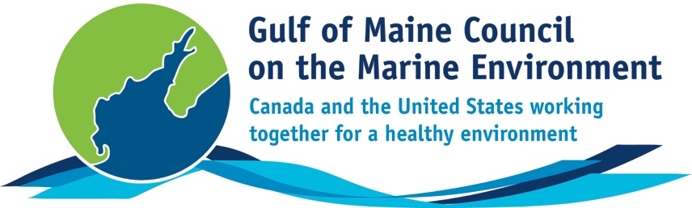**2016**

**Longard Award**

**Nomination Form**

The Longard Award is bestowed upon an outstanding volunteer each year in memory of Art Longard, a founding member of the Gulf of Maine Council on the Marine Environment and long-time Working Group member. This award is given to an individual from one of the five states and provinces bordering the Gulf of Maine. The Longard Award recognizes individual commitment to volunteer programs dedicated to environmental protection and sustainability of natural resources within the marine, near shore, and watershed environments of the Gulf of Maine.

#### Nomination instructions

* 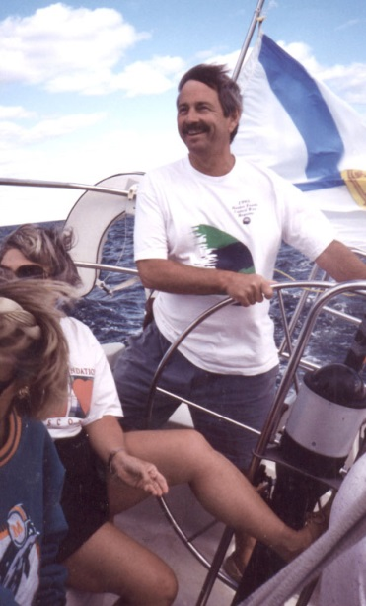Individuals or organizations may submit nominations. Self-nominations are not accepted.
* The nominee must be a resident of Maine, Massachusetts, New Brunswick, New Hampshire, or Nova Scotia. The nominee’s contributions must have been to the Gulf of Maine watershed.
* Longard Award nominees must have contributed to the Gulf of Maine in their capacity as a volunteer, **NOT** as a paid professional.
* Nominations must be made on this form. Attachments will not be accepted.
* Nominations must be emailed to [jleblanc@gulfofmaine.org](mailto:jleblanc@gulfofmaine.org) by the close of business on **March 31, 2016**. Please rename the nomination form with _LastNameofNominee added to the end of the file name.

|  |
| --- |
| Questions? Please contact Council Coordinator Joan LeBlanc at [jleblanc@gulfofmaine.org](mailto:jleblanc@gulfofmaine.org).  To view a list of past award winners, please visit: <http://www.gulfofmaine.org/2/gomc-home/awards/> |

|  |  |
| --- | --- |
| **Nominee information (REQUIRED)**  Name (as it would appear on the award plaque if selected): Bailey Bowden  Mailing address: PO Box 164, Penobscot, ME 04476  Phone: 207-326-8524  Email: clamchair@gmail.com |  |
| **Brief background on why the individual/organization is being nominated (REQUIRED):**  Bailey Bowden is a tireless advocate for the health of the Bagaduce River, its commercial fisheries and its wildlife. A resident of Penobscot, Maine, Bailey has fished both recreationally and commercially in the Bagaduce River for many years and is active in the conservation of alewives, smelt and soft shell clams.  Bailey is spearheading an effort to rebuild the alewife population in several streams that drain into the Bagaduce and to re-establish a commercial alewife fishery in Penobscot. He has dipped tens of thousands of alewives by hand over a dam blocking their migration upstream, helping to sustain the run until fish passage is installed. He led the effort to create a municipal Alewife Advisory Committee in Penobscot. As its chair, he is working closely with Maine Department of Marine Resources to rebuild alewife populations and establish a commercial alewife fishery.  He has taken his alewife restoration message to the neighboring town of Brooksville which recently voted to establish its own fish committee; alewives from Wight’s Pond in Penobscot will be used to restart defunct runs in Parker Pond in Brooksville – and possibly Camp Stream in Sedgwick, which also adjoins Penobscot. Bailey’s goal is to establish a partnership among the three towns to cooperatively manage their alewife populations and habitat.  Bailey values local runs of fish – he likes to smoke alewives for his own consumption and would like others to be able to do the same and to sell alewives as much prized bait in the spring lobster fishery.  But he also appreciates the fact that each alewife run that is reestablished contributes to the numbers of juvenile alewives reaching coastal waters where they are prey for cod, haddock and other ground fish and therefore important to the restoration of these fish.  Bailey is also chair of Penobscot’s Shellfish Conservation Committee and is the town’s clam warden. He has documented the abundance of green crabs for several years as well as their devastating impact on soft shell clams.  He is currently working on a municipal shellfish ordinance that will allow the town’s shellfish harvesters to establish a clam farm where clams can be protected from green crab predation using nets.  He is a keen observer of the flora and fauna of the region, including the osprey, eagles and other wildlife that benefit from a healthy estuary. |  |
| **Summary that will be read during the awards ceremony if nominee is selected. This text will also be used in media releases (not to exceed 2,000 characters, including spaces and punctuation - REQUIRED):**  Bailey Bowden is dedicated to restoring the health of the Bagaduce River, its commercial fisheries and its wildlife. He works tirelessly with his neighbors, conservation groups and Maine Department of Marine Resource managers on projects big and small, all with the goal of bringing back and protecting the fish and shellfish that are so important to the Bagaduce ecosystem and area residents. He is highly deserving of the Longard award; he’ll be happiest that it will bring more attention to the work to which he is so committed: ensuring the health of the Bagaduce River. |  |
| **Name and contact information of person making the nomination (REQUIRED):**  Name: Anne Hayden  Affiliation: Manomet/Downeast Fisheries Partnership  Address: 41 Maine St., Suite 410, Brunswick, ME 04011  Phone: 207-725-9742  Email: ahayden@manomet.org |  |