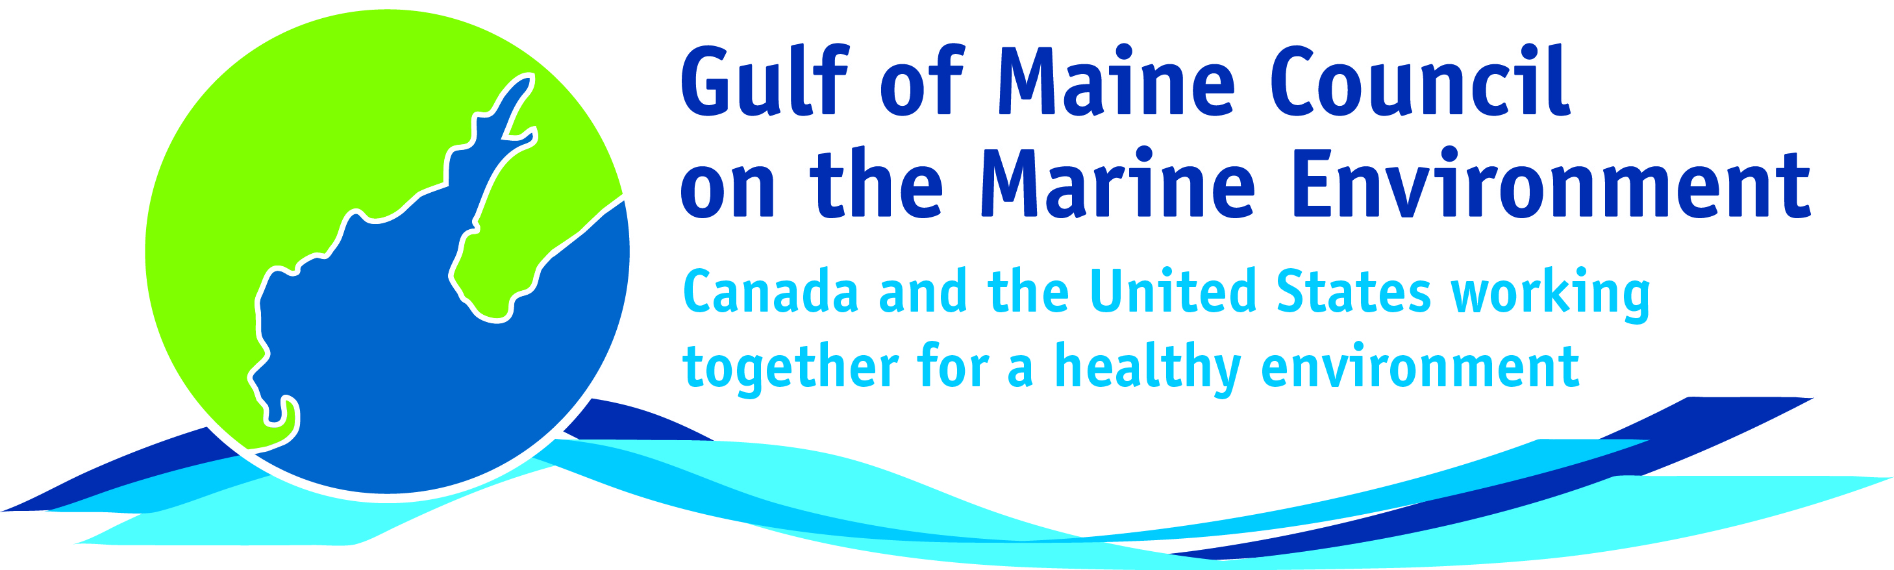**2016**

**Longard Award**

**Nomination Form**

The Longard Award is bestowed upon an outstanding volunteer each year in memory of Art Longard, a founding member of the Gulf of Maine Council on the Marine Environment and long-time Working Group member. This award is given to an individual from one of the five states and provinces bordering the Gulf of Maine. The Longard Award recognizes individual commitment to volunteer programs dedicated to environmental protection and sustainability of natural resources within the marine, near shore, and watershed environments of the Gulf of Maine.

#### Nomination instructions

* 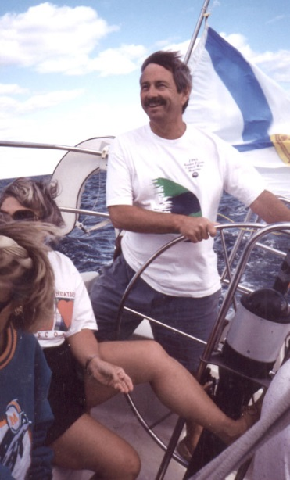Individuals or organizations may submit nominations. Self-nominations are not accepted.
* The nominee must be a resident of Maine, Massachusetts, New Brunswick, New Hampshire, or Nova Scotia. The nominee’s contributions must have been to the Gulf of Maine watershed.
* Longard Award nominees must have contributed to the Gulf of Maine in their capacity as a volunteer, **NOT** as a paid professional.
* Nominations must be made on this form. Attachments will not be accepted.
* Nominations must be emailed to [jleblanc@gulfofmaine.org](mailto:jleblanc@gulfofmaine.org) by the close of business on **March 31, 2016**. Please rename the nomination form with _LastNameofNominee added to the end of the file name.

|  |
| --- |
| Questions? Please contact Council Coordinator Joan LeBlanc at [jleblanc@gulfofmaine.org](mailto:jleblanc@gulfofmaine.org).  To view a list of past award winners, please visit: <http://www.gulfofmaine.org/2/gomc-home/awards/> |

|  |  |
| --- | --- |
| **Nominee information (REQUIRED)**  Name (as it would appear on the award plaque if selected):Bailey Bowden  Mailing address: PO Box 164 Penobscot, ME 04476  Phone: 207-326-8524  Email: clamchair@gmail.com |  |
| **Brief background on why the individual/organization is being nominated (REQUIRED):**  I am writing to support the nomination of Bailey Bowden as the Longard Award recipient for 2016.  Bailey is a champion of community-based stewardship of the marine resources of the region. His work with both shellfish and finfish restoration and conservation in the Bagaduce River watershed speaks volumes about his dedication and effectiveness as a local leader.  My staff and I have worked closely with Bailey to document the abundance of sea-run smelt. The data generated is shared with ME DMR and Bailey proved his commitment to the project by working at all hours of the day and night as a volunteer to determine the extent of smelt populations in his region. Bailey is an eloquent public speaker and natural leader. His testimonies are productive and thoughtful and set a very high bar. His comments at a public hearing on smelt regulations resulted in an important change in the regulations – specifically the allowance for weekend smelting rather than weekday fishing so that children and families can continue to participate in the important heritage fishery. ME DMR would have completely overlooked this important detail and ultimately changed the regulations based upon his testimony.  There are many other examples of his thoughtful and strategic abilities and his sense of justice and fairness. Bailey is supportive of shellfish aquaculture and has managed to help quell fears among shorefront landowners who had concerns about visual and noise pollution. As Chairman of his town’s shellfish committee and river herring committee he has led productive efforts to conserve and restore these very important fisheries. His work at Pierce Pond and Whites Pond to improve fish passage is becoming an example of local initiative, dedication and resourcefulness. Bailey also has a deep ecological understanding and helps people in his community to understand the complexities and importance of the marine ecosystem Of the Bagaduce region and Gulf of Maine. In my 35 years working as a fisheries biologist in eastern Maine, Bailey stands out as one of the most dedicated and wise leaders and champions in the region. |  |
| **Summary that will be read during the awards ceremony if nominee is selected. This text will also be used in media releases (not to exceed 2,000 characters, including spaces and punctuation - REQUIRED):**  **Bailey Bowden of Penobscot, Maine has dedicated his life to the conservation of the marine environment and the coastal communities and maritime fisheries heritage of the region. His work with sea – run fisheries such as alewives and smelt has measurably improved the populations of these important fish. Likewise, his work with municipally managed shellfish has also been an exemplary achievement in the Bagaduce region. Bailey is a natural networker and is resourceful and persuasive in drawing partners together to achieve conservation outcomes that no single organization could accomplish on there own. Bailey is an extraordinary leader and mentor in his coastal community and in the region.** |  |
| **Name and contact information of person making the nomination (REQUIRED):**  Name: Dwayne Shaw  Affiliation: Downeast Salmon Federation  Address: PO Box 201  Phone: Columbia Falls, ME 04623  Email: dwayne@mainesalmonrivers.org |  |