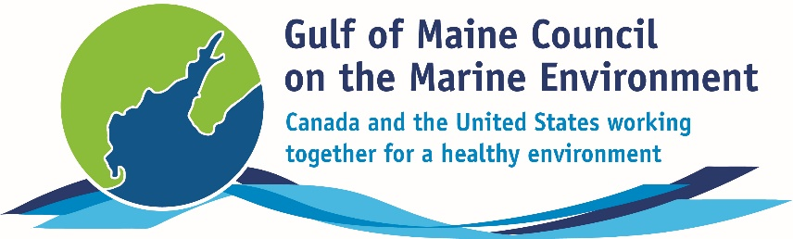**2016**

**Longard Award**

**Nomination Form**

The Longard Award is bestowed upon an outstanding volunteer each year in memory of Art Longard, a founding member of the Gulf of Maine Council on the Marine Environment and long-time Working Group member. This award is given to an individual from one of the five states and provinces bordering the Gulf of Maine. The Longard Award recognizes individual commitment to volunteer programs dedicated to environmental protection and sustainability of natural resources within the marine, near shore, and watershed environments of the Gulf of Maine.

#### Nomination instructions

* 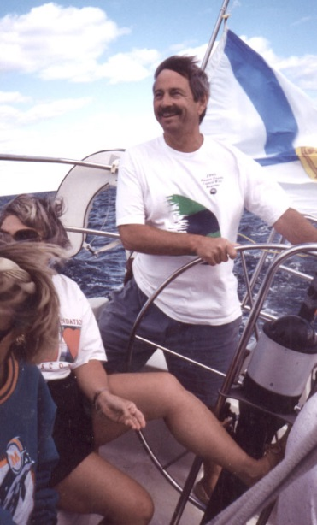Individuals or organizations may submit nominations. Self-nominations are not accepted.
* The nominee must be a resident of Maine, Massachusetts, New Brunswick, New Hampshire, or Nova Scotia. The nominee’s contributions must have been to the Gulf of Maine watershed.
* Longard Award nominees must have contributed to the Gulf of Maine in their capacity as a volunteer, **NOT** as a paid professional.
* Nominations must be made on this form. Attachments will not be accepted.
* Nominations must be emailed to [jleblanc@gulfofmaine.org](mailto:jleblanc@gulfofmaine.org) by the close of business on **March 31, 2016**. Please rename the nomination form with _LastNameofNominee added to the end of the file name.

|  |
| --- |
| Questions? Please contact Council Coordinator Joan LeBlanc at [jleblanc@gulfofmaine.org](mailto:jleblanc@gulfofmaine.org).  To view a list of past award winners, please visit: <http://www.gulfofmaine.org/2/gomc-home/awards/> |

|  |  |
| --- | --- |
| **Nominee information (REQUIRED)**  Name (as it would appear on the award plaque if selected): Walter Emrich  Mailing address: 13 Birchview Terrance, Rothesay, New Brunswick, E2H 1H2  Phone: (506) 847-0002  Email: [waemrich@gmail.com](mailto:waemrich@gmail.com) |  |
| **Brief background on why the individual/organization is being nominated (REQUIRED):**  Walter Emrich is a long-time friend, member, and volunteer of the Nature Trust of New Brunswick—a provincial land conservation organization. He has played an instrumental role in carrying out the three pillars of the Nature Trust’s mission; conservation, stewardship and education. Since 2001, Walter has taken on the role of voluntary land steward for several nature preserves for the Nature Trust. For the past 5 years, he has been an active board member, a member of the Acquisition Committee, and has chaired the Stewardship Committee. Originally from Montreal, he now lives with his wife Margo in picturesque Rothesay, New Brunswick. Walter has always had a passion for the outdoors.  Walter’s love of the environment began in his childhood. At age ten, Walter saw a movie at Expo '67 about forestry which inspired him to pursue a career in this field. In 1980, he completed his forestry degree from the University of New Brunswick where he met Margo, and has called New Brunswick home ever since. Walter’s introduction to the Nature Trust was during his work with the Fundy Model Forest in the 1990s, with which the Nature Trust was involved.  https://scontent.fyhz1-1.fna.fbcdn.net/hphotos-xpf1/v/t34.0-12/12895245_10100202822280535_916404358_n.jpg?oh=a144381c575acdb0a9a8891d73aee4a0&oe=56F73BD2  At the age of 53, he retired from the forestry industry to dedicate his time to the things he loves most: his family, volunteering with the Nature Trust, the Chance Harbour Nature Spa, and leading kayaking tours. Walter’s daughter, Andi, describes her father’s attitude toward his career: “Dad always saw his career as a way to support his true passions; time spent with family, hiking, building trails, kayaking, canoeing, biking, camping, gardening, and forest management.” See below for an overview of how Walter has greatly contributed to the Nature Trust’s mission to conserve, steward, and educate:  *Conserve*: Walter has been and remains actively involved in the acquisition of several nature preserves. This has led to the successful conservation of hundreds of hectares of land within the Gulf of Maine watershed, including the Saints Rest Marsh F. Gordon Carvell Nature Preserve—a significant salt marsh on the Bay of Fundy, Frye Island Nature Preserve in the Bay of Fundy, and the extension of the Clark Gregory Nature Preserve at Chocolate Cove on Deer Island. Walter is always keen to explore potential properties and develop reports that guide the board’s decision-making process on new acquisitions.  *Steward*: Since early on in his involvement with the Nature Trust, Walter has been a key voluntary land steward for those nature preserves without a network of voluntary land stewards to conduct annual monitoring. Walter took on the stewardship of Manawagonish Island Nature Preserve and is instrumental in the monitoring of great blue heron nesting platforms there. Blueberry Hill Nature Preserve in Grand Bay-Westfield, where the Kennebecasis and St. John Rivers converge, is now monitored monthly thanks to Walter’s willingness to take on a leadership role within the ‘Friends of Blueberry Hill’ stewardship group. Aside from helping monitor many nature preserves, Walter spends many days throughout the summer months maintaining trails, signage, and boundaries of nature preserves and often takes on the role of mediator when any land use issues arise. Stewardship Coordinator, Richelle Martin says: “Having Walter’s expertise and leadership on the Stewardship Committee has helped in making informed management decisions and his on-the-ground stewardship work has led to improved visitor experience and protection of the ecological integrity of the nature preserves.”  *Educate*: Walter has led dozens of nature hikes as well as sea and river kayaking tours for interested community members in all seasons across New Brunswick and mainly within the Bay of Fundy region. By guiding nature walks, paddling trips, and helping facilitate workshops, Walter has educated hundreds of people on our natural heritage, inspiring others with his love of nature and passion for forest and ocean ecosystems.  Walter’s active involvement in every aspect of the Nature Trust’s work; land conservation, stewardship, and public engagement make him incredibly deserving of recognition through the Longard Award. The Nature Trust is fortunate to have Walter as a volunteer. In his case, the word “volunteer” is a tremendous understatement when it comes to his involvement and impact due to the amount of time and effort he puts in to the cause, which, some weeks, is on par with paid staff members. |  |
| **Summary that will be read during the awards ceremony if nominee is selected. This text will also be used in media releases (not to exceed 2,000 characters, including spaces and punctuation - REQUIRED):**  Walter’s love of the environment extends deep into his childhood and continued into his adult life, working as a forester in New Brunswick for thirty years. At the age of 53, he retired from the industry to dedicate time to the things he loves most, which include volunteering in environmental conservation, guiding kayak tours and his family. He and his wife Margo live in Rothesay, NB and enjoy spending time with their three daughters, Teri, Katie and Andi, three grandsons, and one grand-dog. His daughter Andi says, “Dad always saw his career as a way to support his true passions: family time, hiking, building trails, kayaking, canoeing, biking, camping, gardening, and forest management.”  Walter supports the Nature Trust in all aspects of their mission to conserve, steward and educate within the province through serving as an active board member, participating in the land acquisition committee, chairing the stewardship committee, and acting as a voluntary land steward for many coastal and nearshore nature preserves within the Bay of Fundy region. He has been an integral part of the successful conservation of hundreds of hectares of land within the Gulf of Maine watershed. Walter is always willing to explore new potential properties for conservation and help guide the board’s decision-making on acquisitions. He spends many hours leading trail days and installing signage, and has been known to mediate land-use issues when they arise. Always keen to get others outside in the natural world, Walter has instilled the conservation ethic within many people through guiding hikes and kayaking tours for community members.  Walter Emrich is a true steward of the ecosystems and natural resources of the Gulf of Maine’s marine, near shore and watershed environments through his dedicated involvement with the Nature Trust of New Brunswick over the past 15 years and is incredibly deserving of recognition through the Longard Award. A sincere thank you, Walter, for all that you do. |  |
| **Name and contact information of person making the nomination (REQUIRED):**  Name: Renata Woodward  Affiliation: The Nature Trust of New Brunswick Inc.  Address: P.O. Box 603 Station A, Fredericton, New Brunswick, E3B 5A6  Phone: (506) 457-2398  Email: [naturetrust@ntnb.org](mailto:naturetrust@ntnb.org) |  |