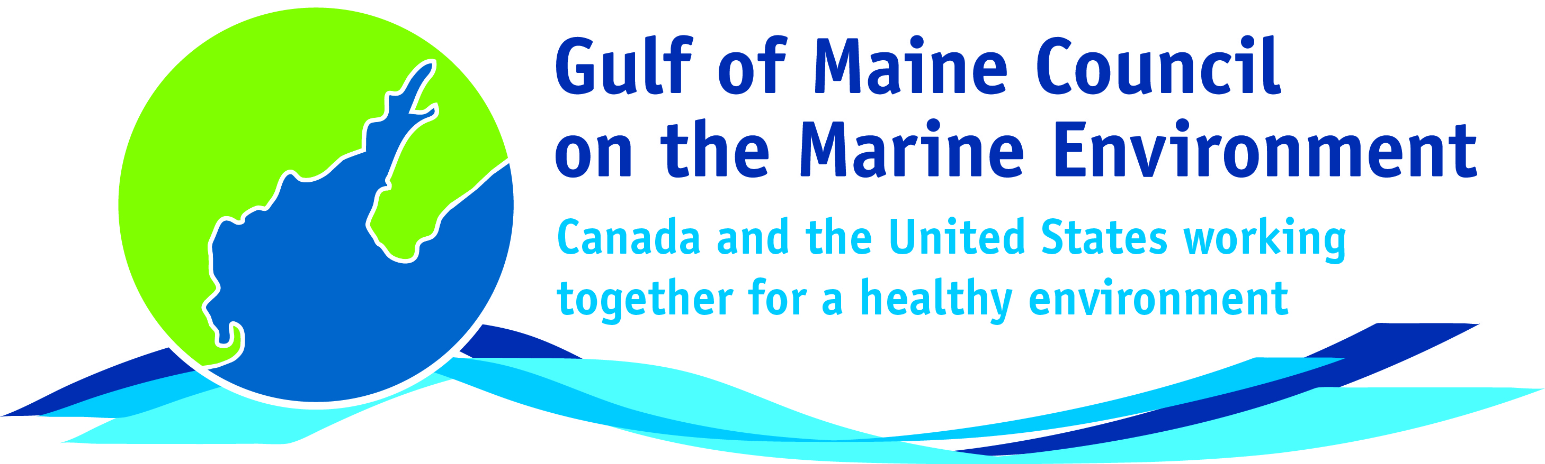**2016**

**Susan Snow Cotter Leadership**

**Award Nomination Form**

The Susan Snow-Cotter Leadership Award is bestowed in memory of Susan Snow-Cotter, a long-time friend of the Council and Working Group. The Award is given to an individual from one of the five states and provinces bordering the Gulf of Maine. The Susan Snow-Cotter Leadership Award honors coastal management professionals who exemplify outstanding leadership or exceptional mentoring in the Gulf of Maine watershed. As former Director of the Massachusetts Office of Coastal Zone Management, Susan was recognized as a leader who exhibited unwavering passion, enthusiasm, and insight to develop pragmatic approaches to coastal management challenges. The Council presents this award to a professional who has demonstrated exceptional leadership in coastal and ocean planning and management by:

* Developing pragmatic approaches;
* Building collaborative efforts through mobilizing and unifying others around an issue or initiative; and/or
* Serving as a strong and supportive mentor to emerging coastal management professionals.

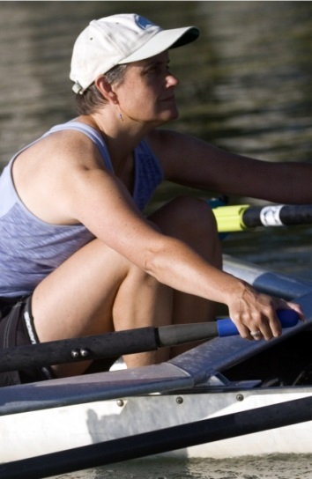

**Nomination instructions**

1. Individuals or organizations may make nominations. Self-nominations are not accepted.
2. The nominee must be a resident of Maine, Massachusetts, New Brunswick, New Hampshire, or Nova Scotia.
3. The nominee’s contributions must have occurred in the Gulf of Maine watershed.
4. Nominations must be made on this nomination form. Nominations with missing information will not be considered. Please provide all information on this form. Additional attachments will not be accepted.
5. Nominations must be emailed to [jleblanc@gulfofmaine.org](mailto:jleblanc@gulfofmaine.org) by the close of business on **March 31, 2016**. Please rename the nomination form with _LastNameofNominee added to the end of the file name.

Susan Snow Cotter

|  |
| --- |
| **Questions?** Please contact Council Coordinator Joan LeBlanc at [jleblanc@gulfofmaine.org](mailto:jleblanc@gulfofmaine.org).  To view a list of past award winners, please visit: <http://www.gulfofmaine.org/2/gomc-home/awards/> |

|  |  |
| --- | --- |
| **Nominee information (REQUIRED)**  Name Marianne Janowicz  Mailing address: 3378 Dixon Road, Breadalbane PEI. C0A 1E0,  Phone: 902-621-0575 Email: mjanowicz@hotmail.com |  |
| **Brief background on why the individual/organization is being nominated (REQUIRED):**  I am nominating Marianne Janowicz for the Susan Snow Cotter Award because of her past and present service to environmental programs in the Bay of Fundy and its watersheds, both as a former public servant with the Department of Environment, New Brunswick Government, and her past and present service to and role with both the Gulf of Maine Council (GOMC) and Bay of Fundy Ecosystem Partnership (BoFEP). Marianne is dedicated to the environmental sustainability of coastal ecosystems in New Brunswick, in the Bay of Fundy region. She worked on environmental issues there while with the NB government, especially on issues of land-based pollution/land-based activities. For several years, she led an effort in the Atlantic Region under the umbrella of the Canadian National Program of Action on Land-based Activities, focusing on the control of non-point sources of pollution, particularly from the many septic systems in existence in residences around the Bay. While with the provincial government in the 1990s and early 2000s, she was an active member of the Council’s working group, and a keen member of the nascent BoFEP. Eventually she became vice chair of BoFEP, coordinating the research and communications efforts of several working groups. She was a pleasure to work with – always keen, capable, and productive. She has been Chair of BoFEP since 2012, providing guidance to many projects, preparing submissions for funding, and chairing various meetings and workshops. Marianne has shown fine leadership and professionalism in all of her undertakings with the Councils WG and especially, of late, with BoFEP. She has especially excelled at including our First Nations people in several BoFEP initiatives such as Talking Circles, and at finding support for original research initiatives such as the ongoing work on the Ocean Health Index for the SW part of the Bay of Fundy. I can think of no better person in the Gulf of Maine/Bay of Fundy region who deserves the Susan Snow Cotter Award more than Marianne, for her long and dedicated service to the protection of the region’s coastal waters and watersheds. |  |
| **Summary that will be read during the awards ceremony if nominee is selected. This text will also be used in media releases (not to exceed 2,000 characters, including spaces and punctuation - REQUIRED):**  Over the span of several decades, Marianne Janowicz has been an exemplary leader in the Bay of Fundy region on issues affecting the Bay and its watersheds. She was a member of the GOMC WG representing the NB government while she worked in its Department of Environment. She led an effort regionally under the Canadian National Program of Action on Land-based Activities, focusing on the control of non-point sources of pollution, particularly from the many septic systems in existence in residences around the Bay. While with the provincial government, she was an active member of the Council’s working group, and a keen member of the nascent bay of Fundy Ecosystem Partnership (BoFEP). Eventually she became vice chair of BoFEP, coordinating the research and communications efforts of several of its working groups. She has been Chair of BoFEP since 2012, providing guidance to many projects, tirelessly preparing submissions for funding, and chairing various meetings and workshops addressing Fundy issues. Marianne has shown fine leadership and professionalism in all of her undertakings with the Councils WG and especially, of late, with BoFEP. She has especially excelled at including our First Nations people in several initiatives such as Talking Circles, and at finding support for original initiatives such as the ongoing work on the Ocean Health Index for the SW part of the Bay of Fundy. Marianne exemplifies the committed coastal environmentalist and conservationist, with her leadership and dedication, and hence is a fine nominee/recipient for the GOMC’s Susan Snow Cotter Award. |  |
| **Name and contact information of person making the nomination (REQUIRED):**  Name: Dr. Peter G. Wells  Affiliation: Dalhousie University (Faculties of Science and Management), and International Ocean Institute (Canada)  Address: 6414 Coburg Road, P.O.Box 15000, Halifax, NS. B3H 4R2.  Phone: 902-477-3674 (home); 902-237-0600 (cell)  Email: oceans2@ns.sympatico.ca |  |