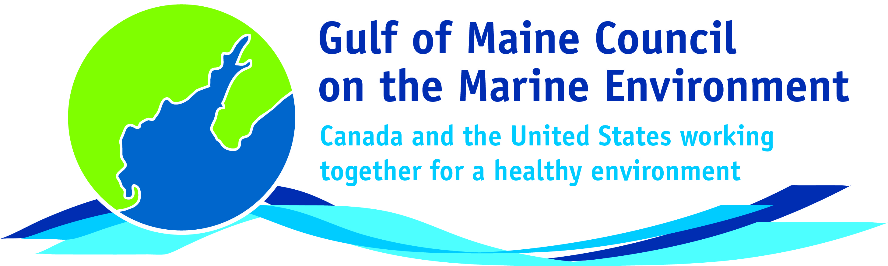**2016**

**Susan Snow Cotter Leadership**

**Award Nomination Form**

The Susan Snow-Cotter Leadership Award is bestowed in memory of Susan Snow-Cotter, a long-time friend of the Council and Working Group. The Award is given to an individual from one of the five states and provinces bordering the Gulf of Maine. The Susan Snow-Cotter Leadership Award honors coastal management professionals who exemplify outstanding leadership or exceptional mentoring in the Gulf of Maine watershed. As former Director of the Massachusetts Office of Coastal Zone Management, Susan was recognized as a leader who exhibited unwavering passion, enthusiasm, and insight to develop pragmatic approaches to coastal management challenges. The Council presents this award to a professional who has demonstrated exceptional leadership in coastal and ocean planning and management by:

* Developing pragmatic approaches;
* Building collaborative efforts through mobilizing and unifying others around an issue or initiative; and/or
* Serving as a strong and supportive mentor to emerging coastal management professionals.

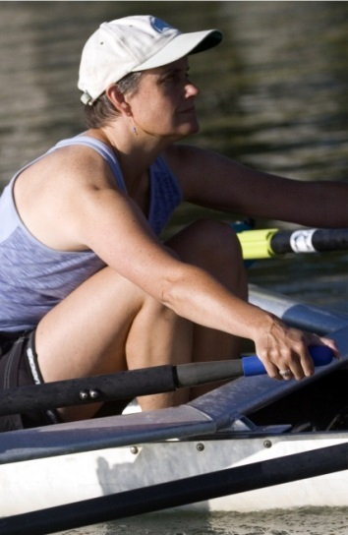

**Nomination instructions**

1. Individuals or organizations may make nominations. Self-nominations are not accepted.
2. The nominee must be a resident of Maine, Massachusetts, New Brunswick, New Hampshire, or Nova Scotia.
3. The nominee’s contributions must have occurred in the Gulf of Maine watershed.
4. Nominations must be made on this nomination form. Nominations with missing information will not be considered. Please provide all information on this form. Additional attachments will not be accepted.
5. Nominations must be emailed to [jleblanc@gulfofmaine.org](mailto:jleblanc@gulfofmaine.org) by the close of business on **March 31, 2016**. Please rename the nomination form with _LastNameofNominee added to the end of the file name.

Susan Snow Cotter

|  |
| --- |
| **Questions?** Please contact Council Coordinator Joan LeBlanc at [jleblanc@gulfofmaine.org](mailto:jleblanc@gulfofmaine.org).  To view a list of past award winners, please visit: <http://www.gulfofmaine.org/2/gomc-home/awards/> |

|  |  |
| --- | --- |
| **Nominee information (REQUIRED)**  Name (as it would appear on the award plaque if selected): Marianne Janowicz  Mailing address: 3378 Dixon Road, Breadalbane, PE C0A 1E0  Phone: 902-621-0575 Email: mjanowicz@hotmail.com |  |
| **Brief background on why the individual/organization is being nominated (REQUIRED):** Marianne Janowicz spent most of her career involved in fisheries management issues and concerns related to the marine environment through her work with the New Brunswick provincial government. She was a long-time New Brunswick government member of the Gulf of Maine Council Working Group and co-chair of the Habitat Conservation Subcommittee. However, her concern for the Bay of Fundy and Gulf of Maine did not end after she left government and moved to Prince Edward Island. As a volunteer, Marianne took on a leadership role in the Bay of Fundy Ecosystem Partnership (BoFEP), and is currently chair of that organization. BoFEP is a “virtual institute” open to individuals and groups. Its goal is to promote the integrity, vitality, biodiversity and productivity of the Bay of Fundy ecosystem and the social well-being and economic sustainability of its coastal communities. Marianne’s dedication to BoFEP’s goal is inspiring. She has helped BoFEP adapt to reduced government funding, fostering and supporting innovative projects that promote the health of the Bay of Fundy ecosystem and the human communities that depend upon it. Under her leadership, BoFEP has initiated work on an Ocean Health Index for the Bay of Fundy, carried out workshops with municipalities on climate change action planning, organized and co-hosted Coastal Zone Canada /BoFEP 2014, and continues to host a biennial science workshop on the Bay of Fundy. |  |
| **Summary that will be read during the awards ceremony if nominee is selected. This text will also be used in media releases (not to exceed 2,000 characters, including spaces and punctuation - REQUIRED):**  NOTE: THIS CAN BE FILLED OUT LATER, NOT DUE MARCH 31. |  |
| **Name and contact information of person making the nomination (REQUIRED):**  Name: Martin Tango  Affiliation: Acadia University and Bay of Fundy Ecosystem Partnership (BoFEP)  Address: School of Engineering, Acadia University, 27 University Avenue, Wolfville Canada, B4P 2R6  Phone: 1 902 585 1149  Email: [martin.tango@acadiau.ca](mailto:martin.tango@acadiau.ca) |  |