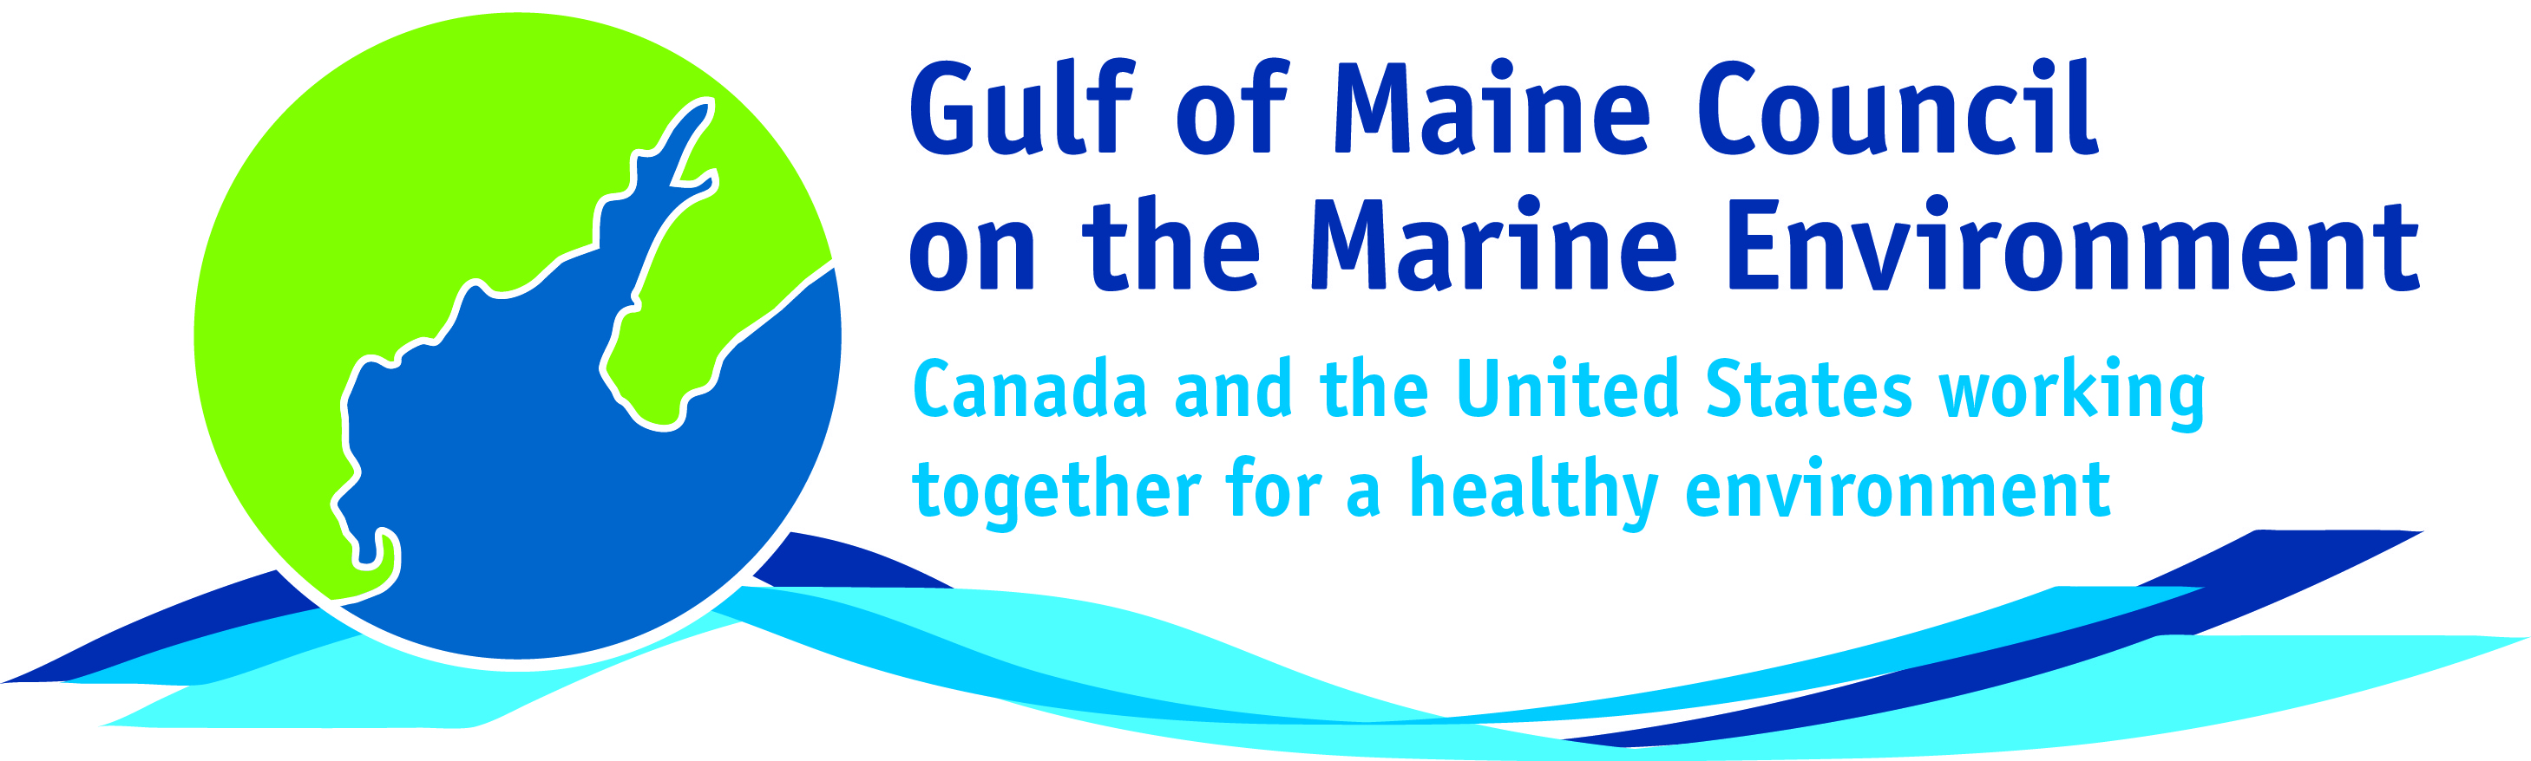**2016**

**Susan Snow Cotter Leadership**

**Award Nomination Form**

The Susan Snow-Cotter Leadership Award is bestowed in memory of Susan Snow-Cotter, a long-time friend of the Council and Working Group. The Award is given to an individual from one of the five states and provinces bordering the Gulf of Maine. The Susan Snow-Cotter Leadership Award honors coastal management professionals who exemplify outstanding leadership or exceptional mentoring in the Gulf of Maine watershed. As former Director of the Massachusetts Office of Coastal Zone Management, Susan was recognized as a leader who exhibited unwavering passion, enthusiasm, and insight to develop pragmatic approaches to coastal management challenges. The Council presents this award to a professional who has demonstrated exceptional leadership in coastal and ocean planning and management by:

* Developing pragmatic approaches;
* Building collaborative efforts through mobilizing and unifying others around an issue or initiative; and/or
* Serving as a strong and supportive mentor to emerging coastal management professionals.



**Nomination instructions**

1. Individuals or organizations may make nominations. Self-nominations are not accepted.
2. The nominee must be a resident of Maine, Massachusetts, New Brunswick, New Hampshire, or Nova Scotia.
3. The nominee’s contributions must have occurred in the Gulf of Maine watershed.
4. Nominations must be made on this nomination form. Nominations with missing information will not be considered. Please provide all information on this form. Additional attachments will not be accepted.
5. Nominations must be emailed to [jleblanc@gulfofmaine.org](mailto:jleblanc@gulfofmaine.org) by the close of business on **March 31, 2016**. Please rename the nomination form with _LastNameofNominee added to the end of the file name.

Susan Snow Cotter

|  |
| --- |
| **Questions?** Please contact Council Coordinator Joan LeBlanc at [jleblanc@gulfofmaine.org](mailto:jleblanc@gulfofmaine.org).  To view a list of past award winners, please visit: <http://www.gulfofmaine.org/2/gomc-home/awards/> |

|  |  |
| --- | --- |
| **Nominee information (REQUIRED)**  **Name (as it would appear on the award plaque if selected):** William S. Spitzer  **Mailing address:** Vice President of Programs, Exhibits, and Planning; New England Aquarium, 1 Central Wharf, Boston, MA 02110  **Phone:** 617.973.6567 **Email:** bspitzer@neaq.org |  |
| **Brief background on why the individual/organization is being nominated (REQUIRED):** Billy Spitzer is the Vice President for Programs, Exhibits, and Planning at the New England Aquarium. For the past 11 years, Billy has served as the host institution liaison to the New England Ocean Science Education Collaborative (NEOSEC), a regional entity that brings together a diversity of marine education organizations around collective work and learning. Also, Billy has served as a leader in climate change education in New England and beyond as a leader of the National Network for Ocean and Climate Change, which has benefitted numerous marine education organizations in the Gulf of Maine watershed over the past 5 years. |  |
| **Summary that will be read during the awards ceremony if nominee is selected. This text will also be used in media releases (not to exceed 2,000 characters, including spaces and punctuation - REQUIRED):**  Billy Spitzer is the Vice President for Programs, Exhibits, and Planning at the New England Aquarium (NEAq) where he develops  mission-driven exhibits and programs and oversees exhibit design, visitor experience, volunteer and education programs, and strategic planning. Billy received his PhD in marine chemistry from WHOI, and spent seven years developing educator resources at TERC before joining the New England Aquarium’s education department.  Since 2005, Billy has served New England Ocean Science Education Collaborative (NEOSEC), first as Chair and then as host institution liaison. NEOSEC is a regional entity that brings together diverse marine education organizations around collective work and learning. Two outstanding leadership qualities define Billy’s most significant contributions to NEOSEC. First, his steadfast belief in the value and power of a network and the “exceeding-the-sum-of-its-parts” collective impact they have. Second, Billy has generously provided invaluable mentoring to members of NEOSEC’s rotating executive leadership, as well as members of its governing council. This has built tremendous capacity among current and emerging leaders in marine education around the Gulf of Maine (GOM). As a standing member of NEOSEC’s Executive Committee, Billy has continuously garnered the commitment of NEAq to remain a backbone of the Collaborative in both flush and lean times, which is no small feat.  As principal investigator of the National Network for Ocean and Climate Change Interpretation, Billy is also a leader in climate change education in the GOM and beyond. This effort has benefitted numerous local marine education organizations and their staff over the past 5 years, and brought national attention to New England-based resources and expertise on these critical issues.  Ocean literacy is essential to the long-term stewardship and management of GOM resources, and marine educators are fostering the next generation of marine scientists, resource managers, decision-makers, and educators. Billy Spitzer has demonstrated outstanding leadership over many years, graciously providing invaluable mentoring and professional development throughout the marine education community, the impacts of which will surely continue to percolate throughout the GOM watershed for a long time to come. |  |
| **Name and contact information of person making the nomination (REQUIRED):**  Name: Carole McCauley  Affiliation: Northeastern University Marine Science Center  Address: 430 Nahant Road, Nahant, MA 01908  Phone: 781-581-7370, x321  Email: c.mccauley@neu.edu |  |