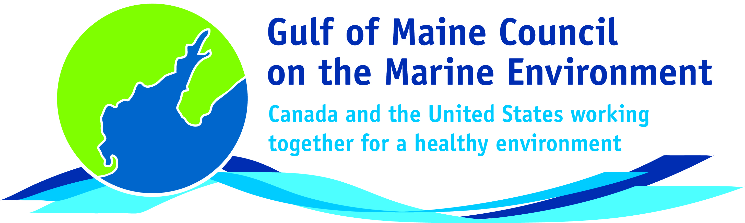**2016**

**Sustainable Communities**

**Award Nomination Form**

The **Sustainable Communities Award** recognizes communities, or groups within communities, for their exemplary work in achieving sustainability outcomes related to the environment and economy, in line with the objectives of the GOMC Action Plan. The selection criteria are derived from the Melbourne Principles and the Government of New Brunswick’s Community Recognition Award selection criteria.

1. Provides a **long-term vision** for communities based on pillars of sustainability: social /cultural, environmental and economic, as well as political equity, and the community’s individuality.
2. Works towards achieving **long-term economic, social, and environmental security**.
3. Recognizes the **intrinsic value of biodiversity and natural ecosystems**, and acts to promote the stewardship of biodiversity and natural ecosystems, and protects and/or restores them.
4. Strives to enable communities to **minimize their ecological footprint**.
5. **Engages the community** in the planning and implementation of sustainable solutions.
6. Builds on the **characteristics of ecosystems** in the development and nurturing of healthy and sustainable communities.
7. Recognizes and builds on the distinctive characteristics of the community, including their **human and cultural values**, history, and natural systems.
8. **Empowers people** and **fosters participation**.
9. Expands and **enables communication and cooperative networks** to work towards sustainability as a common and shared goal.
10. Promotes **sustainable production and consumption**, through appropriate use of environmentally sound technologies and effective demand management.
11. Enables **continual improvement**, based on action planning, accountability, transparency and good governance.

**Overarching Program Criteria**

Nominations should demonstrate that the community, group, program, or project contributed to the long-term viability of the community, improved the health of its immediate environment, and had a positive impact on the health of the Gulf of Maine.

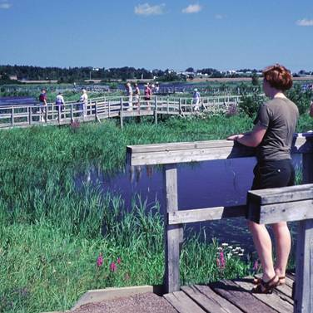**Nomination instructions**

1. Individuals or organizations may make nominations. Self-nominations are not accepted.
2. The community must be based in part or in whole in Maine, Massachusetts, New Brunswick, New Hampshire, or Nova Scotia. The nominee’s contributions must have occurred in the Gulf of Maine watershed.
3. Nominations must be made on this nomination form. This form may be reproduced electronically. Nominations with missing information will not be considered. Please provide all information on this form. Attachments will not be accepted.
4. Nominations must be emailed to [jleblanc@gulfofmaine.org](mailto:jleblanc@gulfofmaine.org) by the close of business on **March 31, 2016**. Please rename the nomination form with _LastNameofNominee added to the end of the file name.

|  |
| --- |
| **Questions?** Please contact Council Coordinator Joan LeBlanc at [jleblanc@gulfofmaine.org](mailto:jleblanc@gulfofmaine.org).  To view a list of past award winners, please visit: <http://www.gulfofmaine.org/2/gomc-home/awards/> |

|  |  |
| --- | --- |
| **Nominee information (REQUIRED)**  Name (as it would appear on the award plaque if selected): Aquaculture Association of Nova Scotia  Mailing address: 2960 Oxford Street, Halifax NS, B3L 2W4  Phone: (902) 422-6234  Email: executivedirector@seafarmers.ca |  |
| **Brief background on why the individual/organization is being nominated (REQUIRED):**  The Aquaculture Association of Nova Scotia (AANS) is a non-profit organization that has been supporting responsible aquaculture in Nova Scotia for over 30 years. Since then they have been working with industry members and their communities to build a strong aquaculture industry and a stronger economy for Nova Scotia and in particular the Gulf of Maine region with a focus on environmental protection and community engagement.  Specifically, the Aquaculture Association of Nova Scotia (AANS) in conjunction with a wide variety of community, industry, and government stakeholders has developed a comprehensive initiative to establish codes of best practice for responsible aquaculture farming in Nova Scotia. It is because of their endless commitment to bettering the aquaculture industry, communities, and the environment, in the Golf of Maine region that they are being nominated. |  |
| **Summary that will be read during the awards ceremony if nominee is selected. This text will also be used in media releases (not to exceed 2,000 characters, including spaces and punctuation – REQUIRED):**  The Aquaculture Association of Nova Scotia (AANS) is a non-profit organization that has been supporting responsible aquaculture in Nova Scotia for over 30 years. Since then they have been working with industry members and their communities to build a strong aquaculture industry and a stronger economy for Nova Scotia and in particular the Gulf of Maine region with a focus on environmental protection and community engagement.  **Innovation and Leadership**  Specifically, the Aquaculture Association of Nova Scotia (AANS), in conjunction with a wide variety of community, industry, and government stakeholders has developed a comprehensive initiative to establish codes of best practice for responsible aquaculture farming in Nova Scotia. An overarching code of responsibility for Nova Scotia sea farmers was adopted as part of the AANS constitution in 2015. To date over 90% of AANS members have adopted this code of responsibility.   * **Code of Containment -** Pertaining to the prevention and procedure of fish escape, reducing the scale of incidence of any escape events while ensuring appropriate and immediate responses. * **Code of Fish Health and Welfare -** Welfare promotion and disease prevention that involves the implementation of good production practicesand farm management methods specific to each species to mitigate risks to fish health. * **Code of Shellfish Health -** Concerned with the operation of socially and environmentally responsible shellfish farms and strengtheningof relationships between members and the local and scientific community. * **Code of Engagement -** The maintenance of strong, positive community relations on a local and global scale by establishing meaningfulconnections with companies and communities in a way that is constructive and transparent. * **Code of Bio-Security -** Defines operational steps that fish follow through the production system, ie; the stock inventory and healthstatus, and external influences. (Neighboring farms, industrial or agricultural influences.) * **Code of Environmental Management -** The Environmental Management plan template for the AANS will consist of: Contacts and basic information, Environmental impact assessment: site plan, Environmental impact assessment, operation description   Specifically, the Code of Environmental Management plan calls for environmental stewardship as a fundamental tenant of responsible seafood aquaculture. This innovative leadership focuses the Aquaculture Association’s efforts to ensure that communities and consumers are aware of the industries commitment in Nova Scotia to responsible and sustainable practices.  In addition, the Aquaculture Association of Nova Scotia and it’s members have broadly embraced Ocean Wise Eco-certification and standards to educate and empower Nova Scotia consumers around the issues of sustainable seafood. Many AANS members are recognized by, and actively promote Ocean Wise as a mark associated with seafood farming for healthy oceans.  **Community Engagement and Outreach**  Another large area of the work the Aquaculture Association of Nova Scotia does is in community engagement and outreach. The community engagement code of best practice highlights the AANS commitment to community outreach and collaboration. The AANS are actively out in communities across the province, specifically in Golf of Maine communities. In the past year alone, community events and presentations have resulted in more than 30,000 contacts regarding aquaculture development in coastal communities. The AANS also coordinates community development working groups to engage community members and municipal leaders in aquaculture development opportunities for coastal communities.  Sea Farming in Nova Scotia is growing and Nova Scotian municipalities, towns, and communities are leading the way. In the past year alone, the AANS partnered with municipal and community leaders throughout the Gulf of Maine to educate Nova Scotia consumers and communicate on the many advances that have been made in aquaculture “farm management” strategies in the past few years.  The aquaculture industry is celebrating the Canadian Federal and Nova Scotia Provincial governments’ development of clear, transparent, and progressive aquaculture regulations that pave the way forward for expansion of seafood farming in Nova Scotia. This initiative along with the Codes of Best Practice, positions our industry as an economic engine for the future of a bright Nova Scotia.  AANS expanded their community outreach this year, working “side by side” in communities throughout the Golf of Maine coastal region to build awareness and strike new relationships:   * World Oceans Day 2015 * Digby Scallop Days (Digby County) * Acadian Day Celebration (Municipality of Argyle) * Aquaculture Development Working Group (Municipality of Argyle & Digby County)   As well, this past year, several Gulf of Maine municipal leaders joined with AANS on an Atlantic Canada trade mission to Norway to see first-hand how aquaculture can positively change the lives of rural communities for a better future. 2016 is shaping up to be a transformative year for Aquaculture in Nova Scotia. |  |
| **Name and contact information of person making the nomination (REQUIRED):**  Name: Brian Blanchard  Affiliation: Vice President/ General Manager Scotian Halibut Ltd.  Address: 25 Kenney St. P.O. Box 119, Clarke’s Harbour, N.s. B0W 1P0  Phone: (902) 477 - 1880  Email: briancblanchard@gmail.com |  |