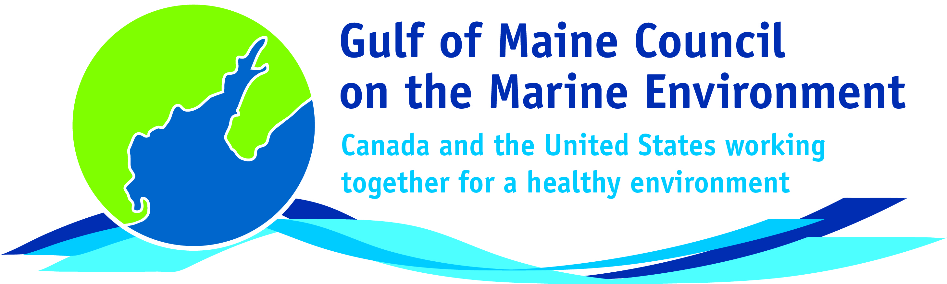**2016**

**Sustainable Communities**

**Award Nomination Form**

The **Sustainable Communities Award** recognizes communities, or groups within communities, for their exemplary work in achieving sustainability outcomes related to the environment and economy, in line with the objectives of the GOMC Action Plan. The selection criteria are derived from the Melbourne Principles and the Government of New Brunswick’s Community Recognition Award selection criteria.

1. Provides a **long-term vision** for communities based on pillars of sustainability: social /cultural, environmental and economic, as well as political equity, and the community’s individuality.
2. Works towards achieving **long-term economic, social, and environmental security**.
3. Recognizes the **intrinsic value of biodiversity and natural ecosystems**, and acts to promote the stewardship of biodiversity and natural ecosystems, and protects and/or restores them.
4. Strives to enable communities to **minimize their ecological footprint**.
5. **Engages the community** in the planning and implementation of sustainable solutions.
6. Builds on the **characteristics of ecosystems** in the development and nurturing of healthy and sustainable communities.
7. Recognizes and builds on the distinctive characteristics of the community, including their **human and cultural values**, history, and natural systems.
8. **Empowers people** and **fosters participation**.
9. Expands and **enables communication and cooperative networks** to work towards sustainability as a common and shared goal.
10. Promotes **sustainable production and consumption**, through appropriate use of environmentally sound technologies and effective demand management.
11. Enables **continual improvement**, based on action planning, accountability, transparency and good governance.

**Overarching Program Criteria**

Nominations should demonstrate that the community, group, program, or project contributed to the long-term viability of the community, improved the health of its immediate environment, and had a positive impact on the health of the Gulf of Maine.

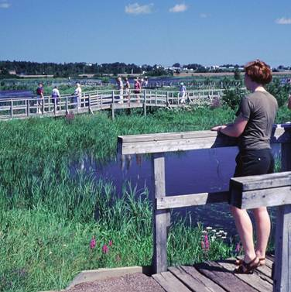**Nomination instructions**

1. Individuals or organizations may make nominations. Self-nominations are not accepted.
2. The community must be based in part or in whole in Maine, Massachusetts, New Brunswick, New Hampshire, or Nova Scotia. The nominee’s contributions must have occurred in the Gulf of Maine watershed.
3. Nominations must be made on this nomination form. This form may be reproduced electronically. Nominations with missing information will not be considered. Please provide all information on this form. Attachments will not be accepted.
4. Nominations must be emailed to [jleblanc@gulfofmaine.org](mailto:jleblanc@gulfofmaine.org) by the close of business on **March 31, 2016**. Please rename the nomination form with _LastNameofNominee added to the end of the file name.

|  |
| --- |
| **Questions?** Please contact Council Coordinator Joan LeBlanc at [jleblanc@gulfofmaine.org](mailto:jleblanc@gulfofmaine.org).  To view a list of past award winners, please visit: <http://www.gulfofmaine.org/2/gomc-home/awards/> |

|  |  |
| --- | --- |
| **Nominee information (REQUIRED)**  Name (as it would appear on the award plaque if selected): Town of Durham  Mailing address: 15 Newmarket Road, Durham NH 03824  Phone: (603) 868-5571  Email: Town Administrator Todd Selig, tselig@ci.durham.nh.us |  |
| **Brief background on why the individual/organization is being nominated (REQUIRED):**  The town of Durham is a municipal leader that consistently challenges itself to think deeply about its vision for the future and the role it can play in achieving long-term sustainability for the community and the natural landscape. The Town demonstrates a consistent, forward-thinking vision for ensuring a high quality of life and protecting the environment through its efforts to incorporate modern-day strategies such as Smart Growth Principles into every aspect of community development. Successes include:   * Adoption of a conservation subdivision ordinance * Numerous land protection efforts, resulting in conservation of approximately 30% of town land area (over 4,200 acres) * Strong support for preservation of natural and historic resources * Substantial investments in improving the downtown * Guiding commercial and industrial development through their zoning to areas located in the downtown core and outlying areas * Pedestrian and bicycle safety enhancements * Designation of four scenic roads * Support of the state recognized Mills Scenic Byway * A transparent and open public engagement process * Development of a Climate Adaptation Chapter of its Hazard Mitigation Plan to protect vulnerable areas at risk of present and future flooding * Collaboration with UNH and other entities on a cutting-edge Watershed-Based Integrated Permit to improve water quality conditions in Great Bay by identifying projects that achieve the most environmental benefits, including green infrastructure and outreach opportunities * Installation of numerous rain gardens throughout the Town * Updates to the Town’s site plan and subdivision regulations to require all developments to provide up-to-date storm water management facilities that do not create or contribute to water quality impairment, resulting in the incorporation of low impact development practices into all proposed site plans * Educating other local communities through participation in regional environmental management gatherings including the 2014 Great Bay Symposium and NH Coastal Climate Summit * Establishment of an Agricultural Commission to “promote the production, availability, and sale of locally grown food, fiber, and forest products” and honor the Town’s agricultural heritage * Establishment of an energy committee in 2007, which was mandated to advise the Town Council on ways to reduce energy use, develop alternative energy sources, and increase the economic security and energy independence of the town   While striving to achieve this innovative vision of the future, the town of Durham also takes great care to reflect on the values of its past and engage its present community members to ensure that, as the town grows and adapts to social, economic, and environmental changes, the distinctive characteristics and core values of the community remain strong and resilient. Nothing is more exemplary of this commitment to the past, present, and future of Durham than the work of the Planning Board and the Master Plan Advisory Committee (MPAC) in capturing the ideas of local residents for addressing various challenges facing the community, including housing, natural and cultural resources, recreation, land use, zoning, business and industry, and community facilities and infrastructure. Citizen input was analyzed from both a visioning forum of 90 individuals and a master plan survey in 2011 with over 460 participants. With guidance from the town’s consultant, the Strafford Regional Planning Commission (SRPC), MPAC also cross-referenced these data with priorities expressed in previous Master Plans to give current priorities a temporal context.  This extensive public engagement process provided the insight necessary to develop a Vision Statement and Vision and Community Character Chapter of the current Master Plan shaped by the shared goals and values of past and present community members. Results from these engagement efforts pervade all ten Master Plan chapters formally adopted by the Planning Board in November of 2015, including Natural Resources, Agriculture, Energy, and Recreation. This commitment to public engagement has empowered the town of Durham to work as a united community towards a sustainable and prosperous future that retains its core values and principles as a town with an engaged community, a vibrant downtown, and an abundant, accessible natural environment. |  |
| **Summary that will be read during the awards ceremony if nominee is selected. This text will also be used in media releases (not to exceed 2,000 characters, including spaces and punctuation - REQUIRED):**  The town of Durham is a municipal leader that consistently challenges itself to think deeply about its vision for achieving long-term sustainability. This forward-thinking vision incorporates modern strategies such as Smart Growth Principles into every aspect of community development. Durham has achieved many Smart Growth successes including substantial investments in improving the downtown, strong support for preservation of natural and historic resources, numerous stormwater projects, and progress towards economic security and energy independence. While maintaining an innovative vision of the future, the Town takes great care to reflect on its past and engage its present citizens to ensure that, as the Town grows and adapts to social, economic, and environmental changes, the distinctive characteristics and core values of the community remain. Nothing is more exemplary of this commitment to the past, present, and future of Durham than the work of the Planning Board and Master Plan Advisory Committee (MPAC), in coordination with the Strafford Regional Planning Commission (SRPC), in capturing the ideas of local residents for addressing local issues, including housing, natural and cultural resources, recreation, land use, zoning, business and industry, and infrastructure. The MPAC established guidelines for the plan while communicating regularly with the Planning Board to ensure that it was operating within acceptable parameters. Given the complexity of the plan and level of citizen involvement, the MPAC had to be creative, nimble, and, at times, firm to keep the process moving. Crafting the plan was an ever-evolving dance among the MPAC, SRPC, Planning Board, topic committees, staff, and citizens. This commitment to public engagement has empowered the town of Durham to work towards a sustainable and prosperous future that retains the core values and principles of a town with an engaged community, a vibrant downtown, and an abundant, accessible natural environment. |  |
| **Name and contact information of person making the nomination (REQUIRED):**  Name: Steven Couture  Affiliation: NHDES  Address: 222 International Drive, Suite 175, Portsmouth, NH  Phone: (603) 271-8801; (603) 559-0027  Email: steven.couture@des.nh.gov |  |