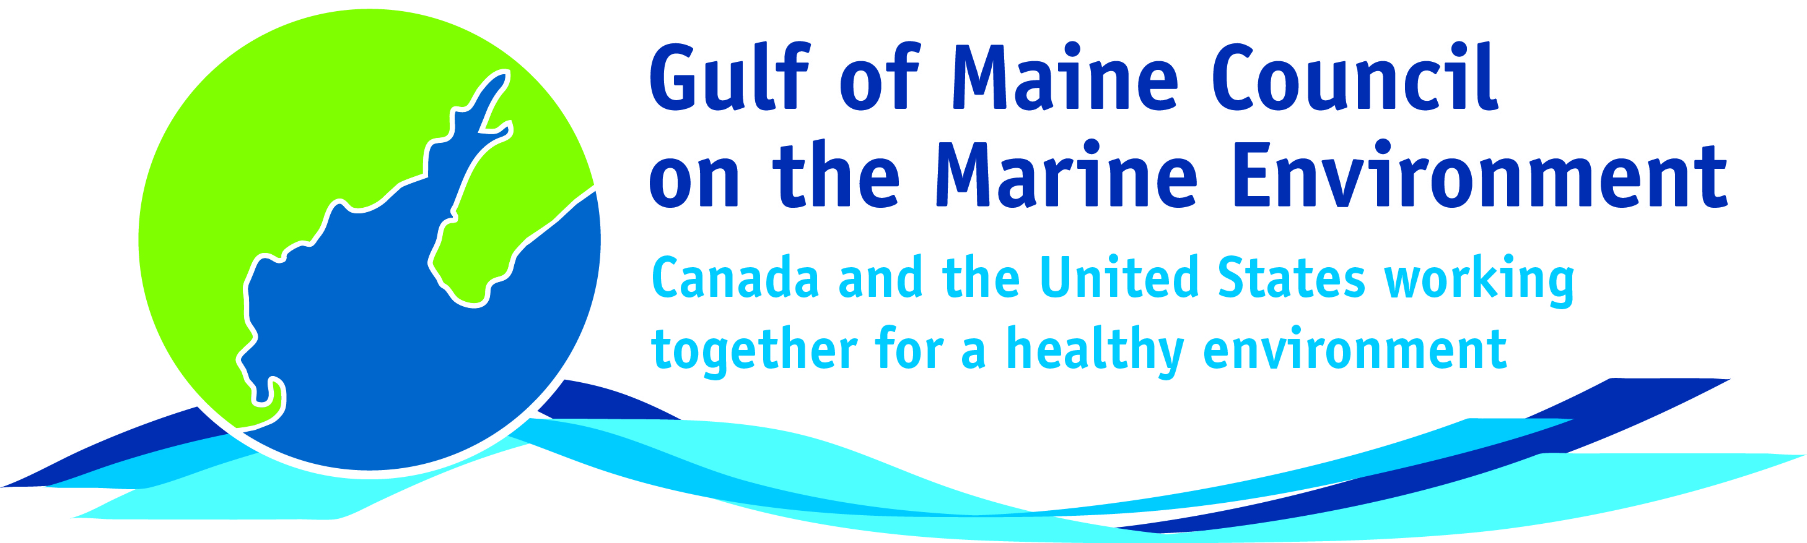**2016**

**Visionary Award**

**Nomination Form**

The Gulf of Maine Visionary Award is presented annually to an individual or organization within each of the five Gulf of Maine jurisdictions of Massachusetts, New Hampshire, Maine, New Brunswick, and Nova Scotia. These awards recognize innovation, creativity, and commitment to marine protection by businesses, environmental organizations, or individuals who are making a difference to the health of the Gulf of Maine.

**Nomination instructions**

1. 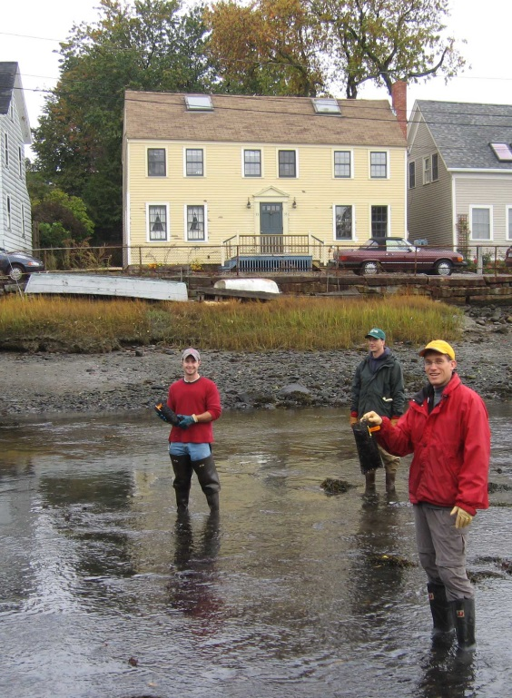Individuals or organizations may make nominations. Self-nominations are not accepted.
2. The nominee must be a resident of (or an organization / company based in) Maine, Massachusetts, New Brunswick, New Hampshire, or Nova Scotia. The nominee’s contributions must have occurred in the Gulf of Maine watershed.
3. Visionary Award nominees may be paid professionals or volunteers.
4. Nominations must be made on this nomination form. Nominations with missing information will not be considered. Please provide all information on this form. Attachments will not be accepted.
5. Nominations must be emailed to [jleblanc@gulfofmaine.org](mailto:jleblanc@gulfofmaine.org) by the close of business on **March 31, 2016**. Please rename the nomination form with _LastNameofNominee added to the end of the file name.

|  |
| --- |
| **Questions?** Please contact Council Coordinator Joan LeBlanc at [jleblanc@gulfofmaine.org](mailto:jleblanc@gulfofmaine.org).  To view a list of past award winners, please visit: <http://www.gulfofmaine.org/2/gomc-home/awards/> |

|  |  |
| --- | --- |
| **Nominee information (REQUIRED)**  Name (as it would appear on the award plaque if selected): Carroll brown Jr  Mailing address:29 Hazen Dr Concord NH  Phone: 603 271-3000  Email: Carroll.Brownjr@des.nh.gov |  |
| **Brief background on why the individual/organization is being nominated (REQUIRED):** |  |
| Since 2002 Carroll Brown of the New Hampshire Department of Environmental Services, has been tireless in his effort to plan for and make sure the region is equipped for a release of oil to the coastal waters of New Hampshire and Southern Maine.  Following the disbanding of the  Piscataqua River Cooperative Carroll was instrumental in continuing the coastal oil spill preparedness efforts by helping to form the Portsmouth Oil Spill Response Workgroup.  Carroll has chaired this group as well as acted as the New Hampshire chair for the Maine/New Hampshire Area Committee. When the Cooperative disbanded NHDES retained the Cooperative’s spill response equipment; Carroll ensured that this equipment was accounted for, repaired and kept in service to continue a high level of response readiness in the region.  Carroll heads a committee that designs and updates geographic response plans for New Hampshire and parts of Maine. When faced with the task of protecting Great Bay and provided with strategies that were unworkable, Carroll spent endless hours creating and overseeing testing of new response strategies.   His creativity and dedication have resulted in a working strategy able to be deployed in a short amount of time, consisting of over a mile of Boom.    Carroll’s outreach efforts and coordination have led to strong partnerships between different agencies and stakeholders.  His effort to create a Memorandum of Understanding with the Portsmouth Naval Shipyard has not only improved coordination in planning but was put successfully into practice during a release this past year.  During this event the agreement with the Navy and coordination with the Coast Guard resulted in a swift response and the mutual use of equipment providing responders with tools necessary to quickly contain the spill and effectively remove the oil.  The region’s response capabilities have been greatly increased by Carroll’s dedication, his creativity and the relationships that he has been able to build. |  |
| **Name and contact information of person making the nomination (REQUIRED):**  Name:Jason Domke  Affiliation: New Hampshire Dept. of Environmental Services  Address:222 International Drive Suite 175  Phone:603 559-1506  Email:Jason.Domke@des.nh.gov |  |