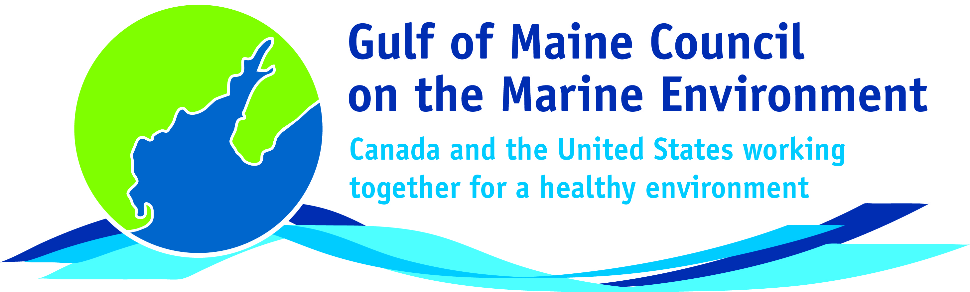**2016**

**Visionary Award**

**Nomination Form**

The Gulf of Maine Visionary Award is presented annually to an individual or organization within each of the five Gulf of Maine jurisdictions of Massachusetts, New Hampshire, Maine, New Brunswick, and Nova Scotia. These awards recognize innovation, creativity, and commitment to marine protection by businesses, environmental organizations, or individuals who are making a difference to the health of the Gulf of Maine.

**Nomination instructions**

1. 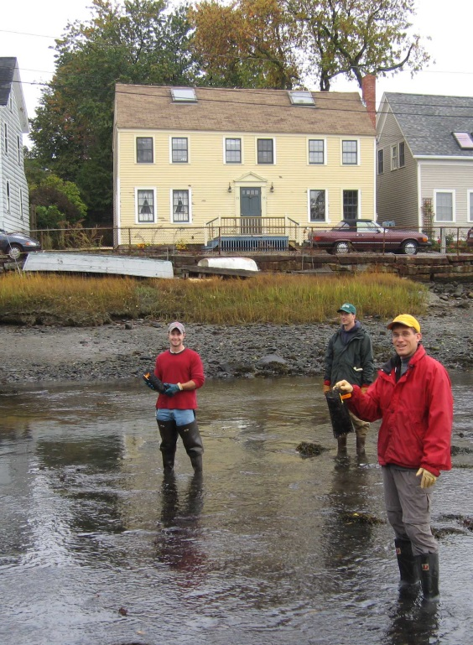Individuals or organizations may make nominations. Self-nominations are not accepted.
2. The nominee must be a resident of (or an organization / company based in) Maine, Massachusetts, New Brunswick, New Hampshire, or Nova Scotia. The nominee’s contributions must have occurred in the Gulf of Maine watershed.
3. Visionary Award nominees may be paid professionals or volunteers.
4. Nominations must be made on this nomination form. Nominations with missing information will not be considered. Please provide all information on this form. Attachments will not be accepted.
5. Nominations must be emailed to [jleblanc@gulfofmaine.org](mailto:jleblanc@gulfofmaine.org) by the close of business on **March 31, 2016**. Please rename the nomination form with _LastNameofNominee added to the end of the file name.

|  |
| --- |
| **Questions?** Please contact Council Coordinator Joan LeBlanc at [jleblanc@gulfofmaine.org](mailto:jleblanc@gulfofmaine.org).  To view a list of past award winners, please visit: <http://www.gulfofmaine.org/2/gomc-home/awards/> |

|  |  |
| --- | --- |
| **Nominee information (REQUIRED)**  Name (as it would appear on the award plaque if selected): Glorianna Davenport and Evan Schulman (please consider as one award for a single partnership or team)  Mailing address: Tidmarsh Farms, Inc., 134 Bartlett Road, Plymouth, MA, 02360  Phone: (617) 642 7934  Email: gid@media.mit.edu |  |
| **Brief background on why the individual/organization is being nominated (REQUIRED):**  Glorianna Davenport and Evan Schulman are owners of Tidmarsh Farms, Inc. of Plymouth Massachusetts, which is a former family-owned cranberry farm encompassing approximately 600-acres. In 2010, Glorianna and Evan enrolled 192-acres of the former farm into a permanent conservation restriction via the USDA Natural Resource Conservation Service. This decision ultimately led to the largest ecological restoration project of its type in the Gulf of Maine. Presently, 250-acres are under transformation as part of a $2.8 million wetland and stream restoration project. Once the restoration is complete (June of 2016,) Mass Audubon has an option to develop a wildlife sanctuary on the property, and ensure on-going public access and protection in perpetuity. In addition, Glorianna has led the creation of Living Observatory at the site (see: <http://tidmarsh.media.mit.edu/>). Dozens of academic and NGO partners are monitoring and interpreting the transformational changes at Tidmarsh, and exploring new ways of bringing nature to students and the public. |  |
| **Summary that will be read during the awards ceremony if nominee is selected. This text will also be used in media releases (not to exceed 2,000 characters, including spaces and punctuation - REQUIRED):**  The Tidmarsh Restoration Project involves comprehensive ecological restoration across 250-acres of retired cranberry bogs and supporting lands in Plymouth Massachusetts. The project area consists of 202-acres of coastal wetlandsand 48-acres of adjacent upland. The site makes up a significant portion of the The Beaver Dam Brook watershed, and benefits include improved water quality, increased biodiversity, and reduction of contaminated sediments.  The project is the largest coastal freshwater wetlands restoration effort to date in Massachusetts, and is supported by Massachusetts Division of Ecological Restoration (DER). There are 20 partnering organizations involved, including Massachusetts Bays National Estuary Program, and the restoration includes a cutting-edge, monitoring and educational component (called the Living Observatory) led by Evan and Glorianna. Living Observatory partners include Massachusetts Institute of Technology and many other organizations. The design and construction phases, led by DER, were funded by NOAA, American Rivers, Gulf of Maine Council on the Marine Environment, Mass Environmental Trust, and U.S. Fish and Wildlife Service (Partners for Fish and Wildlife Program).  Although primarily a freshwater wetland restoration effort, the site (less than a mile from the coast) will be suitable for salt marsh migration as sea level rises, making this ecological restoration project an important example of coastal resiliency and climate change adaptation.  This groundbreaking project is the result of Evan and Glorianna’s vision and dedication to improving the environment for the greater good. They could have sold the property for development or continue to farm the site; instead they chose to restore the land and create a living laboratory for students and practitioners to learn from and apply lessons across the Gulf of Maine. |  |
| **Name and contact information of person making the nomination (REQUIRED):**  Name: Tim Purinton, Director  Affiliation: Massachusetts Division of Ecological Restoration, Department of Fish and Game  Address: 251 Causeway St., Suite 400, Boston, MA 02114  Phone: 617-616-1542  Email: tim.purinton@state.ma.us |  |