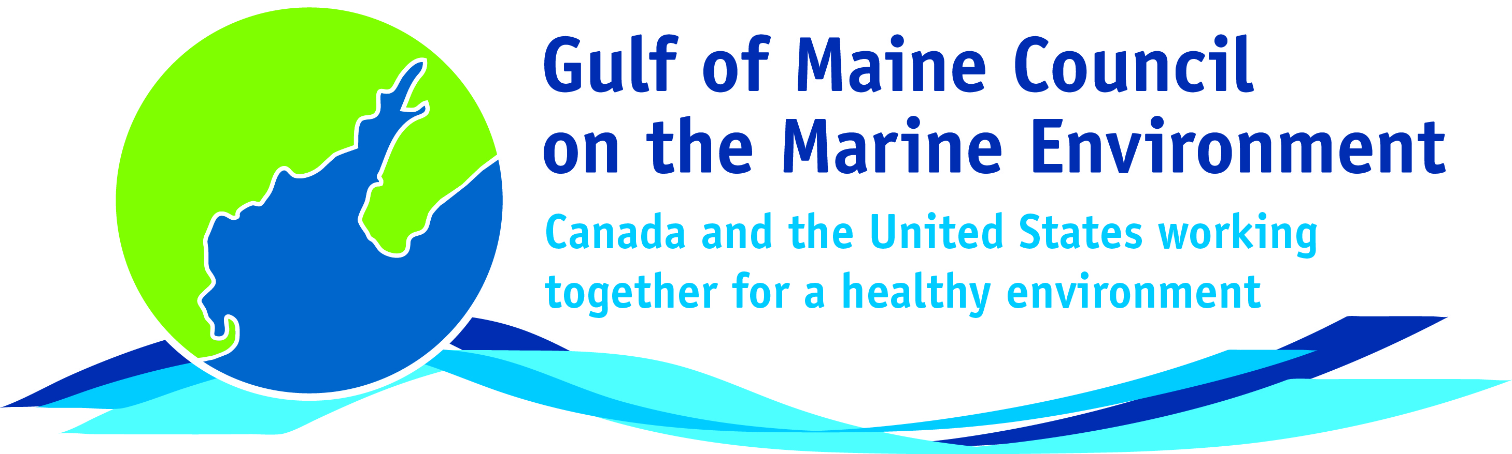**2016**

**Visionary Award**

**Nomination Form**

The Gulf of Maine Visionary Award is presented annually to an individual or organization within each of the five Gulf of Maine jurisdictions of Massachusetts, New Hampshire, Maine, New Brunswick, and Nova Scotia. These awards recognize innovation, creativity, and commitment to marine protection by businesses, environmental organizations, or individuals who are making a difference to the health of the Gulf of Maine.

**Nomination instructions**

1. 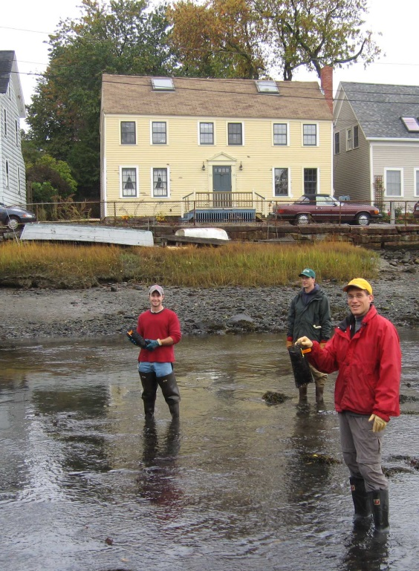Individuals or organizations may make nominations. Self-nominations are not accepted.
2. The nominee must be a resident of (or an organization / company based in) Maine, Massachusetts, New Brunswick, New Hampshire, or Nova Scotia. The nominee’s contributions must have occurred in the Gulf of Maine watershed.
3. Visionary Award nominees may be paid professionals or volunteers.
4. Nominations must be made on this nomination form. Nominations with missing information will not be considered. Please provide all information on this form. Attachments will not be accepted.
5. Nominations must be emailed to [jleblanc@gulfofmaine.org](mailto:jleblanc@gulfofmaine.org) by the close of business on **March 31, 2016**. Please rename the nomination form with _LastNameofNominee added to the end of the file name.

|  |
| --- |
| **Questions?** Please contact Council Coordinator Joan LeBlanc at [jleblanc@gulfofmaine.org](mailto:jleblanc@gulfofmaine.org).  To view a list of past award winners, please visit: <http://www.gulfofmaine.org/2/gomc-home/awards/> |

|  |  |
| --- | --- |
| **Nominee information (REQUIRED)**  Name Dr. Diana Hamilton  Mailing address: Department of Biology, Mount Allison University, Sackville, NB. E4L 1E4  Phone: 506-364-2513 office; 506-364-2507 (lab)  Email: dhamilton@mta.ca |  |
| **Brief background on why the individual/organization is being nominated (REQUIRED):**  Dr. Diana Hamilton is an outstanding marine ecologist, researcher, and teacher, dedicated to understanding the ecology of the extensive mudflats of the upper Bay of Fundy, a coastal environment critical to the survival of millions of migratory shorebirds of hemispheric and global importance. She is a true field biologist, happiest on the mudflats rather than in the office or even her lab! Since the late 1990s, she has specialized in understanding the interactions between the migrating shorebirds and the intertidal invertebrate communities upon which the birds depend on their stopover while migrating southwards from mid- summer to early fall. Her research has focused on the shorebirds themselves (their distribution, behavior, and feeding ecology), the community-level interactions of the intertidal invertebrates (especially the amphipod Corophium, and the mudsnail Ilyanassa), and importantly the top-down and bottom-up ecological interactions in mudflat ecology, the latter producing a new theoretical understanding of how tidal flats function ecologically. Working closely with numerous collaborators, especially at UNB Fredericton, and her continued bevy of undergraduate and graduate students, she has been successful at gaining research grants from NSERC (Canada), the New Brunswick Wildlife Trust, and Environment Canada, amongst others. Although still early in her career, she has authored and co-authored more than 30 peer-reviewed publications, and contributed over many years to both the workshops of the Bay of Fundy Ecosystem Partnership (BoFEP) and ACCESS (Atlantic Canada Coastal and Estuarine Science Society), as well as to the BoFEP mudflat ecology working group. Her scientific dedication, enthusiasm for teaching and working with students, and involvement in the conservation of upper Bay of Fundy ecosystems are exemplary. Diana is truly a role model for young people interested in understanding, protecting, and conserving the environment of the Gulf of Maine and Bay of Fundy, and as such deserves to be considered for a GOMC Visionary Award. |  |
| **Summary that will be read during the awards ceremony if nominee is selected. This text will also be used in media releases (not to exceed 2,000 characters, including spaces and punctuation - REQUIRED):**  Dr. Diana Hamilton of Mount Allison University, Sackville, NB, is an outstanding marine ecologist, researcher, and teacher, dedicated to understanding the ecology of the extensive mudflats of the upper Bay of Fundy, a coastal environment critical to the survival of millions of migratory shorebirds of hemispheric and global importance. Since the late 1990s, she has specialized in understanding the interactions between the migrating shorebirds such as sandpipers and plovers and the intertidal invertebrate communities upon which the birds depend during their stopover while migrating southwards from mid- summer to early fall. Her research has focused on the shorebirds themselves (their distribution, behavior, and feeding ecology), the community-level interactions of the intertidal invertebrates (especially the amphipod, Corophium, and the mudsnail, Ilyanassa), and importantly the top-down and bottom-up ecological interactions in mudflat ecology, the latter producing a new theoretical understanding of how tidal flats function ecologically. She has authored and co-authored more than 30 peer-reviewed publications, and contributed over many years to both the workshops of the Bay of Fundy Ecosystem Partnership (BoFEP) and ACCESS (Atlantic Canada Coastal and Estuarine Science Society), as well as to the BoFEP mudflat ecology working group. Her scientific dedication, enthusiasm for teaching and working with students, and involvement in the conservation of upper Bay of Fundy ecosystems are exemplary. Diana is a tremendous role model for young people interested in understanding, protecting, and conserving the environment of the Gulf of Maine and Bay of Fundy. |  |
| **Name and contact information of person making the nomination (REQUIRED):**  Name: Dr. Peter G. Wells  Affiliation: Dalhousie University and Bay of Fundy Ecosystem Partnership  Address: 6414 Coburg Road, P.O. Box 15000, Halifax, NS. B3H 4R2  Phone: 902-237-0600 cell; 902-477-3674 home  Email: oceans2@ns.sympatico.ca |  |