**2016**

**Visionary Award**

**Nomination Form**

The Gulf of Maine Visionary Award is presented annually to an individual or organization within each of the five Gulf of Maine jurisdictions of Massachusetts, New Hampshire, Maine, New Brunswick, and Nova Scotia. These awards recognize innovation, creativity, and commitment to marine protection by businesses, environmental organizations, or individuals who are making a difference to the health of the Gulf of Maine.

**Nomination instructions**

1. 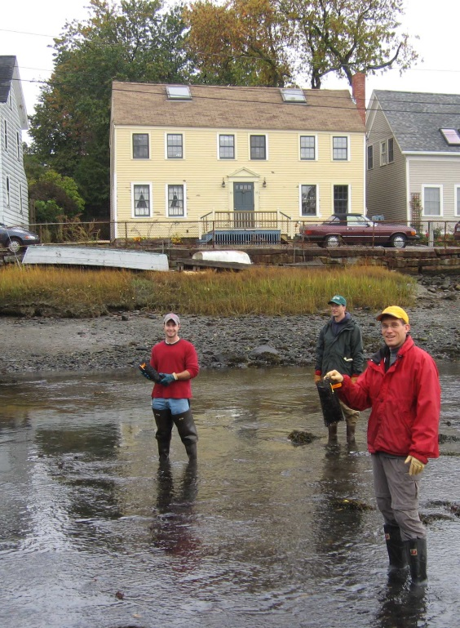Individuals or organizations may make nominations. Self-nominations are not accepted.
2. The nominee must be a resident of (or an organization / company based in) Maine, Massachusetts, New Brunswick, New Hampshire, or Nova Scotia. The nominee’s contributions must have occurred in the Gulf of Maine watershed.
3. Visionary Award nominees may be paid professionals or volunteers.
4. Nominations must be made on this nomination form. Nominations with missing information will not be considered. Please provide all information on this form. Attachments will not be accepted.
5. Nominations must be emailed to [jleblanc@gulfofmaine.org](mailto:jleblanc@gulfofmaine.org) by the close of business on **March 31, 2016**. Please rename the nomination form with _LastNameofNominee added to the end of the file name.

|  |
| --- |
| **Questions?** Please contact Council Coordinator Joan LeBlanc at [jleblanc@gulfofmaine.org](mailto:jleblanc@gulfofmaine.org).  To view a list of past award winners, please visit: <http://www.gulfofmaine.org/2/gomc-home/awards/> |

|  |  |
| --- | --- |
| **Nominee information (REQUIRED)**  Name (as it would appear on the award plaque if selected): Elaine P. Jones  Mailing address: PO Box 8, McKown Point Rd., West Boothbay Harbor, ME 04575  Phone: 207 633 9580 or cell: 207 592 1839  Email: elaine.jones@maine.gov |  |
| **Brief background on why the individual/organization is being nominated (REQUIRED):**  Elaine Jones has been employed by the Maine Department of Marine Resources as Director of the Education Division since 1991. Over her tenure with the Department, Elaine’s visionary approach to marine education has impacted tens of thousands of Maine and New England residents through the programs she has developed and presented. For example, she contributed to the construction of the State’s new laboratory facilities in Boothbay Harbor by not only researching options for an aquarium but, from 1993 to 1995, designing and overseeing the building of the Maine State Aquarium, which is now one of the area’s premier summer attractions (http://www.maine.gov/dmr/rm/aquarium). As a numerical example of the magnitude of the impact this one facility has on marine education in Maine, in a single year, 2014, there were 37,773 visitors to the aquarium. Through programs developed with Elaine’s guidance and supervision, the Maine State Aquarium has increased public awareness, understanding and appreciation of sports fish, marine and estuarine life as well as familiarizing visitor with the culture, history and identity of our state. At the Aquarium, which is open to the public seven days a week throughout the summer months, there are daily presentations on sport and commercial fishing, becoming an ocean scientist, and Maine’s intertidal environment. The demand for such programs has resulted in the Education Division acquiring, in 2015, and renovating a classroom in a former Bigelow Laboratory building to accommodate classroom presentations and activities for students, both young and old, when visiting the Boothbay Harbor facilities.  To further expand marine education in Maine, Elaine, virtually single handedly, lead the charge for DMR to secure ownership of the Burnt Island Light House and five acre island through the Maine Light House Program in 1998 (http://www.maine.gov/dmr/burntisland/index.htm). She then assumed responsible for restoring and transforming the Burnt Island Light Station, in Boothbay Harbor, into an educational and recreational facility that mirrored conditons at the light house in the 1950s; in 2003 she inaugurated a living history program at the site. In 2014 an estimated 8,235 school children, teachers and tourists visited the island, either on their own or as part of an organized event, which included overnight adventures for some school groups.  In addition to activities located in Boothbay Harbor, Elaine organizes and supervises outreach to schools and colleges around Maine. In 2014 “classroom aquaria” were provided to 13 different schools and animals were supplied to various marine organizations for educational purposes. Marine Patrol officers also borrowed animals and small touch tanks for programs in their local communities with the help of “Officer Salty” (aka Elaine). She has reached out to the University of Maine, Orono, to establish an internship program that involves marine science majors in the aquarium operations, and in 2015 this opportunity was extended to University of Maine, Farmington, known as Maine’s “teacher’s college”, to involve these students in marine education and continue Maine’s and Elaine’s legacy of leadership in the field of marine education.  All of the above is a reflection of just some of Elaine’s vision and drive to enlighten Maine students and New England’s older residents about our marine environment and heritage. |  |
| **Summary that will be read during the awards ceremony if nominee is selected. This text will also be used in media releases (not to exceed 2,000 characters, including spaces and punctuation - REQUIRED):**  Elaine Jones has dedicated her life to science education, and marine science in particular. Since 1991, she has led the Maine Department of Marine Resources Education Division and touched tens of thousands of Maine students and residents with the programs she has developed and initiated. In the early 1990s she researched, designed, built, and supervised the construction of the Maine State Aquarium, at the DMR laboratory in Boothbay Harbor. This aquarium, and the associated educational programs, attracts more than 35,000 visitors every summer. In 1998 Elaine spearheaded the efforts to secure Burnt Island for the Department and restored and transformed the Burnt Island Light Station into an educational and recreational facility unequaled in New England; initiating a living history program on site in 2003 that gave visitors a taste of what the life of a lighthouse keeper was like in the 1950s. Thousands of people visit the island every summer either on their own or as part of an organized school adventure. Going beyond Boothbay, Elaine conducts outreach programs to schools and colleges around the State of Maine. This ranges from supplying classroom aquarium systems with marine animals, to working on educational programs with the Marine Patrol as “Officer Salty”, to establishing aquarium based internships for students at the University of Maine that involve training the next generation of marine educators who will continue Maine’s and Elaine’s legacy of leadership in the field of marine education. |  |
| **Name and contact information of person making the nomination (REQUIRED):**  Name: Patrick Keliher  Affiliation: Commissioner, Department of Marine Resources  Address: 21 State House Station, Augusta ME 04333-0021  Phone: 207 624 6553  Email: Patrick.Keliher@maine.gov |  |