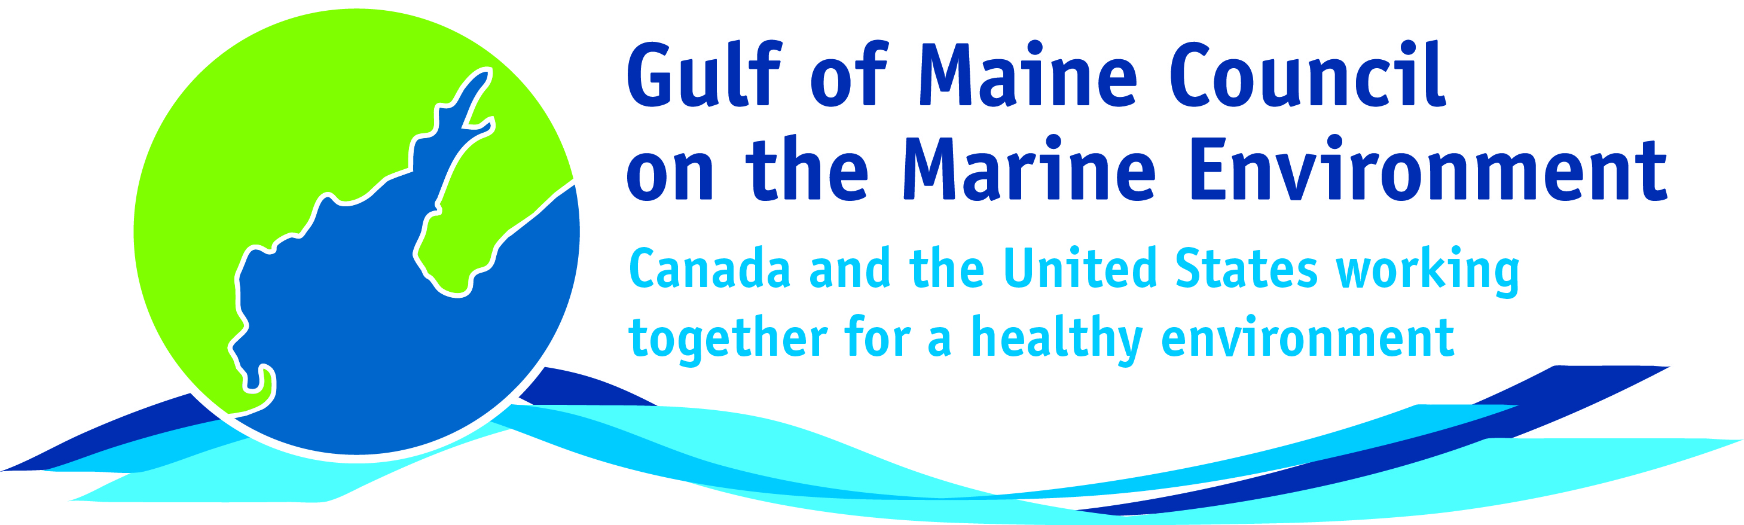**2016**

**Visionary Award**

**Nomination Form**

The Gulf of Maine Visionary Award is presented annually to an individual or organization within each of the five Gulf of Maine jurisdictions of Massachusetts, New Hampshire, Maine, New Brunswick, and Nova Scotia. These awards recognize innovation, creativity, and commitment to marine protection by businesses, environmental organizations, or individuals who are making a difference to the health of the Gulf of Maine.

**Nomination instructions**

1. 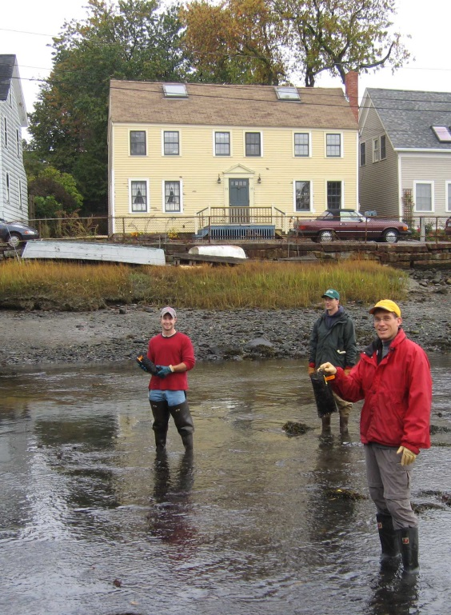Individuals or organizations may make nominations. Self-nominations are not accepted.
2. The nominee must be a resident of (or an organization / company based in) Maine, Massachusetts, New Brunswick, New Hampshire, or Nova Scotia. The nominee’s contributions must have occurred in the Gulf of Maine watershed.
3. Visionary Award nominees may be paid professionals or volunteers.
4. Nominations must be made on this nomination form. Nominations with missing information will not be considered. Please provide all information on this form. Attachments will not be accepted.
5. Nominations must be emailed to [jleblanc@gulfofmaine.org](mailto:jleblanc@gulfofmaine.org) by the close of business on **March 31, 2016**. Please rename the nomination form with _LastNameofNominee added to the end of the file name.

|  |
| --- |
| **Questions?** Please contact Council Coordinator Joan LeBlanc at [jleblanc@gulfofmaine.org](mailto:jleblanc@gulfofmaine.org).  To view a list of past award winners, please visit: <http://www.gulfofmaine.org/2/gomc-home/awards/> |

|  |  |
| --- | --- |
| **Nominee information (REQUIRED)**  Name (as it would appear on the award plaque if selected): Dr. Robert Pett  Mailing address: 1672 Granville Street, Johnston Building  P.O Box 186  Halifax, Nova Scotia, B3J 2N2  Phone: 902-424-4082  Email: bob.Pett@novascotia.ca |  |
| **Brief background on why the individual/organization is being nominated (REQUIRED):**  The replacement of the tidal restrictive culvert at Cheverie Creek in the fall of 2005, resulting in the restoration of tidal flow to the former tidal river and the recovery of over 40 ha of salt marsh habitat, was the first project of its type in Nova Scotia. Today, ten years later, over a dozen tidal wetland restoration projects (over 400 ha/1000 acres) have been or are in the process of being completed. The person who called me in the spring of 2005 to tell me that the Department of Transportation and Infrastructure Renewal (NSTIR) would be going ahead with culvert replacement at Cheverie Creek, has been the same person that has called me for each of the other 11 projects. If it were not for the vision, dedication, and leadership of Bob Pett none of these projects would have happened. And the same is true for a host of freshwater wetland and riverine restoration projects throughout the province.  As an Environmental Analyst at NSTIR, Bob is constantly trying to find ecologically significant restoration opportunities for compensation, and strives to find projects that are “win-win-win-win” for NSTIR, the environment and the social and economic well-being of the communities in which each project occurs, the province and region as a whole. It has been his recognition of the importance of partnerships, willingness to champion social and ecologically significant projects, and his ability to find creative ways to support projects (i.e., provincial-federal government department cost sharing; habitat banking) has been what has made the difference on so many projects. It has also made NSTIR the leader in wetland restoration in the province. A fact that was nationally recognized in 2006 with a Transport Association of Canada Environmental Achievement Award. Bob’s efforts to establish new and novel partnerships and his habitat banking initiative has been a game change for restoration in the region, and has meant the undertaking of larger bankable projects which typically yield much higher ecological values than many smaller projects with lower risks for government regulators and the Public.  It maybe the years spent growing up kayaking the lakes and rivers in Ontario, or his PhD in Oceanography, but a hallmark of Bob’s work has been his desire to do what is ecologically sound, even when that is in excess of what is required by regulators, as is often the case. He appreciates that the cost of doing something well does not have to be significantly more than just doing it, and that there is inherently a payback to both his Department and to society for going the extra step. He believes in leading by example, and feels that it is in part the role of government to do things better than is expected. Because of this he is open to innovation and improvement without being afraid of the odd failure, as long as we learn how to do business in a more environmentally/ecologically friendly way along the journey.  A big part of that learning is gained through the monitoring of restoration works, not just doing the restoration and walking away. He knows that if we do not critically evaluate projects through monitoring that we don’t get any better at achieving functionally effective and biologically diverse restoration. As such, each and every one of NSTIR’s wetland restoration projects include pre- and post-restoration ecological monitoring programs that in most cases go well beyond what is required by regulators. Bob encourages and supports the groups, organizations, academics and industries involved in NSITR funding restoration projects to use the sites for education and research purposes, and to use the data and experience to expand our scientific knowledge of these systems through conference presentations and scientific publications.  There are many wetland restoration practitioners in NS who owe our careers, companies and rosters of completed and pending restoration projects to Bob. And although he has often invited and introduced us at conferences, workshops and regulatory meetings as being “the god-father of river restoration” or “ the prince of tidal wetland restoration”, it is he who deserves such titles, accolades and all of the awards.  Should you require clarification or additional information, please do not hesitate to contact me. |  |
| **Summary that will be read during the awards ceremony if nominee is selected. This text will also be used in media releases (not to exceed 2,000 characters, including spaces and punctuation - REQUIRED):**  Bob Pett believes in leading by example and that it is in part the role of government to do things better than is expected. As an Environmental Analyst at Nova Scotia Department of Transportation and Infrastructure Renewal (NSTIR), Bob is constantly trying to find ecologically significant restoration opportunities to offset historical and unavoidable wetland losses, increase coastal reliance and to plan for climate change. He constantly strives to find projects that are beneficial for NSTIR, the environment and the social and economic well being of the communities in which each project occurs, as well as the province and region as a whole. It has been his recognition of the importance of partnerships, willingness to champion social and ecologically significant projects, and his ability to find creative ways to support projects (i.e., provincial-federal government department cost sharing; habitat banking) has made the difference on so many tidal and freshwater wetland restoration projects. Bob’s willingness to establish new partnerships, champion the establishment of large habitat banks, and support of adaptive restoration projects has been a game change for restoration in the region. It has meant the undertaking of novel and often significantly larger projects that typically yield much higher ecological values and benefits than traditional or smaller projects.  Part of that leading by example is the monitoring programs associated with each restoration that Bob supports. That a successful project is not one that involves doing the restoration and walking away, but one that includes scientifically sound ecological monitoring. He knows that if we do not critically evaluate projects through monitoring that our ability to restore functionally effective, biologically diverse and resilient wetland systems will not improve. As such, each and every one of NSTIR’s wetland restoration projects include pre- and post-restoration ecological monitoring programs that in most cases go well beyond what is required by regulators.  Since 2005, over a dozen tidal wetland restoration projects, a majority of which are in the Bay of Fundy, totaling over a 1000 acres have been, or are in the process of, being completed. If it were not for the vision, dedication, and leadership of Bob Pett none of these projects would have happened. The same is true for a host of freshwater wetland and riverine restoration projects throughout the province. Bob truly is the godfather of wetland restoration in Nova Scotia. |  |
| **Name and contact information of person making the nomination (REQUIRED):**  Name: Tony M. Bowron  Affiliation: CBWES Inc.  Address: 34 Nice View Drive, Terence Bay, NS, B3T 1X7  Phone: 902-802-1261  Email: tony.bowron@cbwes.com  This nomination was completed with the assistance & support of the CBWES Team (Nancy Neatt, Jennie Graham, Dr. Danika van Proosdij), John Brazner (NSDNR, formerly the Wetland Specialists with NSE), and Mike Parker (East Coast Aquatics). |  |
|  |  |