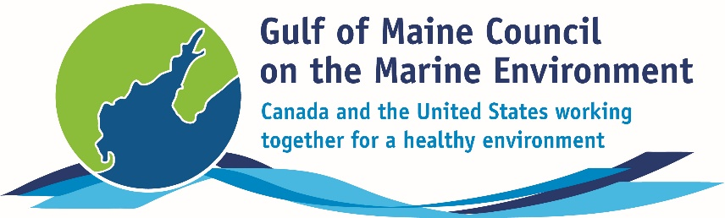**2016**

**Visionary Award**

**Nomination Form**

The Gulf of Maine Visionary Award is presented annually to an individual or organization within each of the five Gulf of Maine jurisdictions of Massachusetts, New Hampshire, Maine, New Brunswick, and Nova Scotia. These awards recognize innovation, creativity, and commitment to marine protection by businesses, environmental organizations, or individuals who are making a difference to the health of the Gulf of Maine.

**Nomination instructions**

1. 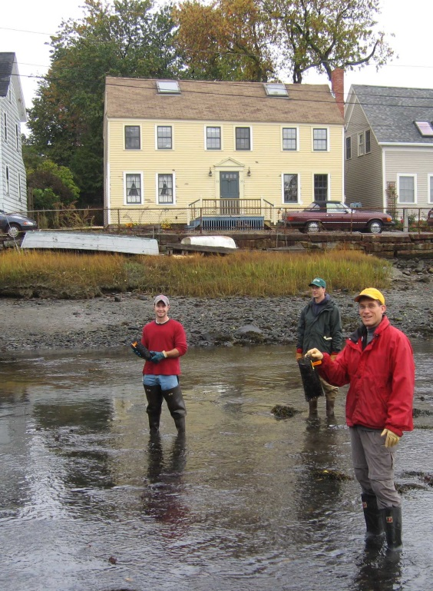Individuals or organizations may make nominations. Self-nominations are not accepted.
2. The nominee must be a resident of (or an organization / company based in) Maine, Massachusetts, New Brunswick, New Hampshire, or Nova Scotia. The nominee’s contributions must have occurred in the Gulf of Maine watershed.
3. Visionary Award nominees may be paid professionals or volunteers.
4. Nominations must be made on this nomination form. Nominations with missing information will not be considered. Please provide all information on this form. Attachments will not be accepted.
5. Nominations must be emailed to [jleblanc@gulfofmaine.org](mailto:jleblanc@gulfofmaine.org) by the close of business on **March 31, 2016**. Please rename the nomination form with _LastNameofNominee added to the end of the file name.

|  |
| --- |
| **Questions?** Please contact Council Coordinator Joan LeBlanc at [jleblanc@gulfofmaine.org](mailto:jleblanc@gulfofmaine.org).  To view a list of past award winners, please visit: <http://www.gulfofmaine.org/2/gomc-home/awards/> |

|  |  |
| --- | --- |
| **Nominee information (REQUIRED)**  Name (as it would appear on the award plaque if selected): Dwayne Shaw  Mailing address: PO Box 201, Columbia Falls, ME 04476  Phone: 207-483-4336  Email: dwayne@mainesalmonrivers.org |  |
| **Brief background on why the individual/organization is being nominated (REQUIRED):**  Dwayne has been a leader in river and fisheries restoration in Eastern Maine for decades, starting long before he became Executive Director or the Downeast Salmon Federation (DSF). He has been director of DSF for 15 years, and has been with the organization since 1989. In that time he has been involved in and led a number of fish passage projects, dam removals, and repurposing old hydro facilities into hatcheries and community hubs for conservation education and outreach. He is deeply respected by partners and his community and understands the importance of collaboration. He helped found the Downeast Fisheries Partnership, a working collaboration of like-minded organizations includes DSF, Penobscot East Resource Center, Maine Coast Heritage Trust, Sunrise County Economic Council, Manomet, and a growing list of organizations and individuals. Dwayne’s continuing efforts and growing list of collaborators will continue to pay dividends for the Gulf of Maine ecosystem. Just this year he was involved in the acquisition of a dam on the Orange River that flows into Cobscook Bay and once boasted a diverse run of anadromous fishes. He is part of plans to restore passage on this critical system. |  |
| **Summary that will be read during the awards ceremony if nominee is selected. This text will also be used in media releases (not to exceed 2,000 characters, including spaces and punctuation - REQUIRED):**  Dwayne Shaw has been with the Downeast Salmon Federation since 1989 and its Executive Director for 15 years. He has forged DSF into a powerhouse for anadromous fisheries restoration in eastern Maine. With dam removals on the Pleasant and East Machias Rivers, and conversion of former hydro facilities into hatcheries and a true community hub for conservation activities in eastern Maine.  Dwayne as championed a holistic approach to salmon restoration, and understands better than just about anyone the importance of restoring the whole range of anadromous fisheries.  He has helped keep eastern Maine’s commercial smelt fishery open and worked to restore river herring throughout the area, working with local partners and leaders.  Dwayne has also spearheaded DSF’s role in community outreach and education related to fisheries, including summer programs for high schoolers, a “hooks and ladders” classroom program, and getting students involved in the release of juvenile salmon. Knowing the best way to the heart is through the stomach, he has also added a mobile smokehouse to bring smoked alewives to the masses and raise awareness of critical river herring resources in eastern Maine.  Dwayne has raised considerable funding for habitat restoration, and in particular, improvements in fish passage. Just this year, DSF moved forward on purchasing a dam on the Orange River in Whiting, a move that will eventually allow fish to pass upstream in that system for the first time in decade.  For all this and all of the great work yet to come we are proud to nominate Dwayne Shaw for the Gulf of Maine Council on the Marine Environment Visionary Award. |  |
| **Name and contact information of person making the nomination (REQUIRED):**  Name: Robin Alden  Affiliation: Executive Director, Penobscot East Resource Center  Address: PO Box 27, Stonington, ME 04681  Phone: 207-367-2708  Email: robin@penobscoteast.org |  |