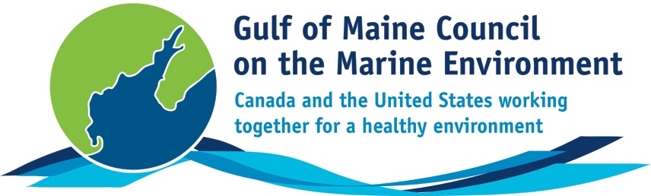**2016**

**Visionary Award**

**Nomination Form**

The Gulf of Maine Visionary Award is presented annually to an individual or organization within each of the five Gulf of Maine jurisdictions of Massachusetts, New Hampshire, Maine, New Brunswick, and Nova Scotia. These awards recognize innovation, creativity, and commitment to marine protection by businesses, environmental organizations, or individuals who are making a difference to the health of the Gulf of Maine.

**Nomination instructions**

1. 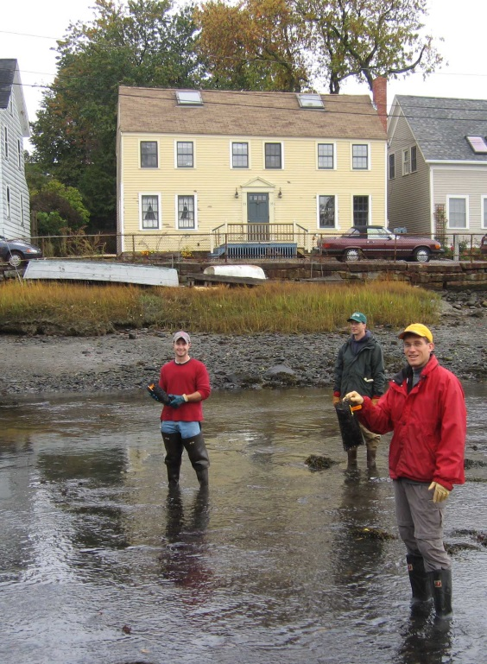Individuals or organizations may make nominations. Self-nominations are not accepted.
2. The nominee must be a resident of (or an organization / company based in) Maine, Massachusetts, New Brunswick, New Hampshire, or Nova Scotia. The nominee’s contributions must have occurred in the Gulf of Maine watershed.
3. Visionary Award nominees may be paid professionals or volunteers.
4. Nominations must be made on this nomination form. Nominations with missing information will not be considered. Please provide all information on this form. Attachments will not be accepted.
5. Nominations must be emailed to [jleblanc@gulfofmaine.org](mailto:jleblanc@gulfofmaine.org) by the close of business on **March 31, 2016**. Please rename the nomination form with _LastNameofNominee added to the end of the file name.

|  |
| --- |
| **Questions?** Please contact Council Coordinator Joan LeBlanc at [jleblanc@gulfofmaine.org](mailto:jleblanc@gulfofmaine.org).  To view a list of past award winners, please visit: <http://www.gulfofmaine.org/2/gomc-home/awards/> |

|  |  |
| --- | --- |
| **Nominee information (REQUIRED)**  Name (as it would appear on the award plaque if selected): Dwayne Shaw, Executive Director, Downeast Salmon Federation  Mailing address: PO Box 201 (187 Main St.), Columbia Falls, ME 04623  Phone: 207-483-4336  Email: Dwayne@mainesalmonrivers.org |  |
| **Brief background on why the individual/organization is being nominated (REQUIRED):**  Dwayne has been with the Downeast Salmon Federation since 1989 (Executive Director since 2001).  He has overseen the growth of the organization into a powerhouse for fisheries restoration in eastern Maine. First came removal of the dam on the Pleasant River and conversion of the hydrofacility into a salmon hatchery, research center and the organization’s headquarters.  Next came removal of the dam on the East Machias River and conversion of that hydrofacility into a state of the art salmon conservation hatchery, a demonstration site for alternative energy, a community center, and a hub for conservation activities in eastern Maine.  Dwayne has a passion for salmon restoration and recognizes that success will require restoring the full range of anadromous fish, particularly alewives, a keystone species in eastern Maine’s aquatic ecosystems. He led the fight to keep eastern Maine’s commercial smelt fishery open and has taken on documenting and monitoring many of eastern Maine’s smelt streams. His work on fisheries recognizes the importance of commercial fishing to the maintenance and stewardship of eastern Maine’s heritage fisheries and the critical role of local knowledge in their effective management.  Community engagement is central to Dwayne’s strategies for restoring eastern Maine’s rivers. He has developed and implemented a series of outreach and education programs focused on creating connections between people and their environment and promoting local stewardship. These range from classroom-based programs and EMARC field trips to volunteer-based alewife monitoring and public events. Under Dwayne’s leadership, DSF’s annual smelt fry has grown into a regional event with 400+ attendance.  Dwayne has been at the forefront of fisheries habitat restoration in eastern Maine; through his efforts - negotiating with landowners, designing projects and fund raising. He has had a hand – literally and figuratively – in the fish passage that has been achieved at many perched culverts, dams and nonfunctioning fish ladders in eastern Maine.  Just recently, and after many years of negotiation with the dam owner, Dwayne signed a purchase and sale agreement for the dam in Whiting, a signal achievement that will eventually allow fish to pass up the Orange River for the first time in forty plus years.  In a related effort, Dwayne has joined forces with the Sunrise County Economic Council, Washington County Council of Governments, and the Maine Coast Heritage Trust to create the Downeast Sustainability Project; the goal is to engage Whiting and the surrounding area in a planning effort built on the opportunities presented by a restored river herring fishery.  Dwayne has always been more concerned about restoring fish than in building a bigger organization or personal reputation. In addition to the Downeast Sustainability project, Dwayne was a founding partner in the Downeast Fisheries Partnership, a network of groups focused on rebuilding fisheries so that the communities of eastern Maine can sustain themselves forever.  As another example, Dwayne has used his considerable networking skills to assemble a powerful coalition of groups, including state and federal agencies, fisheries groups and the Passamaquoddy tribe; they are working to ensure that fish passage is addressed in the upcoming relicensing of the hydroelectric facility on the Union River in Ellsworth.  Dwayne is or has been a member of several fisheries-related boards and advisory committees including Maine Sea Grant Public Advisory Committee, Federal Recovery Team for Endangered Atlantic Salmon and the University of Maine at Machias Board of Visitors. |  |
| **Summary that will be read during the awards ceremony if nominee is selected. This text will also be used in media releases (not to exceed 2,000 characters, including spaces and punctuation - REQUIRED):**  Dwayne Shaw has led the fight for fisheries restoration in eastern Maine for 25+ years. Undaunted by the challenge, he has made Downeast Salmon Federation into a powerhouse for community engagement, fisheries conservation, environmental research, and community education. Dwayne has championed fisheries restoration, including replacement of perched culverts, installation of state-of-the-art fish ladders, advocacy in dam relicensing and stocking with river specific Atlantic salmon. He has partnered with many groups - including many types of groups - to scale up the impact of restoration efforts. Today, there is new hope that fisheries will once again provide livelihoods, recreation and food for the people of eastern Maine. Dwayne Shaw is no small part of that achievement and he shows no sign of slowing down! |  |
| **Name and contact information of person making the nomination (REQUIRED):**  Name: Anne Hayden  Affiliation: Manomet/Downeast Fisheries Partnership  Address: 41 Maine St., Suite 410, Brunswick, ME 04011  Phone: 207-725-9742  Email: ahayden@manomet.org |  |