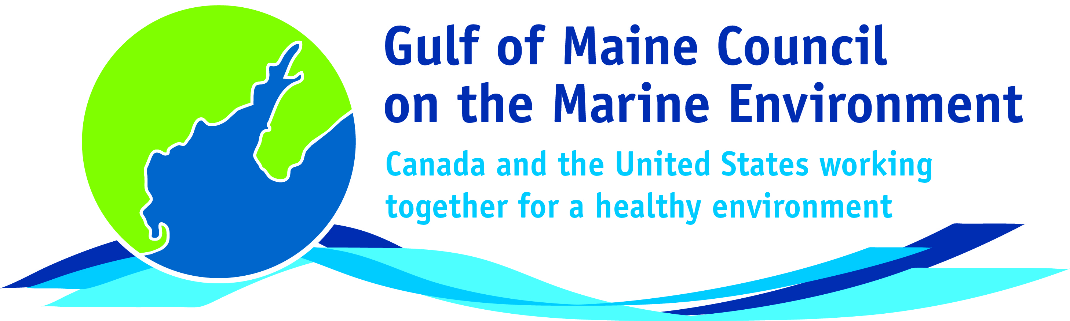**2016**

**Visionary Award**

**Nomination Form**

The Gulf of Maine Visionary Award is presented annually to an individual or organization within each of the five Gulf of Maine jurisdictions of Massachusetts, New Hampshire, Maine, New Brunswick, and Nova Scotia. These awards recognize innovation, creativity, and commitment to marine protection by businesses, environmental organizations, or individuals who are making a difference to the health of the Gulf of Maine.

**Nomination instructions**

1. 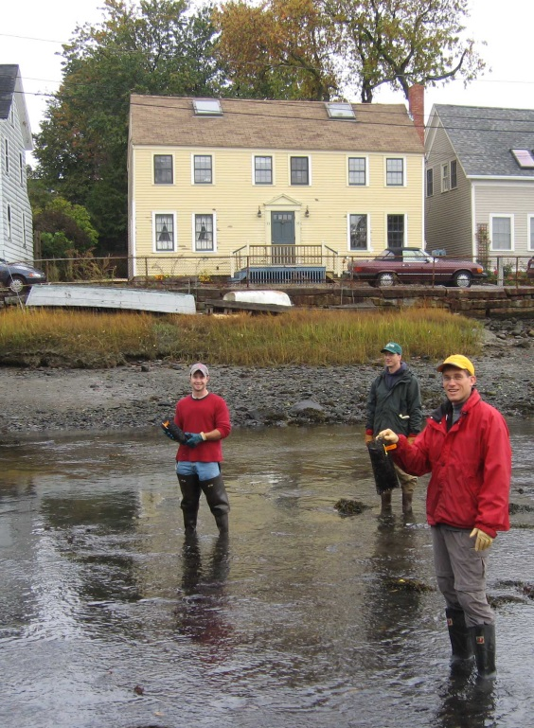Individuals or organizations may make nominations. Self-nominations are not accepted.
2. The nominee must be a resident of (or an organization / company based in) Maine, Massachusetts, New Brunswick, New Hampshire, or Nova Scotia. The nominee’s contributions must have occurred in the Gulf of Maine watershed.
3. Visionary Award nominees may be paid professionals or volunteers.
4. Nominations must be made on this nomination form. Nominations with missing information will not be considered. Please provide all information on this form. Attachments will not be accepted.
5. Nominations must be emailed to [jleblanc@gulfofmaine.org](mailto:jleblanc@gulfofmaine.org) by the close of business on **March 31, 2016**. Please rename the nomination form with _LastNameofNominee added to the end of the file name.

|  |
| --- |
| **Questions?** Please contact Council Coordinator Joan LeBlanc at [jleblanc@gulfofmaine.org](mailto:jleblanc@gulfofmaine.org).  To view a list of past award winners, please visit: <http://www.gulfofmaine.org/2/gomc-home/awards/> |

|  |  |
| --- | --- |
| **Nominee information (REQUIRED)**  Name (as it would appear on the award plaque if selected): Dwayne Shaw  Mailing address: PO Box 201 Columbia Falls, ME 04476  Phone: 207-483-4336  Email: Dwayne@mainesalmonrivers.org |  |
| **Brief background on why the individual/organization is being nominated (REQUIRED):**  Dwayne Shaw has been with the Downeast Salmon Federation since 1989 (Executive Director since 2001).  He has overseen the growth of the organization into a powerhouse for fisheries restoration in eastern Maine. First came removal of the dam on the Pleasant River and conversion of the hydrofacility into a salmon hatchery, research center and the organization’s headquarters.  Next came removal of the dam on the East Machias River and conversion of that hydrofacility into a state of the art salmon conservation hatchery, a demonstration site for alternative energy, a community center, and a hub for conservation activities in eastern Maine.  Dwayne as championed a wholistic approach to salmon restoration, fighting for restoration of aquatic ecosystems and a whole range of anadromous fisheries.  He led the fight to keep eastern Maine’s commercial smelt fishery open and has taken on documenting and monitoring many of eastern Maine’s smelt streams. His work on fisheries recognizes the importance of commercial fishing to the maintenance and stewardship of eastern Maine’s heritage fisheries and the critical role of local knowledge in their effective management.  He has spearheaded DSF’s role in community outreach and education related to fisheries, running summer programs for high school students, a “hooks and ladders” classroom program, and engagement of students in fin clipping and release of juvenile salmon raised in the hatchery. This year, he has added a mobile smokehouse to DSF’s outreach toolbox and will be bringing bloaters to communities in eastern Maine to raise awareness of the state of river herring resources in eastern Maine. Under his leadership, DSF’s annual smelt fry has grown into a regional event with 400+ attendance.  Dwayne has raised considerable funding for habitat restoration, and in particular, improvements in fish passage. Fish passage has been achieved at perched culverts, dams and nonfunctioning fish ladders.  After many years of negotiation with the dam owner, DSF has signed a purchase and sale agreement for the dam in Whiting, a signal achievement that will eventually allow fish to  pass up the Orange River for the first time in forty plus years.  In a related effort, Dwayne has joined forces with the SCEC, WCCOG, and the Maine Coast Heritage Trust to engage Whiting and the surrounding area in a planning effort built on the opportunities presented by a restored river herring fishery.  Dwayne has used his considerable networking skills to assemble a powerful coalition of groups, including state and federal agencies, fisheries groups and the Passamaquoddy tribe; they are working to ensure that fish passage is addressed in the relicensing of the hydroelectric facility on the Union River in Ellsworth.  Dwayne has built a relationship with the Passamaquoddies; he was one of only two non native americans asked to speak at recent conference of Maine’s native american tribes.  Dwayne is or has been a member of several fisheries-related boards and advisory committees including Maine Sea Grant Public Advisory Committee, Federal Recovery Team for Endangered Atlantic Salmon and the University of Maine at Machias Board of Visitors.  Last but not least, DSF, under Dwayne’s leadership, is a founding partner in Downeast Fisheries Partnership and a founding site on the Downeast Fisheries Trail. |  |
| **Summary that will be read during the awards ceremony if nominee is selected. This text will also be used in media releases (not to exceed 2,000 characters, including spaces and punctuation - REQUIRED):**  Dwayne has been with the Downeast Salmon Federation since 1989 (Executive Director since 2001).  He has overseen the growth of the organization into a powerhouse for fisheries restoration in eastern Maine. First came removal of the dam on the Pleasant River and conversion of the hydrofacility into a salmon hatchery, research center and the organization’s headquarters.  Next came removal of the dam on the East Machias River and conversion of that hydrofacility into a state of the art salmon conservation hatchery, a demonstration site for alternative energy, a community center, and a hub for conservation activities in eastern Maine. Dwayne has championed a wholistic approach to salmon restoration, fighting for restoration of aquatic ecosystems and a whole range of anadromous fisheries. His work on fisheries recognizes the importance of commercial fishing to the maintenance and stewardship of eastern Maine’s heritage fisheries and the critical role of local knowledge in their effective management. He has spearheaded DSF’s role in community outreach and education related to fisheries, running summer programs for high school students, a “hooks and ladders” classroom program, and engagement of students in fin clipping and release of juvenile salmon raised in the hatchery. Under his leadership, DSF’s annual smelt fry has grown into a regional event with 400+ attendance. Dwayne has raised considerable funding for habitat restoration, and in particular, improvements in fish passage. Dwayne has used his considerable networking skills to assemble a powerful coalition of groups, including state and federal agencies, fisheries groups and the Passamaquoddy tribe, that are working together to ensure that fish passage is addressed in the relicensing of the hydroelectric facility on the Union River in Ellsworth. DSF, under Dwayne’s leadership, is a founding partner in the Downeast Fisheries Partnership and a founding site on the Downeast Fisheries Trail. |  |
| **Name and contact information of person making the nomination (REQUIRED):**  Name: Natalie Springuel  Affiliation: Maine Sea Grant  Address: 105 Eden St, Bar Harbor, ME 04609  Phone: 207-288-2944 ext 5834  Email: nspringuel@coa.edu |  |