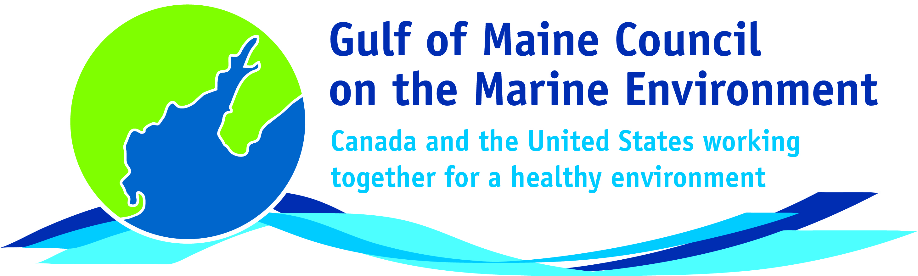**2016**

**Visionary Award**

**Nomination Form**

The Gulf of Maine Visionary Award is presented annually to an individual or organization within each of the five Gulf of Maine jurisdictions of Massachusetts, New Hampshire, Maine, New Brunswick, and Nova Scotia. These awards recognize innovation, creativity, and commitment to marine protection by businesses, environmental organizations, or individuals who are making a difference to the health of the Gulf of Maine.

**Nomination instructions**

1. 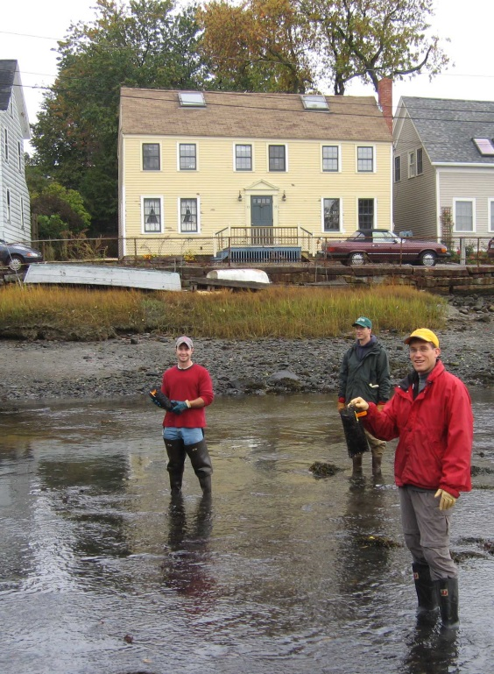Individuals or organizations may make nominations. Self-nominations are not accepted.
2. The nominee must be a resident of (or an organization / company based in) Maine, Massachusetts, New Brunswick, New Hampshire, or Nova Scotia. The nominee’s contributions must have occurred in the Gulf of Maine watershed.
3. Visionary Award nominees may be paid professionals or volunteers.
4. Nominations must be made on this nomination form. Nominations with missing information will not be considered. Please provide all information on this form. Attachments will not be accepted.
5. Nominations must be emailed to [jleblanc@gulfofmaine.org](mailto:jleblanc@gulfofmaine.org) by the close of business on **March 31, 2016**. Please rename the nomination form with _LastNameofNominee added to the end of the file name.

|  |
| --- |
| **Questions?** Please contact Council Coordinator Joan LeBlanc at [jleblanc@gulfofmaine.org](mailto:jleblanc@gulfofmaine.org).  To view a list of past award winners, please visit: <http://www.gulfofmaine.org/2/gomc-home/awards/> |

|  |  |
| --- | --- |
| **Nominee information (REQUIRED)**  Name (as it would appear on the award plaque if selected): Linda Schier  Mailing address: PO Box 235, Union, NH, 03887  Phone: (603) 473-2500  Email: lindaschier@awwatersheds.org |  |
| **Brief background on why the individual/organization is being nominated (REQUIRED):**  Linda Schier is the Executive Director for the Acton Wakefield Watersheds Alliance (AWWA). In her work, Linda Schier brings lakes in the Acton-Wakefield region of Main and New Hampshire to the attention of many including municipalities, local businesses, educational institutions, governmental agencies, residents, visitors, and students. She organizes hundreds of volunteers to monitor water quality, conduct lake clean ups, assess watersheds, and install stormwater management practices. Lakes and communities in the AWWA region have benefited greatly from Linda’s dedication and patience.  Link to AWWA’s web site: <http://awwatersheds.org/> |  |
| **Summary that will be read during the awards ceremony if nominee is selected. This text will also be used in media releases (not to exceed 2,000 characters, including spaces and punctuation - REQUIRED):**  In her work as the Executive Director for the Acton Wakefield Watersheds Alliance (AWWA), Linda Schier brings lakes in the Acton-Wakefield region of Maine and New Hampshire to the attention of many including municipalities, local businesses, educational institutions, governmental agencies, residents, visitors, and students. Lakes and communities in the AWWA region have benefited greatly from Linda’s dedication and patience.  In 2005, Linda founded the AWWA Youth Conservation Corps (YCC) to provide summer jobs in lake conservation for local youth. Under Linda’s guidance, AWWA’s YCC has installed over 750 stormwater management practices that have prevented tons of sediment and many pounds of phosphorus from reaching lakes. She has also served as the leader for two significant watershed management planning efforts for Province Lake and the Salmon Falls headwaters lakes. During the projects, Linda brought diverse stakeholders together to analyze watershed data and recommend specific actions for reducing pollutant loads to the lakes. Linda is now implementing recommendations from the plans through stormwater management projects on local roads, land conservation outreach, septic system programs, and other efforts. The full list of Linda’s accomplishments is simply too long to include…starting Weed Watcher Programs, organizing water quality monitoring volunteers, hosting special interest workshops, advocating for lake protection at town board meetings, organizing educational events and lake clean ups, conducting watershed assessments, leading hands-on school programs, and so on; if a lake has a programmatic or scientific need, Linda finds a way to fill it.  Linda does not shy away from the technical, environmental, and social challenges inherent in lake protection work; instead, she embraces challenge and works diligently to find common ground among all of her partners. Linda is a tireless fighter for lakes. She simply does not give up. When she encounters a challenge, she digs in harder. Through Linda’s enthusiasm and curiosity, she motivates others to care about lakes too. Her passion, creativity, and deep knowledge and understanding of lakes and people have earned her the respect of many. We are greatly thankful for her leadership and dedication. |  |
| **Name and contact information of person making the nomination (REQUIRED):**  Name: Sally Soule, Coastal Watershed Supervisor  Affiliation: NH Department of Environmental Services  Address: 222 International Drive, Suite 175, Portsmouth, NH 03801  Phone: 603-559-0032  Email: sally.soule@des.nh.gov |  |