**2016**

**Visionary Award**

**Nomination Form**

The Gulf of Maine Visionary Award is presented annually to an individual or organization within each of the five Gulf of Maine jurisdictions of Massachusetts, New Hampshire, Maine, New Brunswick, and Nova Scotia. These awards recognize innovation, creativity, and commitment to marine protection by businesses, environmental organizations, or individuals who are making a difference to the health of the Gulf of Maine.

**Nomination instructions**

1. 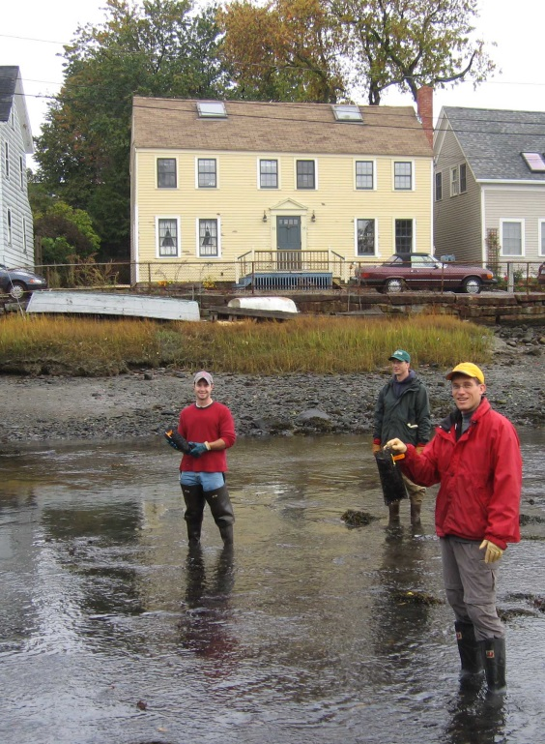Individuals or organizations may make nominations. Self-nominations are not accepted.
2. The nominee must be a resident of (or an organization / company based in) Maine, Massachusetts, New Brunswick, New Hampshire, or Nova Scotia. The nominee’s contributions must have occurred in the Gulf of Maine watershed.
3. Visionary Award nominees may be paid professionals or volunteers.
4. Nominations must be made on this nomination form. Nominations with missing information will not be considered. Please provide all information on this form. Attachments will not be accepted.
5. Nominations must be emailed to [jleblanc@gulfofmaine.org](mailto:jleblanc@gulfofmaine.org) by the close of business on **March 31, 2016**. Please rename the nomination form with _LastNameofNominee added to the end of the file name.

|  |
| --- |
| **Questions?** Please contact Council Coordinator Joan LeBlanc at [jleblanc@gulfofmaine.org](mailto:jleblanc@gulfofmaine.org).  To view a list of past award winners, please visit: <http://www.gulfofmaine.org/2/gomc-home/awards/> |

|  |  |
| --- | --- |
| **Nominee information (REQUIRED)**  Name (as it would appear on the award plaque if selected):  Mailing address:  Phone:  Email: |  |
| **Brief background on why the individual/organization is being nominated (REQUIRED):** |  |
| **Summary that will be read during the awards ceremony if nominee is selected. This text will also be used in media releases (not to exceed 2,000 characters, including spaces and punctuation - REQUIRED):** |  |
| **Name and contact information of person making the nomination (REQUIRED):**  Name:  Affiliation:  Address:  Phone:  Email: |  |