**2018**

**Industry Award**

**Nomination Form**

The Gulf of Maine Council’s Industry Award is made annually to an individual, company, or organization within the Gulf of Maine region (Massachusetts, New Hampshire, Maine, New Brunswick, and Nova Scotia). This award recognizes demonstrated innovation and leadership in efforts to improve the well-being of the Gulf of Maine ecosystem and the communities that call it home. Nominations are sought from the following sectors: tourism; fisheries (commercial and recreational); aquaculture (finfish and shellfish); renewable energy generation (tidal, wave and wind); and / or transportation (shipping, ferries, etc.).

**Nomination instructions**

1. 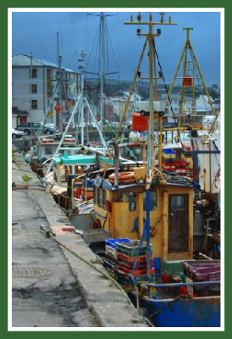Individuals or organizations may make nominations. Self-nominations are not accepted.
2. The nominee must be a resident of (or a company or organization doing business in) Maine, Massachusetts, New Brunswick, New Hampshire, or Nova Scotia. The nominee’s contributions must have occurred in the Gulf of Maine watershed.
3. Industry Award nominees may be paid professionals or volunteers.
4. Nominations must be made on this nomination form. Nominations with missing information will not be considered. Please provide all information on this form. Attachments will not be accepted.
5. Nominations must be emailed to [jleblanc@gulfofmaine.org](mailto:jleblanc@gulfofmaine.org) by Friday, **March 30, 2018**. Please rename the nomination form with _LastNameofNominee added to the end of the file name.

|  |
| --- |
| **Questions?** Please contact Council Coordinator Joan LeBlanc at [jleblanc@gulfofmaine.org](mailto:jleblanc@gulfofmaine.org).  To view a list of past award winners, please visit: <http://www.gulfofmaine.org/2/gomc-home/awards/> |

|  |  |
| --- | --- |
| **Nominee information (REQUIRED)**  Name (as it would appear on the award plaque if selected):  Contact Name (if different than above):  Mailing address:  Phone:  Email: |  |
| **Summary highlighting why the individual or organization is being nominated. This summary will be read during the awards ceremony and text will be used in media releases if the nominee is selected. (REQUIRED)**  *Please be sure that summary does not exceed 2,000 characters, including spaces and punctuation.* |  |
| **Name and contact information of person making the nomination (REQUIRED)**  Name:  Affiliation:  Address:  Phone:  Email: |  |