**2018**

**Longard Award**

**Nomination Form**

The Longard Award is bestowed upon an outstanding volunteer each year in memory of Art Longard, a founding member of the Gulf of Maine Council on the Marine Environment and long-time Working Group member. This award is given to an individual from one of the five states and provinces bordering the Gulf of Maine. The Longard Award recognizes individual commitment to volunteer programs dedicated to environmental protection and sustainability of natural resources within the marine, near shore, and watershed environments of the Gulf of Maine.

#### Nomination instructions

* 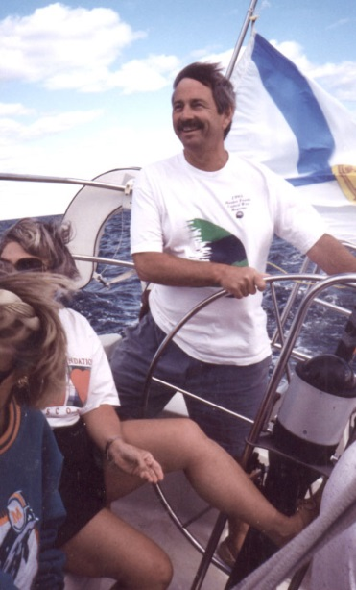Individuals or organizations may submit nominations. Self-nominations are not accepted.
* The nominee must be a resident of Maine, Massachusetts, New Brunswick, New Hampshire, or Nova Scotia. The nominee’s contributions must have been to the Gulf of Maine watershed.
* Longard Award nominees must have contributed to the Gulf of Maine in their capacity as a volunteer, **NOT** as a paid professional.
* Nominations must be made on this form. Attachments will not be accepted.
* Nominations must be emailed to [jleblanc@gulfofmaine.org](mailto:jleblanc@gulfofmaine.org) by Friday, **March 30, 2018**. Please rename the nomination form with _LastNameofNominee added to the end of the file name.

|  |
| --- |
| Questions? Please contact Council Coordinator Joan LeBlanc at [jleblanc@gulfofmaine.org](mailto:jleblanc@gulfofmaine.org).  To view a list of past award winners, please visit: <http://www.gulfofmaine.org/2/gomc-home/awards/> |

|  |  |
| --- | --- |
| **Nominee information (REQUIRED)**  Name (as it would appear on the award plaque if selected):  Mailing address:  Phone:  Email: |  |
| **Summary highlighting why the individual or organization is being nominated. This summary will be read during the awards ceremony and text will be used in media releases if the nominee is selected. (REQUIRED)**  *Please be sure that summary does not exceed 2,000 characters, including spaces and punctuation.* |  |
| **Name and contact information of person making the nomination (REQUIRED)**  Name:  Affiliation:  Address:  Phone:  Email: |  |