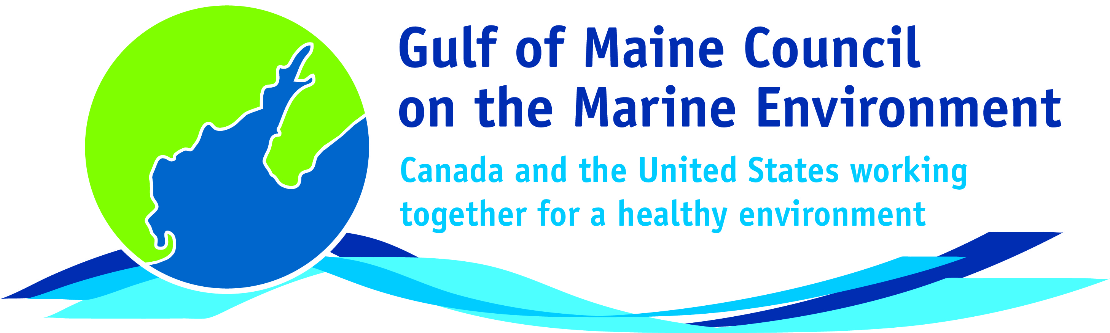**2018**

**Sustainable Communities**

**Award Nomination Form**

The **Sustainable Communities Award** recognizes communities, or groups within communities, for their exemplary work in achieving sustainability outcomes related to the environment and economy, in line with the objectives of the GOMC Action Plan. The selection criteria are derived from the Melbourne Principles and the Government of New Brunswick’s Community Recognition Award selection criteria.

1. Provides a **long-term vision** for communities based on pillars of sustainability: social /cultural, environmental and economic, as well as political equity, and the community’s individuality.
2. Works towards achieving **long-term economic, social, and environmental security**.
3. Recognizes the **intrinsic value of biodiversity and natural ecosystems**, and acts to promote the stewardship of biodiversity and natural ecosystems, and protects and/or restores them.
4. Strives to enable communities to **minimize their ecological footprint**.
5. **Engages the community** in the planning and implementation of sustainable solutions.
6. Builds on the **characteristics of ecosystems** in the development and nurturing of healthy and sustainable communities.
7. Recognizes and builds on the distinctive characteristics of the community, including their **human and cultural values**, history, and natural systems.
8. **Empowers people** and **fosters participation**.
9. Expands and **enables communication and cooperative networks** to work towards sustainability as a common and shared goal.
10. Promotes **sustainable production and consumption**, through appropriate use of environmentally sound technologies and effective demand management.
11. Enables **continual improvement**, based on action planning, accountability, transparency and good governance.

**Overarching Program Criteria**

Nominations should demonstrate that the community, group, program, or project contributed to the long-term viability of the community, improved the health of its immediate environment, and had a positive impact on the health of the Gulf of Maine.

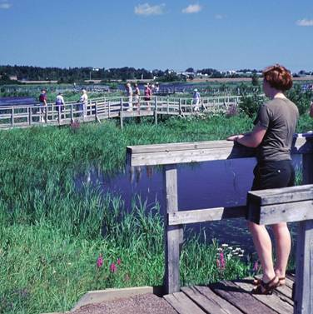**Nomination instructions**

1. Individuals or organizations may make nominations. Self-nominations are not accepted.
2. The community must be based in part or in whole in Maine, Massachusetts, New Brunswick, New Hampshire, or Nova Scotia. The nominee’s contributions must have occurred in the Gulf of Maine watershed.
3. Nominations must be made on this nomination form. This form may be reproduced electronically. Nominations with missing information will not be considered. Please provide all information on this form. Attachments will not be accepted.
4. Nominations must be emailed to [jleblanc@gulfofmaine.org](mailto:jleblanc@gulfofmaine.org) by Friday, **March 30, 2018**. Please rename the nomination form with _LastNameofNominee added to the end of the file name.

|  |
| --- |
| **Questions?** Please contact Council Coordinator Joan LeBlanc at [jleblanc@gulfofmaine.org](mailto:jleblanc@gulfofmaine.org).  To view a list of past award winners, please visit: <http://www.gulfofmaine.org/2/gomc-home/awards/> |

|  |  |
| --- | --- |
| **Nominee information (REQUIRED)**  Name (as it would appear on the award plaque if selected):  Nominee Contact Name (if different than above):  Mailing address:  Phone:  Email: |  |
| **Summary highlighting why the individual or organization is being nominated. This summary will be read during the awards ceremony and text will be used in media releases if the nominee is selected. (REQUIRED)**  *Please be sure that summary does not exceed 2,000 characters, including spaces and punctuation.* |  |
| **Name and contact information of person making the nomination (REQUIRED)**  Name:  Affiliation:  Address:  Phone:  Email: |  |