Northeast Coastal Indicators Workshop

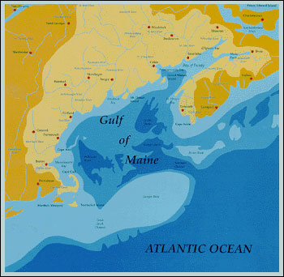

January 6-8, 2004

New England Center, Durham, NH

Sponsored By:
 |  | 
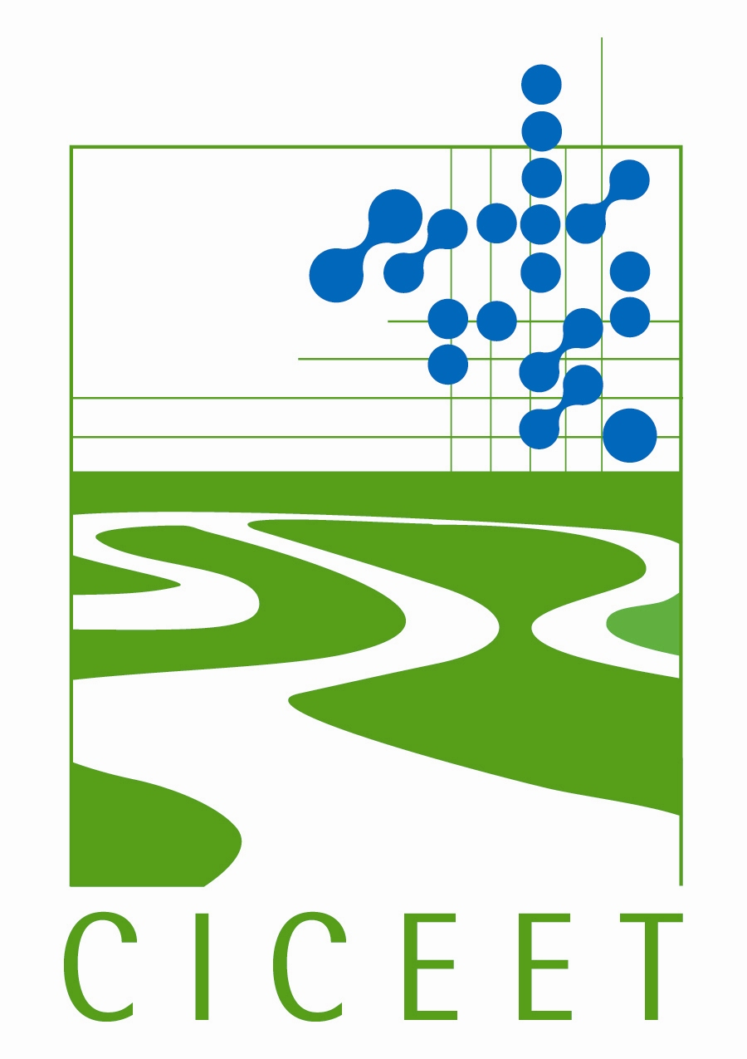 |  | 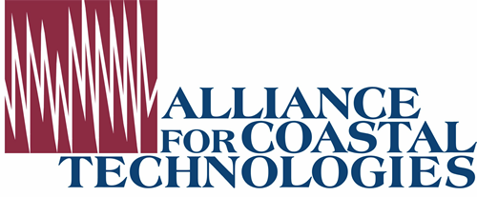
 | 

[Return to Northeast Coastal Indicators Workshop Home Page]

Agenda
Vision for the region – A sustainable Northeast Atlantic ecosystem that ensures environmental integrity and that supports and is supported by economically viable, healthy human communities.
Mission for regional indicators – To track the status and trends in ecosystem integrity throughout the Northeast Atlantic region through collaborative partnerships. To provide information for management decisions at regional and local scales.

Indicators Workshop Goal – Consensus on a list of key indicators for which regional data will be compiled and tracked to indicate changing trends in ecosystem integrity through the Northeast Atlantic region.
This workshop will:
- Review present efforts to coordinate monitoring and indicator development throughout the region.
- Develop indicators that apply to the northeast coastal region of the United States (from New York to Maine) and Canada (Gulf of Maine) under six categories: fisheries, eutrophication, contaminants, coastal development, aquatic habitat, and climate change.
- Report its findings to senior environmental policy managers and discuss how these indicators might be incorporated into programs throughout the region in the near future.

Day 1: Tuesday, January 6, 2004
11:00 - 1:00 Registration
1:00 - 1:30 Workshop Welcome, Introductions, and Charge to Workshop
1:30 – 1:50 Review of Progress in Implementing December 2002 Monitoring
Workshop Recommendations
1:50 – 2:10 Role of the National Coastal Assessment and Findings
2:10 – 2:30 Governors’ responses to the US Ocean Commission Report
2:30 – 3:00 Results of Fall 2003 Indicators Survey
3:00 – 3:15 Break
3:15 – 4:00 Keynote Speaker - Dr. Ken Sherman, NMFS – International Large
Marine Ecosystem Program in Relation to the Northeast
4:00 – 4:30 Charge to the Breakout Sessions
5:00 – 6:30 Poster Session & Reception
6:30 Dinner

Day 2: Wednesday, January 7, 2004
7:30 – 8:30 Continental Breakfast
8:00 – 3:30 Developing Regional Indicators -- Breakout Sessions
Workshop participants will be divided into six topics: fisheries, contaminants, eutrophication, aquatic habitat, coastal development, and climate change. Each breakout session will discuss questions and indicators developed during pre-workshop activities by experts in each area.
Approximate schedule:
8:00 - 10:00 Session #1
10:00 - 10:15 Break
10:15 - 12:15 Session #2
12:15 - 1:30 Lunch
1:30 - 3:30 Session # 3
3:30 – 3:45 Break
3:45 - 5:00 Keynote speaker Congressman Tom Allen, Maine
Congressman Tom Allen of Maine is a co-chair of the bipartisan House Oceans Caucus. He also serves on the subcommittees on Energy & Air Quality and Environment & Hazardous Materials.
5:00 - 6:30 Evening Reception
6:30 Dinner

Day 3: Thursday, January 8, 2004
7:30 - 8:00 Continental Breakfast
8:00 - 9:30 Report Out from each Break-out Session
9:30 - 11:30 Senior Management Panel
A panel of senior environmental policy managers will be convened to discuss the findings of the workshop and how they might be incorporated into future regional environmental management efforts. Panel members committed to participate include:
- Mr. Robert Varney, EPA Region 1
- Dr. Michael Sissenwine, NOAA;
- Mr. Byron James, New Brunswick Department of Environment and Local Government - Deputy Minister of Agriculture, Fisheries, and Aquaculture;
- Faith Scattalon, Fisheries and Oceans, Canada
- Ms. Priscilla Brooks, Conservation Law Foundation
- Secretary Ellen Herzfelder, Executive Office of Environmental Affairs, Massachusetts DEP
- Dr. Rick Spinrad, National Ocean Service
11:30 - 12:00 Closing Remarks

