Northeast Coastal Indicators Workshop

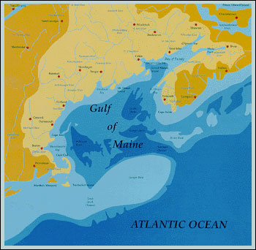

January 6-8, 2004

New England Center, Durham, NH

Sponsored By:
 |  | 
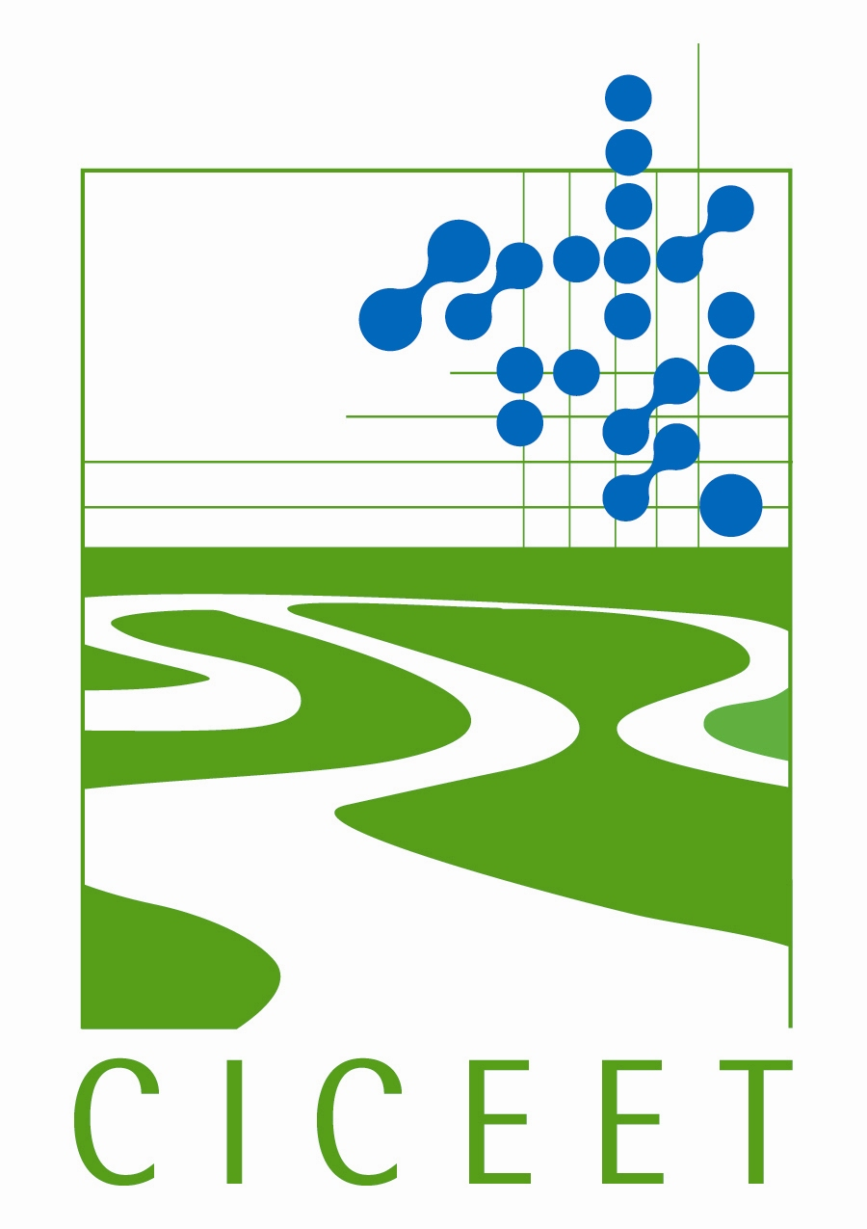 | 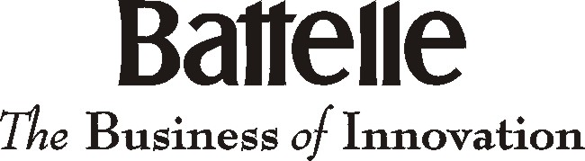 | 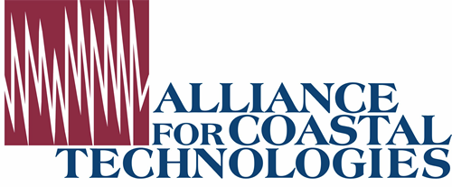
 | 

Agenda
Vision for the region – A sustainable Northeast Atlantic ecosystem that ensures environmental integrity and that supports and is supported by economically viable, healthy human communities.
Mission for regional indicators – To track the status and trends in ecosystem integrity throughout the Northeast Atlantic region through collaborative partnerships. To provide information for policy, management and advocacy decisions at regional and local scales.

Indicators Workshop Goal – Consensus on a list of key indicators for which regional data will be compiled and tracked to indicate changing trends in ecosystem integrity through the Northeast Atlantic region.
This workshop will:
- Review present efforts to coordinate monitoring and indicator development throughout the region.
- Develop indicators that apply to the northeast coastal region of the United States (from New York to Maine) and Canada (Gulf of Maine) under six categories: fisheries, eutrophication, contaminants, coastal development, aquatic habitat, and climate change.
- Discuss how indicators could be created and managed, including incorporation into existing programs, in the near future.

Day 1: Tuesday, January 6, 2004
11:00 - 1:00 Registration
1:00 - 1:30 Workshop Welcome - Barry Burgan
Introductions and Workshop Charge - Carlton Hunt
1:30 – 1:45 Review of December 2002 Monitoring Workshop Recommendations & Progress - David Keeley
1:45 – 2:10 Role of the National Coastal Assessment and Findings - Hal Walker
2:10 – 2:20 Implementing a regional indicators effort – A “straw-man” - David Keeley
2:20 – 3:00 Results of Fall 2003 Indicators Survey - Carlton Hunt
3:00 – 3:15 Break
3:15 – 4:00 Keynote Speaker - Dr. Ken Sherman, NMFS – The Use of Indicators in International Large Marine Ecosystem Program in Relation to the Northeast
4:00 – 5:00 Charge to the Breakout Sessions and Logistics - Carlton Hunt
5:00 – 6:30 Poster Session & Reception -- Sponsored by the Alliance for Coastal
Technologies (ACT)
6:30 Dinner (provided to participants in the main dining room)

Day 2: Wednesday, January 7, 2004
7:30 – 8:30 Continental Breakfast (provided to participants in the main dining room)
8:00 – 3:30 Developing Regional Indicators -- Breakout Sessions
Workshop participants will be divided into six topics: fisheries, contaminants, eutrophication, aquatic habitat, coastal development, and climate change. Breakout sessions will run concurrently and each will discuss conceptual models, topic issues, questions and indicators developed during pre-workshop activities.
Approximate schedule:
8:00 - 10:00 Session #1
10:00 - 10:15 Break
10:15 - 12:15 Session #2
12:15 - 1:30 Lunch
1:30 - 3:30 Session # 3
3:30 – 3:45 Break
3:45 - 5:00 Keynote speaker Congressman Tom Allen, Maine
Congressman Tom Allen of Maine is a co-chair of the bipartisan House Oceans Caucus. He also serves on the subcommittees on Energy & Air Quality and Environment & Hazardous Materials.
5:00 - 6:30 Evening Reception
6:30 Dinner (provided to participants in the main dining room)

Day 3: Thursday, January 8, 2004
7:30 - 8:00 Continental Breakfast (provided to participants in the main dining room)
8:00 - 9:00 Report Out from each Break-out Session

9:00 - 11:30 Senior Management Panel
The panel of senior environmental policy managers will respond to outcomes of the breakout session including question and clarification discussions among all participants and indicate how the outcomes might be incorporated into future regional environmental management efforts. Panel members committed to participate include:
- Dr. Priscilla Brooks, Conservation Law Foundation – Marine Project Director and Staff Economist;
- Secretary Ellen Roy Herzfelder, Executive Office of Environmental Affairs, Massachusetts Department of Environmental Protection;
- Mr. Byron James, New Brunswick - Deputy Minister of Agriculture, Fisheries, and Aquaculture;
- Ms. Faith Scattolon, Fisheries and Oceans, Canada – Regional Director;
- Dr. John Boreman, NOAA Acting Science and Research Director;
- Dr. Rick Spinrad, Assistant Administrator, National Ocean Service;
- Ms. Jane Stahl, Connecticut Department of Environmental Protection – Deputy Administrator; and
- Mr. Robert Varney, EPA Region 1
11:30 - 11:50 Next Steps

11:50 - 12:00 Closing Remarks

