Northeast Coastal Indicators Workshop

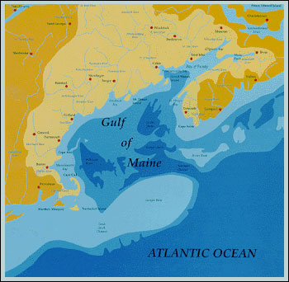

January 6-8, 2004

New England Center, Durham, NH

Sponsored By:
 |  | 
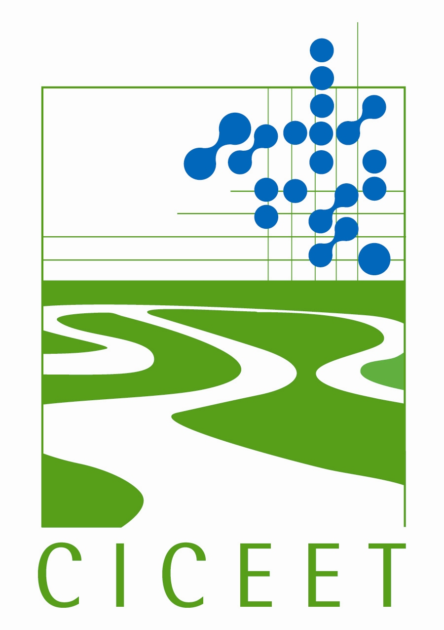 |  | 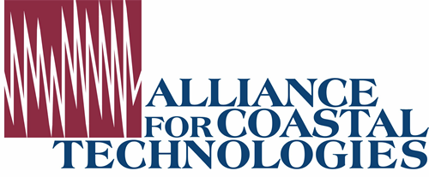
 | 

NOTE: IMPORTANT DOCUMENTS RELATED TO THE CONFERENCE CAN BE FOUND ON THE AGENDA PAGE
The Northeast Coastal Indicators Workshop will develop indicators that apply to the northeast coastal region of the United States (from New York to Maine) and Canada (Gulf of Maine). Participation is by invitation only, so your involvement in this meeting is important to its success.
The workshop is being held at the New England Center located on the campus of the University of New Hampshire, Durham, NH. Registration for the meeting is from 11:00 am to 1:00 pm on Tuesday, January 6 with the workshop beginning promptly at 1pm. We plan to conclude on Thursday, January 8 no later than noon.
We will discuss ongoing efforts to implement coordinated regional monitoring/indicator efforts that respond to the region’s leading coastal and marine management questions. Workshop presentations will include keynote presentations by Dr. Kenneth Sherman, NOAA, on international large marine ecosystem programs focusing specifically on the northeast and Congressman Tom Allen of Maine, Co-Chair of the House Oceans Caucus, who will address Congressional plans and the US Ocean Commission’s report. Presentations on and discussion of current indicator efforts and future needs will also be an important part of the workshop.

Six breakout sessions will be held on Day 2 to develop proposed regional indicators for fisheries, contaminants, eutrophication, aquatic habitat, coastal development, and climate change. Information developed during these breakout sessions will be presented to a Senior Management Panel on Day 3. Identified panelists at this time are Mr. Robert Varney, EPA Region 1; Dr. Michael Sissenwine, NMFS; Mr. Byron James, Deputy Minister New Brunswick Department of the Environment; Ms. Faith Scattalon, Fisheries and Oceans, Canada; and Ms. Priscilla Brooks of the Conservation Law Foundation. After hearing the results of the breakout sessions, each panel member will be asked to discuss how this information may be incorporated in their programs throughout the region.

Agenda and Workshop Materials
Click here to view the Agenda [HTM], [PDF]
Click here to view and download the Workshop Materials (link to be added)

Poster Session Instructions

We encourage participants to develop and present posters on indicators developed for their programs especially for the following topics: fisheries, contaminants, eutrophication, aquatic habitats, land use, and climate change. The poster presentations are intended to help inform participants of current indicator activities, provide information on the location and scale of active programs, show where present monitoring links to the ecological basis of the indicators being developed, and provide opportunities of participants to network with each other. Poster presentations should be designed to support the workshop discussions and expected outcomes by presenting information that addresses the following: Purpose and goal(s) of the indicators including any regulatory mandates, Agencies/entities funding the program and parties conducting the indicator development, Questions being addressed, and the type, location and frequency of measurements. Presentation of indicator data and results should be at a summary level and limited to information that will support discussions on the strategy and framework. Please contact Melissa Manley at manleym@battelle.org if you plan to bring a poster.

Hotel Reservations
A block of rooms have been reserved at the New England Center (immediately adjacent to the conference facility) for those who need to stay overnight. The rate is $89.00 per night plus tax. Hotel reservations must be made as specified on the separate hotel reservation form. Please note that Battelle and all other affiliates of the workshop are not responsible for any portion of the room reservation process or billing. Payment, reservations, and cancellations for hotel accommodations are the responsibility of each individual attendee.
CANCELLATIONS OR CHANGES MUST BE MADE WITH THE FACILITY BEFORE DECEMBER 22, 2003 OR THE ATTENDEE WILL BE RESPONSIBLE FOR FULL PAYMENT OF THE EVENINGS RESERVED.
New England Center Hotel Reservation Form [PDF]

Travel Directions to the Summit
Directions from Interstate 95 Traveling North
Directions from Interstate 95 Traveling South
Directions from the Manchester Airport
Directions from Logan International Airport
These links also have information about the New England Center and the surrounding area.

Travel Funds
Limited funds are available for travel support to those state, local, and academic individuals that would not otherwise be able to attend. Since these funds are limited, we would like to reserve them for individuals with insurmountable travel obstacles. Please inform Barry Burgan at (burgan.barry@epa.gov) if you need travel support to ensure that you can attend the workshop.

Workshop Registration Information
Early registration is encouraged due to limited space. Registrations mailed prior to December 4, 2003 will be allowed to register at the discounted conference fee of $200 for the full conference (includes all breaks, receptions, and meals) or $150 for the two-day rate. Registrations mailed after December 4, 2003 will be subject to the full conference fee of $240 or $190 for the two-day rate. Please see the attached registration form for specifics.
The registration form and payment must be made by check IN ADVANCE (made out to the U.S. Gulf of Maine Association) and can be mailed to:
Edna Cayford
NW Atlantic Indicators Conference
State House Station #38
Augusta, Maine 04333
Registration Form [PDF]
On behalf of our sponsors and the Workshop Steering Committee we look forward to a very productive exchange of information at the workshop!

Steering Committee Members
John Bratton – U.S. Geological Survey
Suzanne Bricker - NOAA
Barry Burgan - U.S. EPA
Lee Doggett - Maine Department of Environmental Protection
David Dow - NOAA/ NMFS
Michelle Dionne - Wells National Estuarine Research Reserve
Diane Gould - U.S. EPA Region 1
Tracy Hart – Maine Sea Grant Program
Carlton Hunt - Battelle
David Keeley - Maine State Planning Board
Christian Krahforst - Massachusetts Coastal Zone Management
Wendy Leo - Massachusetts Water Resources Authority
Gary Matlock - NOAA
Terry McTigue – NOAA
Hilary Neckles – U.S. Geological Survey
Mark Parker – Connecticut Department of Environmental Protection
Gerald Pesch - U.S. EPA Narragansett Bay Laboratory
Jan Smith - Massachusetts Bays Program
Paul Stacy - Connecticut Department of Environmental Protection
Hal Walker - U.S. EPA Narragansett Bay Laboratory
Peter Wells – Environment Canada

